

**Stage: Systems Analysis and Design**

**System Design Specification**

**LO Grade Reporting**

**HSS Portfolio Projects**

**HSS013**

**[ANNUAL PLAN NUMBER]**

**Document Version: 0.12**

**(Alex Burford comments 15/06/16)**

**Date: 10/06/16**

**Contents**

1 Document Management 3

1.1 Contributors 3

1.2 Version Control 3

2 OVERVIEW 4

3 DEVELOPMENT TOOLS AND STANDARDS 5

3.1 Development Tools 5

3.2 Development Standards 5

4 SYSTEM PROCESSES 6

4.1 Student process (BRD 2-Student ‘TO BE’ Process Map) 6

4.2 Staff process (BRD 2-Staff ‘TO BE’ Process Map) 6

5 USER INTERFACE 8

5.1 Transactional Interface 8

5.1.1 Student interaction 8

5.1.2 Staff interaction 13

5.1.3 MyEd Interface 14

5.2 Reporting Interface 14

6 APPLICATION SECURITY 15

6.1 Authentication 15

6.2 Authorisation 15

6.3 Business Objects 15

7 DATABASE DESIGN 16

8 APPLICATION INTERFACES 17

9 DATA 18

9.1 Data Migration 18

9.2 Archiving Policy 18

10 IMPLEMENTATION 19

10.1 Generic DB query 19

# Document Management

When completing this document, please mark any section that is not required as ‘N/A’. A brief description of why the section is not required should also be included.

## Contributors

Please provide details of all contributors to this document.

|  |  |  |
| --- | --- | --- |
| **Role** | **Unit** | **Name** |
| Systems Analyst Designer (Owner) | IS Apps | Geir Granum |
| Business Analyst |  |  |
| Project Manager | IS Apps | **Nikki Hacket Reed** |
| Project Sponsor |  |  |
| Business Area Manager |  |  |
| *Other document contributors* |  |  |

## Version Control

Please document all changes made to this document since initial distribution.

|  |  |  |  |  |
| --- | --- | --- | --- | --- |
| **Date** | **Version** | **Author** | **Section** | **Amendment** |
| 07/06/16 | 0.1 | GG | **All** | **Initial version** |
| 09/06/16 | 0.5 | GG | **All** | **Details and images** |
| 10/06/16 | 0.9 | GG | **10** | **Minor changes** |
|  |  |  |  |  |
|  |  |  |  |  |
|  |  |  |  |  |
|  |  |  |  |  |
|  |  |  |  |  |

# OVERVIEW

This project will develop a learn Building Block (B2B) to display detailed information on Gradebook grades/scores marked using Rubrics. There will be two views:

1. A student view: Displaying the rubric-level grades and feedback relating to a single assignment in a course.
2. A staff view: Allowing staff to export the detailed rubric data used to generate a gradebook grade as a CSV file. For a single gradebook column and all gradebook columns (that are using rubric data)



The student view will be implemented as a BB Learn ‘tool’.

The staff view will be implemented as a BB Learn ‘course tool’ and as such will only be available to users who have permission to see and use the control panel in BB Learn.

# DEVELOPMENT TOOLS AND STANDARDS

## Development Tools

PL/SQL and Java/JSP

## Development Standards

Tick the appropriate box to indicate the standards being followed for this application:

|  |  |
| --- | --- |
| **Standard** | **√ indicates compliance** |
| Database Design | NA |
| Cold Fusion | NA |
| Java | **√** |
| Uportal Development | NA |
| Accessibility |  |
| Web Style Standards |  |
| [Supported Web Browsers](http://www.ed.ac.uk/schools-departments/information-services/services/computing/application-development/application-support/supported-web-browsers/browser-application) |  |
|  |  |
|  |  |

The tool will be implemented as a Blackboard Learn building block using the built in html tag-library and CSS files. This means that it will follow the Learn Web Style, it will be as accessible as Learn and it will support the same browsers as Learn

# SYSTEM PROCESSES

The requirements will be fulfilled by creating one Learn Building block (B2B). This B2B will contain use a query that joins data from the following areas of Learn:

* Course data
* User data
* Enrolments data
* Gradebook data
* Rubric data

This result of this query will be used to generate the requested data and display/generate a CSV file from it. The query is detailed in section 10

If the B2B is unable to connect to the Learn database tables a message will be displayed indication that the service is currently unavailable

## Student process (BRD 2-Student ‘TO BE’ Process Map)

In the student process the query will be run twice. The first time it will be filtered on the current course and user. This data is found from the current context in Learn. Once a specific gradebook entry has been selected from the Learn UI the query is run a second time, now filtering on the current course and user and on the selected gradebook entry. The results from this query are formatted and displayed in the learn UI



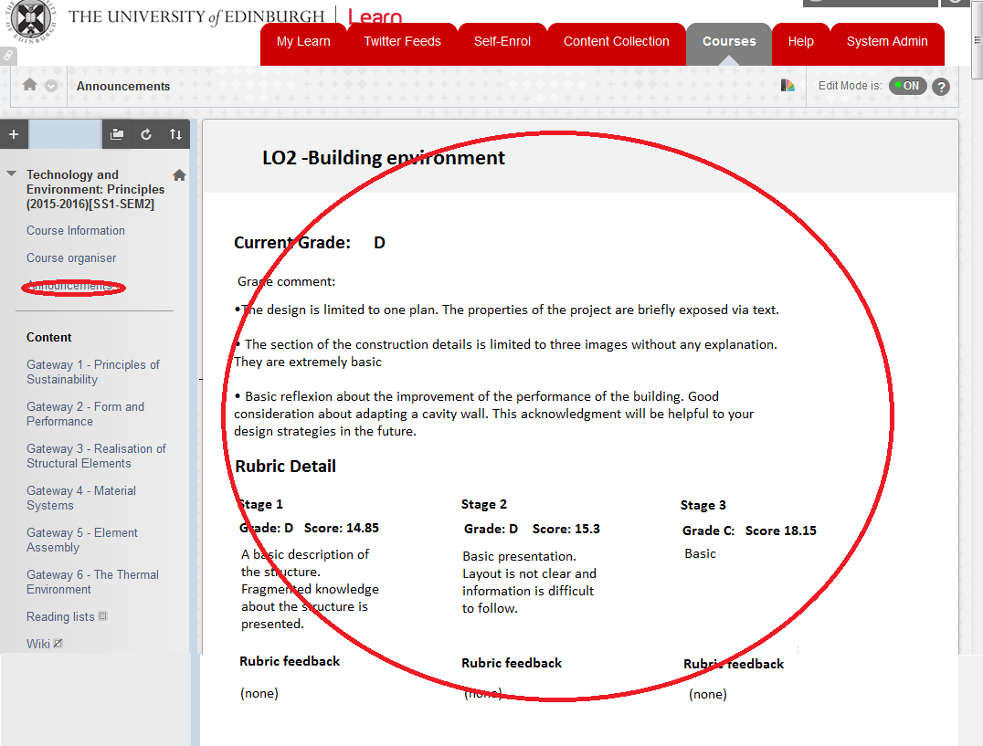

What the student interface may look like

## Staff process (BRD 2-Staff ‘TO BE’ Process Map)

In the staff process the query will be run twice. The first time it will be filtered on the current course. This data is found from the current context in Learn. Once a specific gradebook entry (or ALL) has been selected from the Learn UI the query is run a second time, filtering on a single gradebook item if applicable.



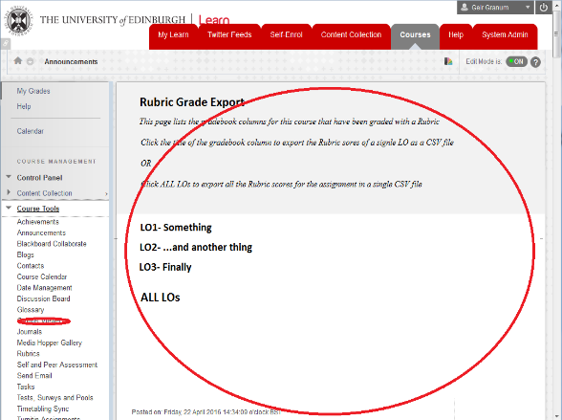

What the staff interface may look like

The results of the second query will be formatted into a CSV file. Part of this formatting may (depending on the CSV format) be to programmatically ‘rotate’ the rubric rows found (containing the LOs). i.e. when the query finds something like this (assuming that both the grade, score and the max possible score from the rubric should be exported in the CSV):

|  |  |  |  |
| --- | --- | --- | --- |
| **Rubric Grade** | **Rubric score** | **Rubric Max score** | **Rubric row name** |
| A2 | 0.283305 | 33.33 | LO1 - Research: Research and reason a critical understanding of the key theories, practices and methods that inform your project and employ an appropriate range of research applications and sources. |
| A3 | 0.25005 | 33.34 | LO2 - Analysis: Creatively analyse and synthesise the results of your research. |
| A3 | 0.249975 | 33.33 | LO3 - Communication: Demonstrate your ability to manage, structure, resolve and communicate your own innovative research project. |

It may have to be programmatically converted to:

|  |  |  |  |  |  |  |  |  |
| --- | --- | --- | --- | --- | --- | --- | --- | --- |
| **LO1 Grade** | **LO2 Grade** | **LO3 Grade** | **LO1 Score** | **LO2 Score** | **LO3 Score** | **LO1 Max** | **LO2 Max** | **LO3 Max** |
| A2 | A3 | A3 | 0.283305 | 0.25005 | 0.249975 | 33.33 | 33.34 | 33.33 |

This may turn out to be the most challenging part of the build. Especially making it flexible enough to handle any number of rubric rows.

# USER INTERFACE

## Transactional Interface

All the mocked up screenshots below are created using font sizes and spacing close to Learn defaults. This should indicate how much can information can be displayed on a screen. As a worst case scenario a non-wide display is assumed.

### Student interaction

Students will be able to access their detailed rubric information in two clicks when they are in a course that is using the new building block.

1. Click the tool from the course menu in the upper left part of the screen.
2. Click the name of the assignment/gradebook column you want to see detailed rubric information on.

#### Result selection screen

This is a mocked up screenshot of what the screen that allows students to select which assignment/gradebook column they want to see detailed rubric information from looks like. Only assignments/gradebook columns that have been made available to students and that are have been marked using a rubric will be available for selection.

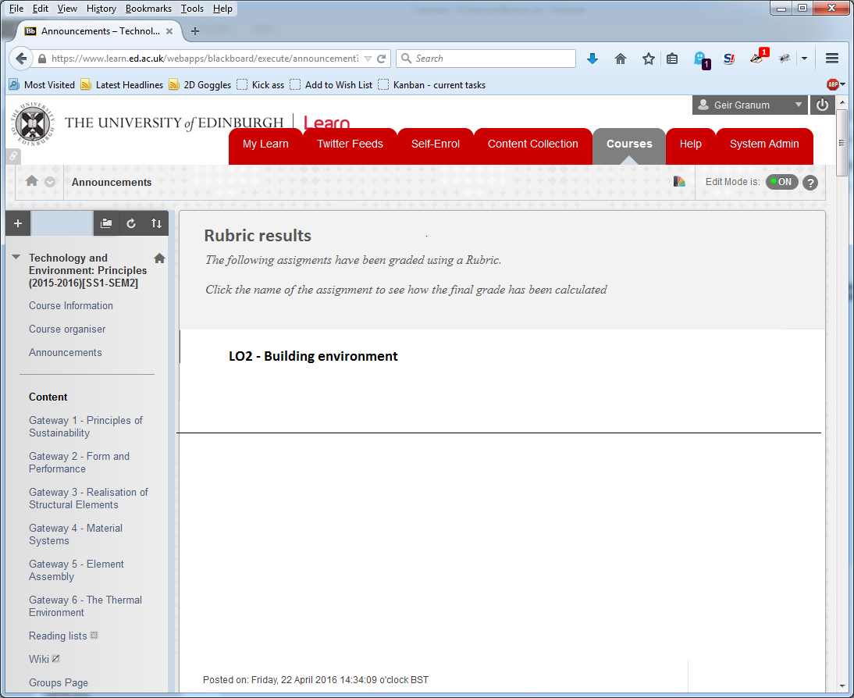

The student selection screen

#### Nothing found screen

If the current course have no assignments/gradebook columns that are visible to students and have been marked using a rubric a message like in the mocked up screenshot below will be displayed:

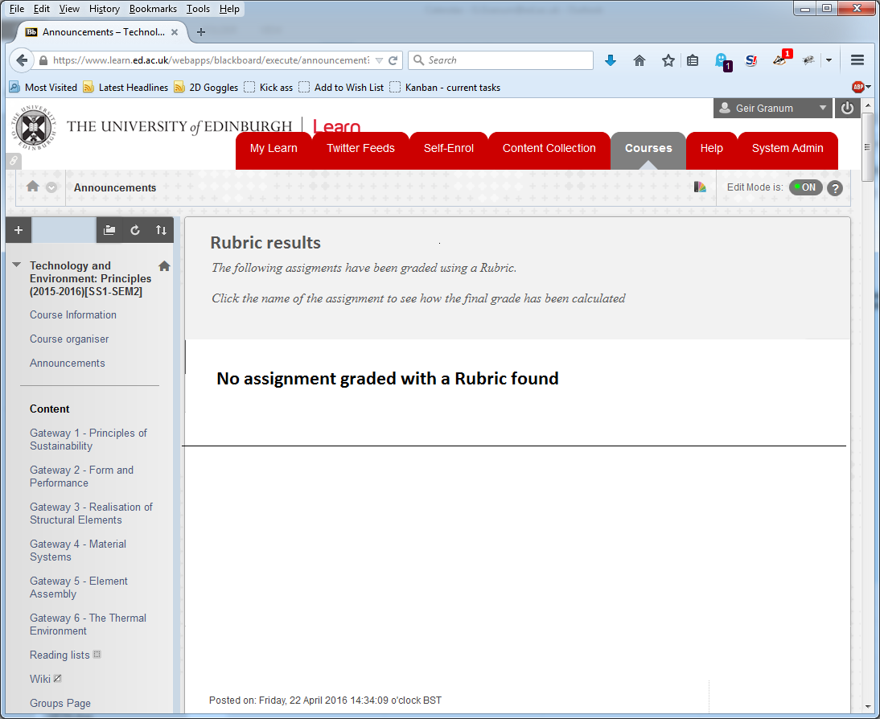

The student ‘nothing found’ screen

#### Rubric display screen 3 rows or fewer

If there are 3 or fewer rubric rows to display then a horizontal layout appears to be feasible. The screen could be laid out like this:



The following to mock up screenshots show what the horizontal layout would look like with real data.

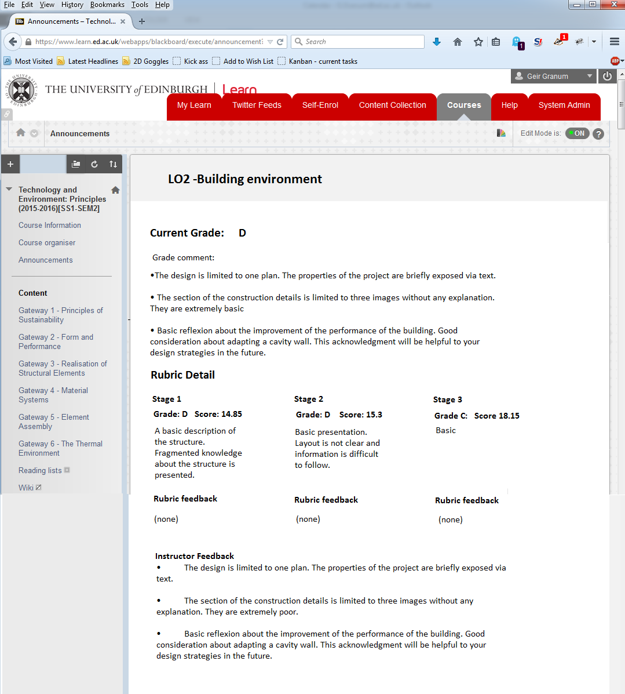

Example 1: 3 columns or fewer – no rubric feedback

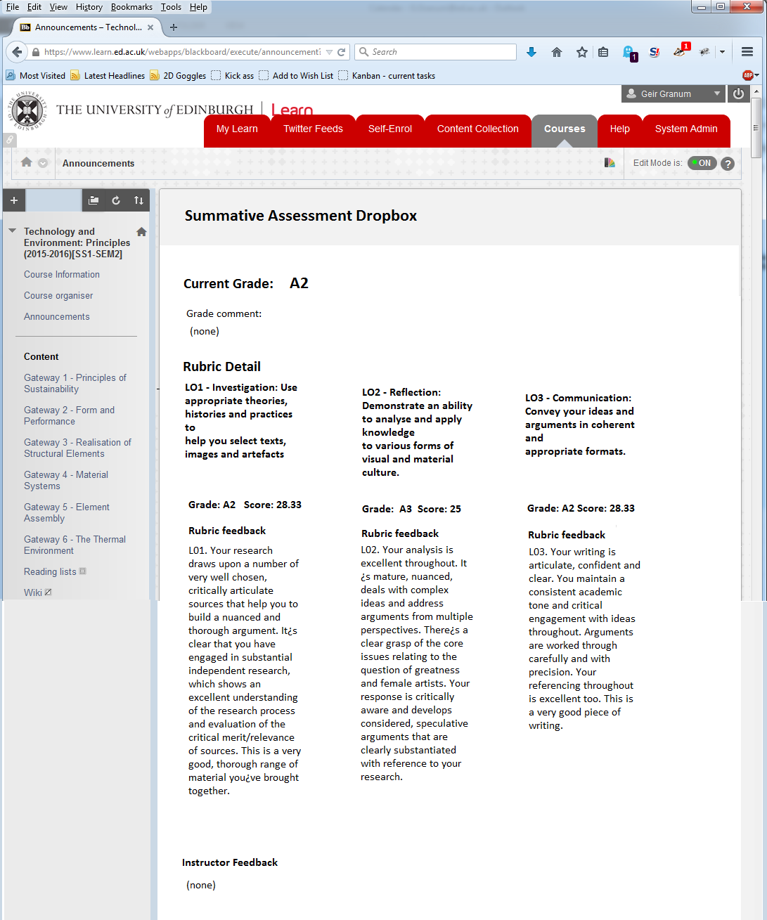

Example 2: 3 columns or fewer – no rubric description

#### Rubric display screen more than 3 rows

If there are more than 3 rows in the rubric then the data will not display in a horizontal lay-out without introducing scrolling.

If this is the case then a vertical layout of the detailed rubric information is needed.



The following mock up screenshot shows what the vertical layout look like with real data.

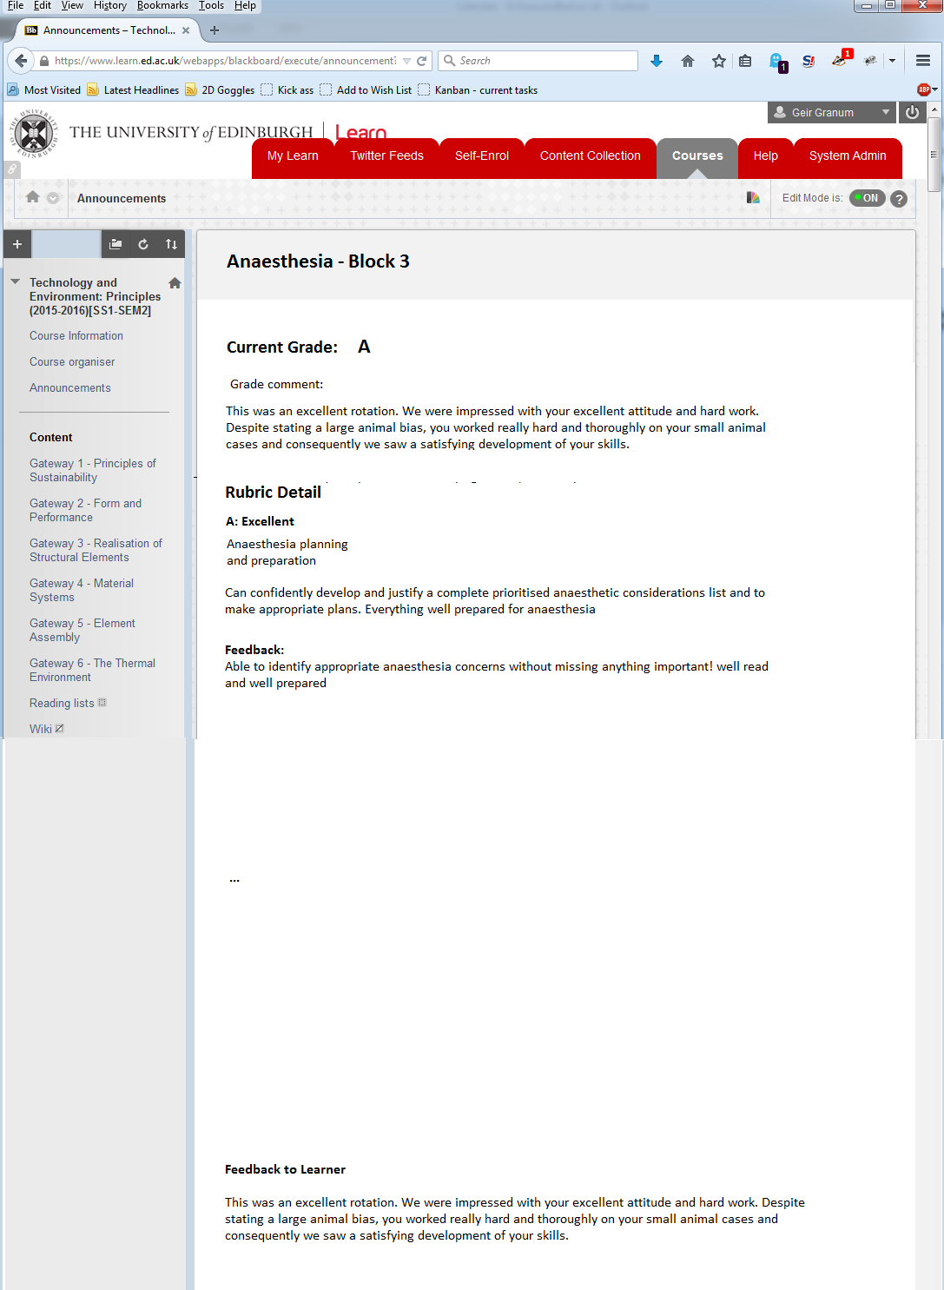

Example: more than 3 columns

### Staff interaction

The staff interaction part of the tool will be available from the ‘course tools’ area of the course ‘control panel’. Once the tool is selected a page will display with explanatory text at the top followed by a list of assignments/gradebook columns found in the course that have been marked using rubrics. Each entry in the list will be a link that creates and downloads a CSV file (with the columns in the same order as the Turnitin export) for that particular assignment/gradebook column. At the bottom of the screen there will be a separate link that will allow for the creation and download of a CSV file that will contain the information from ALL the single assignments/gradebook columns in one file.

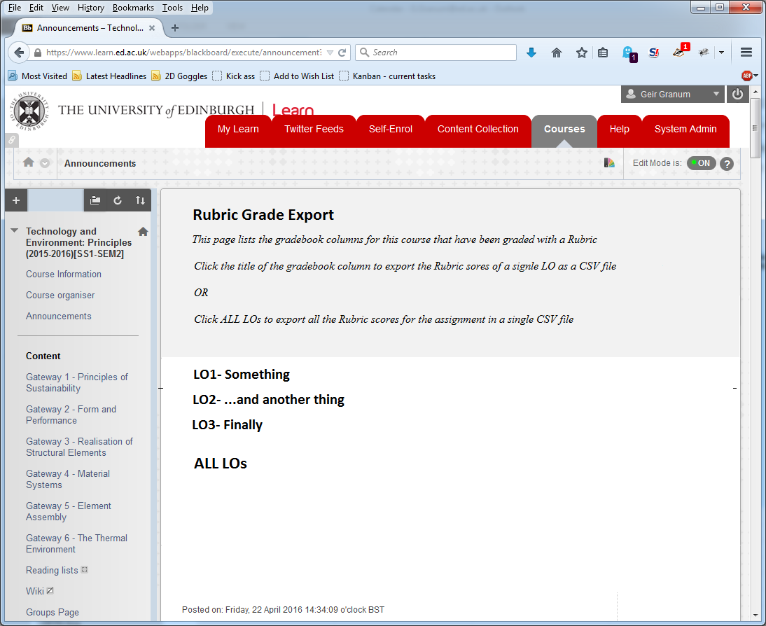

Example: export CSV screen

(Need example CSV file here)

### MyEd Interface

*NA*

## Reporting Interface

NA

# APPLICATION SECURITY

This section relates to application rather than physical security which is covered in the Technical Architecture Document (TAD).

## Authentication

The B2B will use the authenticated identity from the Learn session.

## Authorisation

The will use the assigned role from Learn to authorise what the user has access to

## Business Objects

NA.

# DATABASE DESIGN

Insert an Entity-Relationship Diagram of the system. If new tables have been added to an existing system then highlight these in your ER Diagram (full diagram of existing system not needed).

Full specifications should be provided for all new tables/views/columns in the system (ie name, datatype, mandatory, default values, constraints).

No new database is needed. The information can be extracted with SELECT queries from the BBLEARN schema

# APPLICATION INTERFACES

Provide technical details of any inputs to the system from other applications and any outputs from the system to other applications. Full data specifications should be included. Identify possible impact on existing processes.

The system will use the following tables from the BBLEARN schema directly:

* BBLEARN.RUBRIC_CELL
* BBLEARN.RUBRIC_CELL_EVAL
* BBLEARN.RUBRIC_EVAL
* BBLEARN.RUBRIC_LINK
* BBLEARN.EVALUATION_ENTITY
* BBLEARN.ATTEMPT
* BBLEARN.GRADEBOOK_GRADE
* BBLEARN.COURSE_USERS
* BBLEARN.USERS
* BBLEARN.COURSE_MAIN
* BBLEARN.RUBRIC_ROW
* BBLEARN.RUBRIC_COLUMN
* BBLEARN.GRADEBOOK_MAIN
* BBLEARN.RUBRIC
* BBLEARN.GRADEBOOK_TRANSLATOR
* BBLEARN.GRADEBOOK_SYMBOL

The only grant that is needed is SELECT. An existing Read only users such as: DSGBROWER can be used.

# DATA

## Data Migration

NA

## Archiving Policy

*NA*

# IMPLEMENTATION

## Generic DB query

This is the database query that extracts all the data that is needed to fulfil the requirements. Filtering on a rubrics visibility and/or availability may need to be added:

SELECT BBLEARN.COURSE_MAIN.COURSE_ID,

BBLEARN.USERS.USER_ID,

BBLEARN.GRADEBOOK_MAIN.TITLE,

BBLEARN.GRADEBOOK_SYMBOL.SYMBOL AS calculated_grade,

GRADEBOOK_GRADE.MANUAL_SCORE ,

GRADEBOOK_GRADE.MANUAL_GRADE ,

GRADEBOOK_GRADE.AVERAGE_SCORE,

BBLEARN.ATTEMPT.SCORE,

BBLEARN.ATTEMPT.GRADE,

BBLEARN.RUBRIC_COLUMN.HEADER AS column_val,

BBLEARN.RUBRIC_ROW.HEADER AS row_val,

BBLEARN.RUBRIC_ROW.PERCENTAGE AS row_PERCENTAGE,

BBLEARN.RUBRIC_CELL_EVAL.SELECTED_PERCENT,

BBLEARN.RUBRIC_EVAL.COMMENTS AS rubric_eval_comm,

BBLEARN.RUBRIC_CELL.DESCRIPTION as rubric_desc,

BBLEARN.ATTEMPT.ATTEMPT_DATE,

BBLEARN.GRADEBOOK_GRADE.STATUS,

BBLEARN.USERS.FIRSTNAME,

BBLEARN.USERS.LASTNAME,

BBLEARN.GRADEBOOK_GRADE.EXCLUDED_IND,

BBLEARN.GRADEBOOK_GRADE.EXEMPT_IND,

BBLEARN.RUBRIC_EVAL.MAX_VALUE,

BBLEARN.RUBRIC_EVAL.TOTAL_VALUE,

BBLEARN.ATTEMPT.INSTRUCTOR_COMMENTS,

BBLEARN.RUBRIC.TITLE AS TITLE1,

BBLEARN.RUBRIC.TYPE,

BBLEARN.RUBRIC.STATUS AS STATUS1,

BBLEARN.RUBRIC.PUBLIC_IND,

BBLEARN.GRADEBOOK_SYMBOL.SYMBOL,

BBLEARN.RUBRIC_CELL_EVAL.FEEDBACK

FROM BBLEARN.RUBRIC_CELL

INNER JOIN BBLEARN.RUBRIC_CELL_EVAL

ON BBLEARN.RUBRIC_CELL.PK1 = BBLEARN.RUBRIC_CELL_EVAL.RUBRIC_CELL_PK1

INNER JOIN BBLEARN.RUBRIC_EVAL

ON BBLEARN.RUBRIC_EVAL.PK1 = BBLEARN.RUBRIC_CELL_EVAL.RUBRIC_EVAL_PK1

INNER JOIN BBLEARN.RUBRIC_LINK

ON BBLEARN.RUBRIC_LINK.PK1 = BBLEARN.RUBRIC_EVAL.RUBRIC_LINK_PK1

INNER JOIN BBLEARN.EVALUATION_ENTITY

ON BBLEARN.EVALUATION_ENTITY.PK1 = BBLEARN.RUBRIC_LINK.EVAL_ENTITY_PK1

INNER JOIN BBLEARN.ATTEMPT

ON BBLEARN.ATTEMPT.PK1 = BBLEARN.EVALUATION_ENTITY.ATTEMPT_PK1

INNER JOIN BBLEARN.GRADEBOOK_GRADE

ON BBLEARN.GRADEBOOK_GRADE.PK1 = BBLEARN.ATTEMPT.GRADEBOOK_GRADE_PK1

INNER JOIN BBLEARN.COURSE_USERS

ON BBLEARN.COURSE_USERS.PK1 = BBLEARN.GRADEBOOK_GRADE.COURSE_USERS_PK1

INNER JOIN BBLEARN.USERS

ON BBLEARN.USERS.PK1 = BBLEARN.COURSE_USERS.USERS_PK1

INNER JOIN BBLEARN.COURSE_MAIN

ON BBLEARN.COURSE_MAIN.PK1 = BBLEARN.COURSE_USERS.CRSMAIN_PK1

INNER JOIN BBLEARN.RUBRIC_ROW

ON BBLEARN.RUBRIC_ROW.PK1 = BBLEARN.RUBRIC_CELL.RUBRIC_ROW_PK1

INNER JOIN BBLEARN.RUBRIC_COLUMN

ON BBLEARN.RUBRIC_COLUMN.PK1 = BBLEARN.RUBRIC_CELL.RUBRIC_COLUMN_PK1

INNER JOIN BBLEARN.GRADEBOOK_MAIN

ON BBLEARN.GRADEBOOK_MAIN.PK1 = BBLEARN.GRADEBOOK_GRADE.GRADEBOOK_MAIN_PK1

INNER JOIN BBLEARN.RUBRIC

ON BBLEARN.RUBRIC_COLUMN.RUBRIC_PK1 = BBLEARN.RUBRIC.PK1

AND BBLEARN.RUBRIC.PK1 = BBLEARN.RUBRIC_ROW.RUBRIC_PK1

left outer JOIN BBLEARN.GRADEBOOK_TRANSLATOR

ON BBLEARN.GRADEBOOK_TRANSLATOR.PK1 = BBLEARN.GRADEBOOK_MAIN.GRADEBOOK_TRANSLATOR_PK1

INNER JOIN BBLEARN.GRADEBOOK_SYMBOL

ON BBLEARN.GRADEBOOK_TRANSLATOR.PK1 = BBLEARN.GRADEBOOK_SYMBOL.GRADEBOOK_TRANSLATOR_PK1

WHERE (BBLEARN.ATTEMPT.SCORE > BBLEARN.GRADEBOOK_SYMBOL.LOWER_BOUND)

AND (BBLEARN.ATTEMPT.SCORE <= BBLEARN.GRADEBOOK_SYMBOL.UPPER_BOUND)

AND GRADEBOOK_MAIN.VISIBLE_IND ='Y'

/*filters – use one or more to limit to course, user and/or specific gradebook entry

And BBLEARN.COURSE_MAIN.COURSE_ID = ‘’

And BBLEARN.USERS.USER_ID =’’

And BBLEARN.GRADEBOOK_MAIN.PK1 = ‘’

*/