New College Library
Funk Donation Projects Update
March 2015

The Funk Projects
Creating a treasure house of New College Library Special Collections through:
- Access
- Conservation
- Security

Financial Overview | Estimated spend  2014-15 | Actual spend  2014-15
Cataloguing Projects  - Cataloguer salaries | £65,000 | £34157.72
Preservation & Conservation Projects  - Book moving  - Boxing / hoovering / Conservation staff costs | £1020  £5000 | £182.37  £963
Other  - Andrew Walls Library (CSWC) Project Work- | £5834.10 | £3,400.00
TOTAL | £77034.21 | £38,703.09

Projected expenditure 2014-2016
Current Funk Balance | £129,534
2015 Cheque | £67,614*
Total available | £197,148
Planned expenditure
2014-15 | £77, 034
2015-16 | £73,200
Total | £150,234
*estimate

After reviewing the Funk funds and expenditure, I’ve reached these conclusions:

- The potential available balance for final projects is : £46,914
- Therefore if the final Funk cheque is received in 2015 as expected, there is enough available from the Funk funds to pay a part time archivist post in 2015-16, as well as the existing salary commitments.
- If the final Funk cheque were not received, there is a risk that we would run out of funds to pay the existing rare book cataloguer posts in about March 2016, with a shortfall of 22K approx. However as Dr Funk has always proved reliable in the past, I judge this risk to be low.
Projects 2014-2016

Cataloguing Projects.
- Approximately 31,000 items have now been handled since the beginning of the Funk Cataloguing projects in May 2009, and nearly 25,000 new catalogue records created for Special Collections items.
- In January 2015 Finlay West, Funk Cataloguer since the beginning of the projects, was seconded to a 12 month post at the Centre for Research Collections. His post has been filled by Patrick Murray and Paul Nicholas without interruption to the workflow.
- Over 2000 items from the Longforgan Free Church Ministers Library have now been catalogued, with the final bookcase in the Library Hall now being tackled by Patrick Murray. More about this here: http://libraryblogs.is.ed.ac.uk/newcollegelibrarian/2015/02/10/tackling-a-library-time-capsule-the-longforgan-free-church-ministers-library/
- Oreste de Tommasso has catalogued over 3400 Hymnology items out of the 5,000+ items in the collection.
- Janice Gailani has begun work on the TR sequence and already catalogued over 350 items.
- Paul Nicholas has begun work on the MH sequence, and has discovered a fascinating seventeenth century book covered in a medieval manuscript wrapper detailing the Benedictus antiphon for the feast of St Nicholas.
- The Funk cataloguer PCs have been replaced by the Library & University Collections PC replacement programme.
Preservation and Conservation Projects.
- Peter Scott has been working on cleaning and basic preservation measures for the Dumfries Presbytery Library.
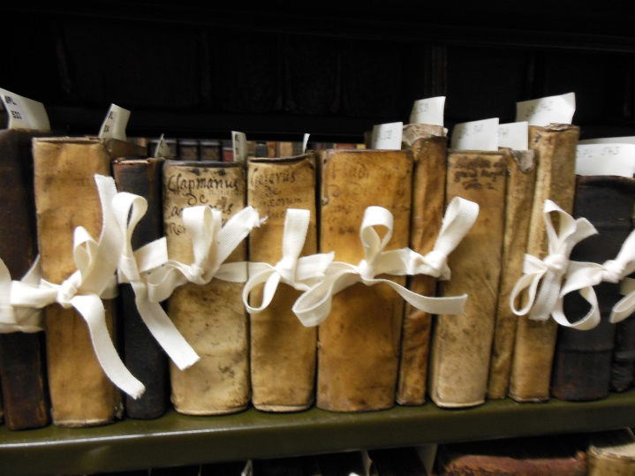

Christine Love-Rodgers led a tour for Library & University Collections and Security staff on a Disaster Response and Recovery Plan visit on 24 February.

Exhibitions
The museum-standard display case purchased by the Funk Donation has featured exhibitions on Christmas Carols from the recently catalogued Hymnology Collections and Robert Burns items from New College Special Collections.

Special Collections usage
We have experienced a high volume of Special Collection requests this semester, including over 200 requests in January. There have been an increasing number of consultations for the Hymnology section which is currently being catalogued online as part of the Funk Donation Projects.

Other projects
We’re pleased to have recruited a new volunteer for the Library Donations Register Project, New College student Lydia Webster.

New College Library Objects Collection.
A successful workshop was held as [art of the University’s Innovative Learning Week which assembled a historic model of the Tabernacle from New College Library’s object collection.

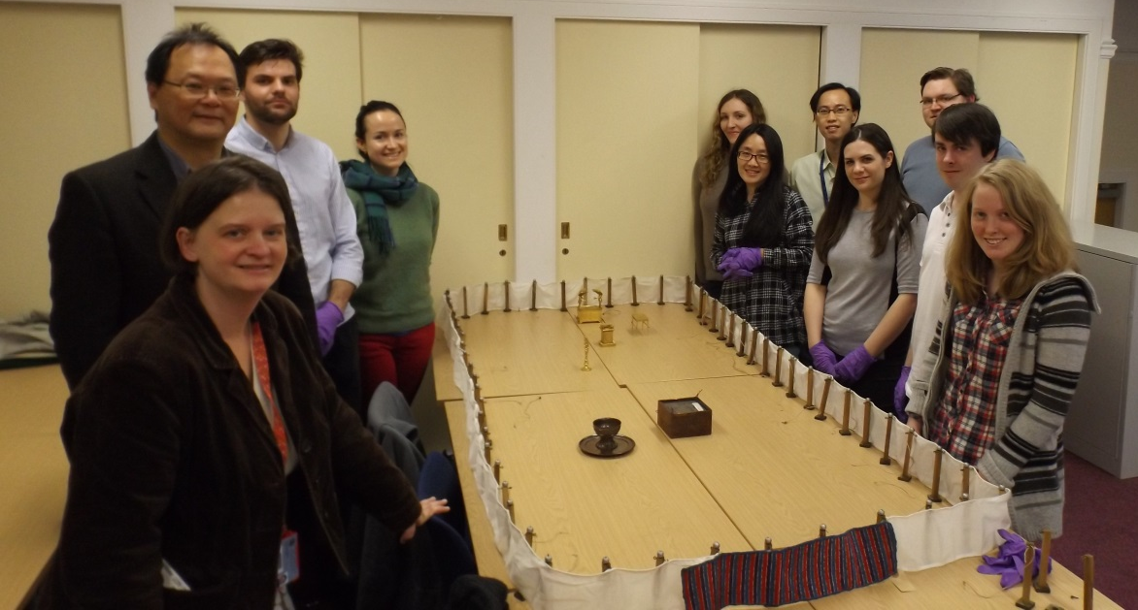

Future Project Priorities
- Archive projects. An archivist is urgently required at New College Library to address:
  - Uncatalogued collections : Gorbals Group Papers, Papers of Dr Ruth Page, Papers of Dr Robert Mackie
  - Scoping work for Centre for World Christianity Archives
  - Archive space management isssues
- Space management. Space for Special Collections has reached a critical point at New College Library. We need to actively review our collections to identify material for transfer or disposal, to release space to enable appropriate collection care and for selected archive acquisitions.
- Cataloguing of Stack III Collections. We plan to continue with the cataloguing of Stack III Special Collections, many of which came from the original donations to New College Library in 1843-1853. These sequences contain many of New College Library’s most unique and valuable items.

Christine Love-Rodgers
March 2015

