

***User Guide***

###### ***ARCHIBUS/EBIS Online/Web Central***

*On Demand SLA Set Up***Foreword**

This User Guide document has been designed for the purpose of training relevant members of staff within Estates and Buildings.

**System Support**

If you require assistance please contact [Ebisusers@ed.ac.uk](mailto:Ebisusers@ed.ac.uk) in the first instance. All urgent requests should be directed to the Ebisusers Support Desk on  50 9683.

More information on the EBIS Project is available at:-

<http://www.ebis.estates.ed.ac.uk>

**Logging on to EBIS Online**

Login to the following url using user name and password which are supplied by Ebisusers.

<https://www-live.ebis.estates.ed.ac.uk>

This will open menu bar showing what access you have been set up with.

**Logging on to Archibus**

Double click on the Archibus-FM 17 icon  on desktop to open Core Archibus Program.

In Project double clik on  to open up Project

Enter User Name and Password – which are supplied by Ebisusers – then click OK

This will now open up the Archibus/FM Navigator showing all modules/groups you have access to.

**Logging on to Web Central**

Login to the following url (Firefox or Google Chrome Browsers should be used) using your EASE user name and password:-

<https://www.webcentral.estates.ed.ac.uk/archibus/login.axvw>

This will open Web Central Application showing access you have been set up with.

**Create Problem Types**

First you need to set up Problem Type to which SLAs to be set against. To do this from within Web Central select Building Operations Management | On Demand Work | Business Process Owner | Define Problem Types

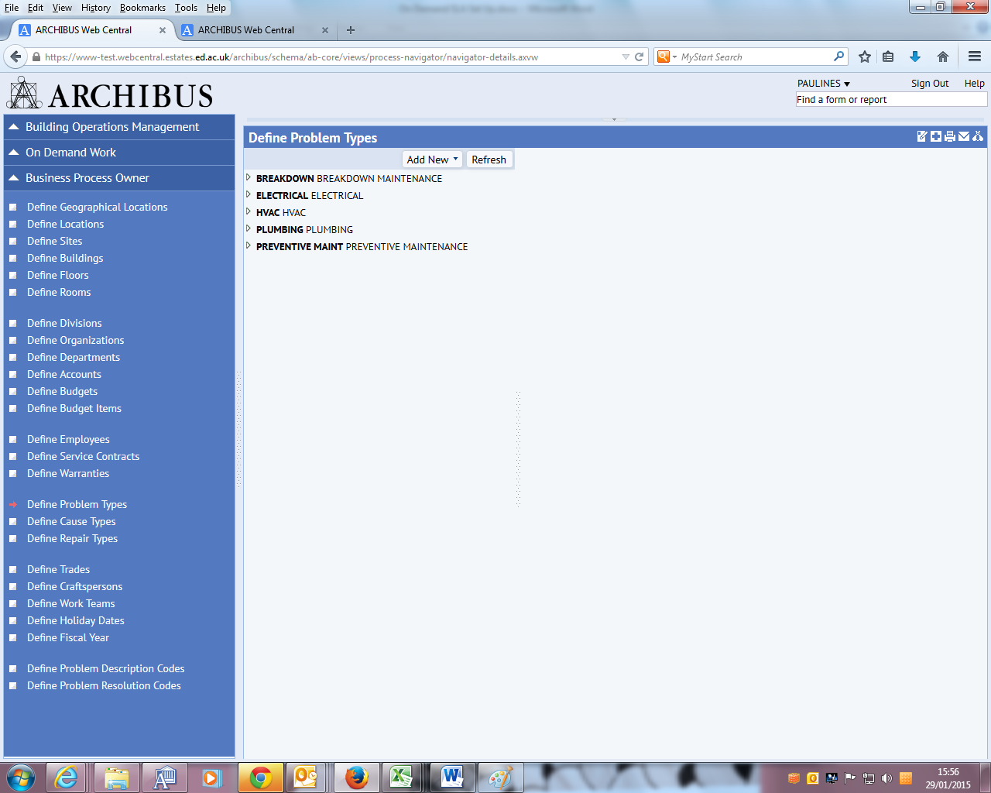

Click Add New | First Tier

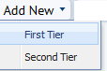

Enter top level Problem Type Code, Description and select Problem Class as On Demand Work then Save

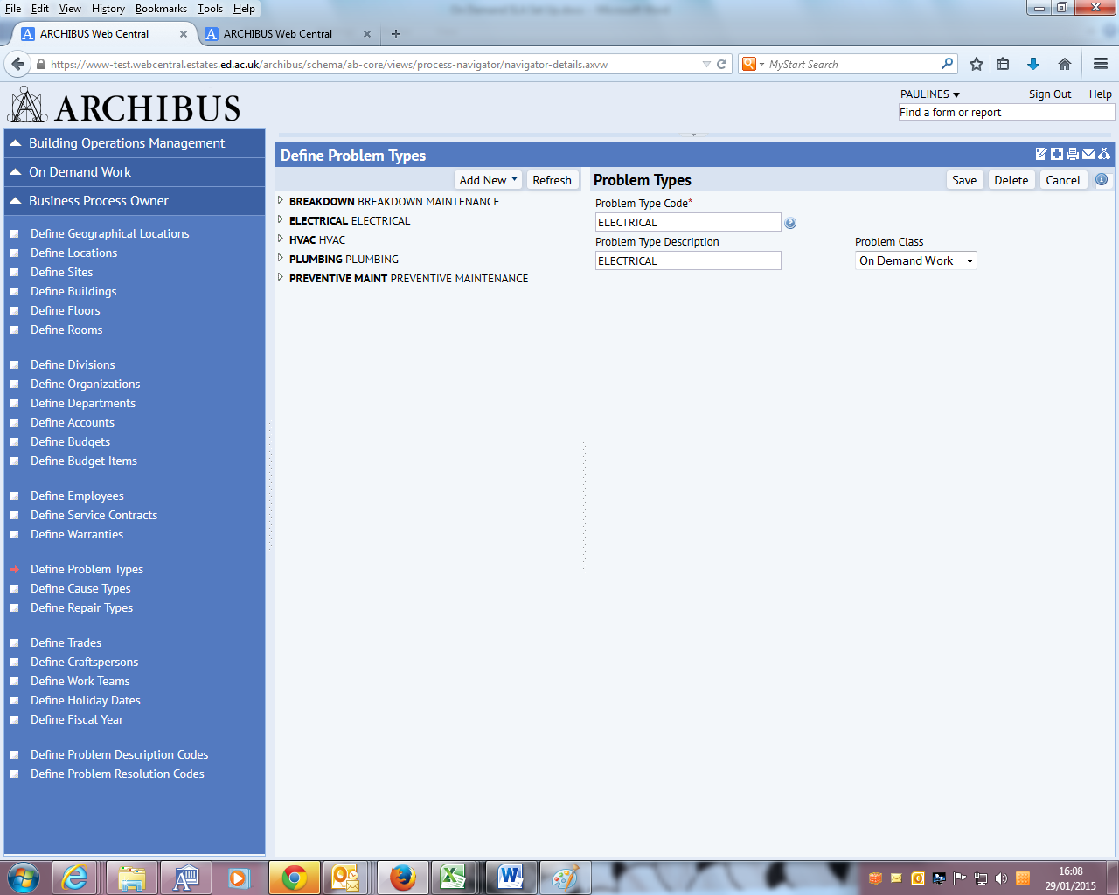

To enter sub Problem Type click on Problem Type you want to set up for and then Add New | Second Tier

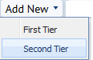

Enter Problem Type Code, Description and select Problem Class as On Demand Work then Save

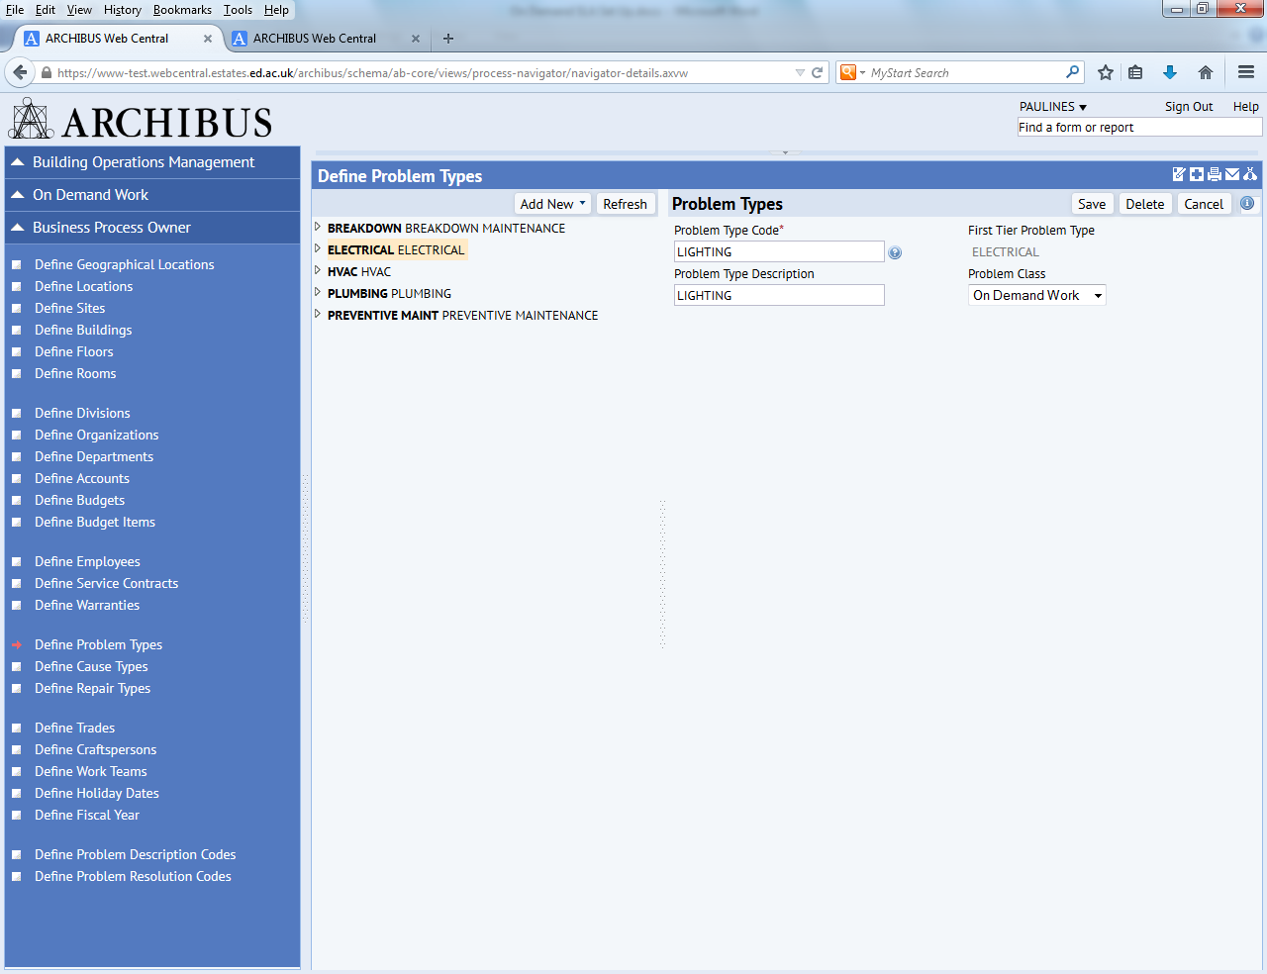

This then creates sub Problem Type under selected Problem Type

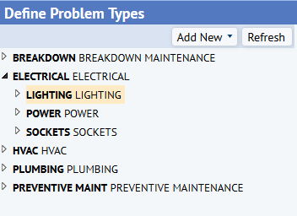

**Create Service Level Agreements**

From within Web Central select Building Operations Management | On Demand Work | Service Desk Manager | Manage Service Level Agreements

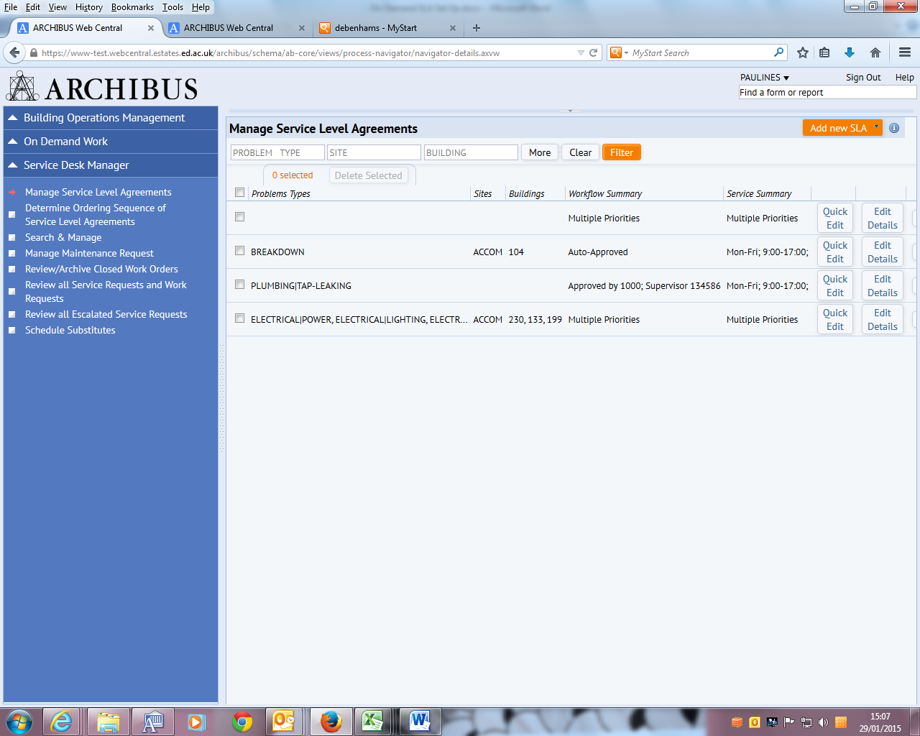

Select Add new SLA | On Demand SLA

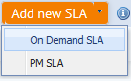

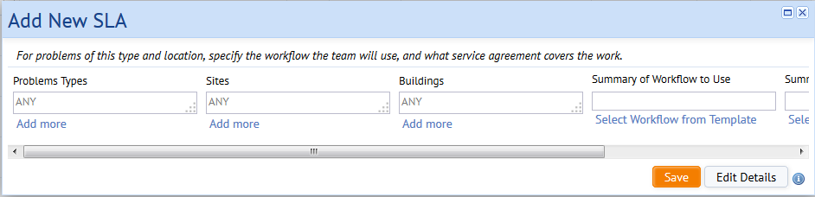

Click on Add more to select the Problem Type/s you wish to set up SLA for –

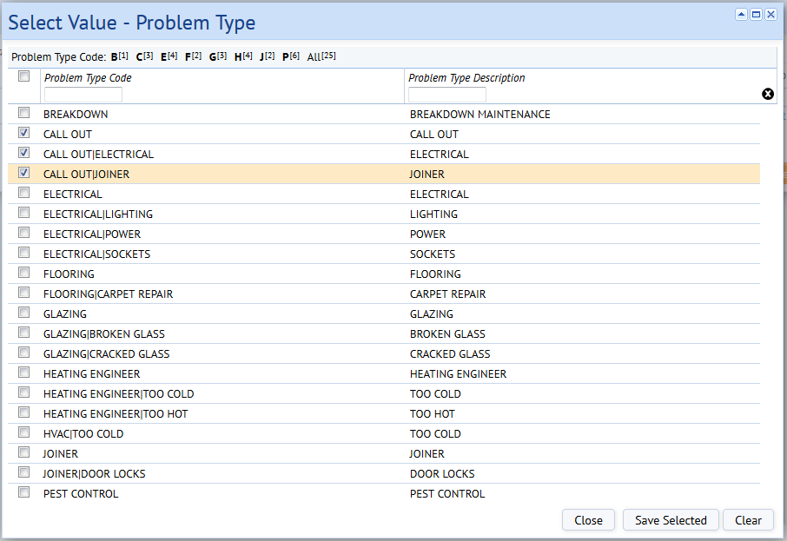

You can select more than 1 Problem Type if you have same SLA for multiples then click Save Selected.

Under Sites click Add more to enter the Zone SLA to be set up for

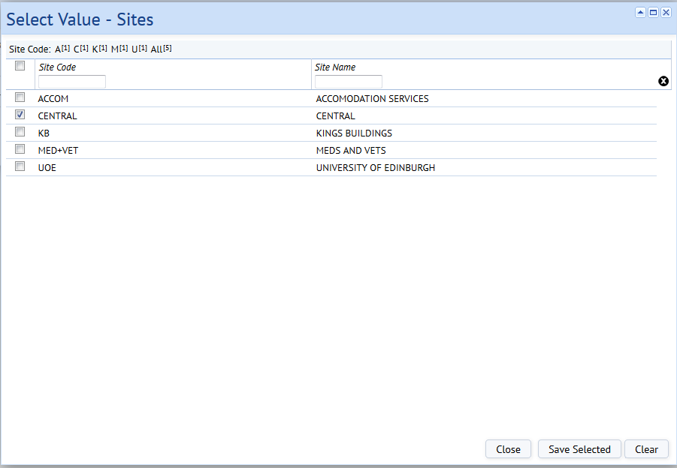

Save Selected

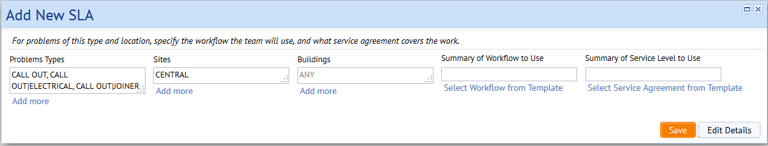

Click Edit Details to create Workflow for SLA

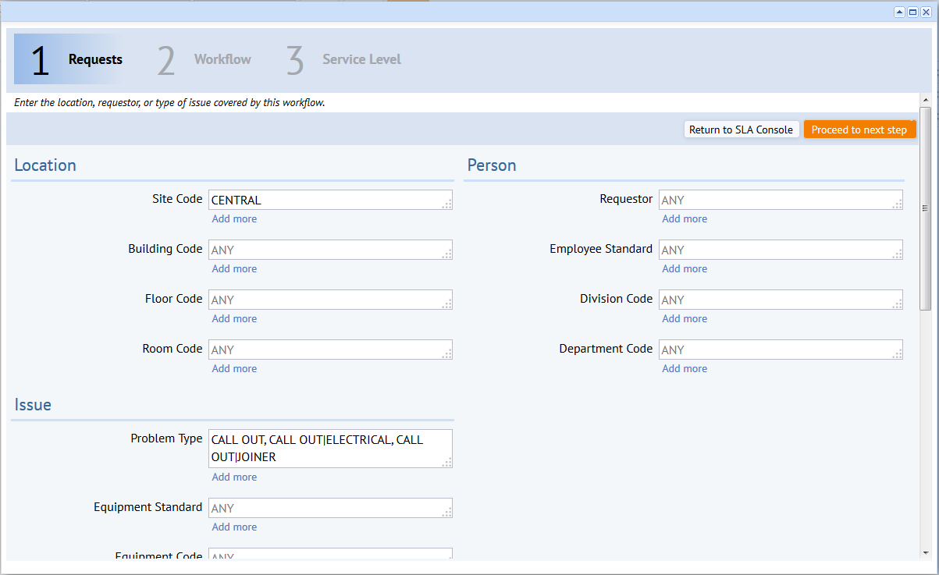

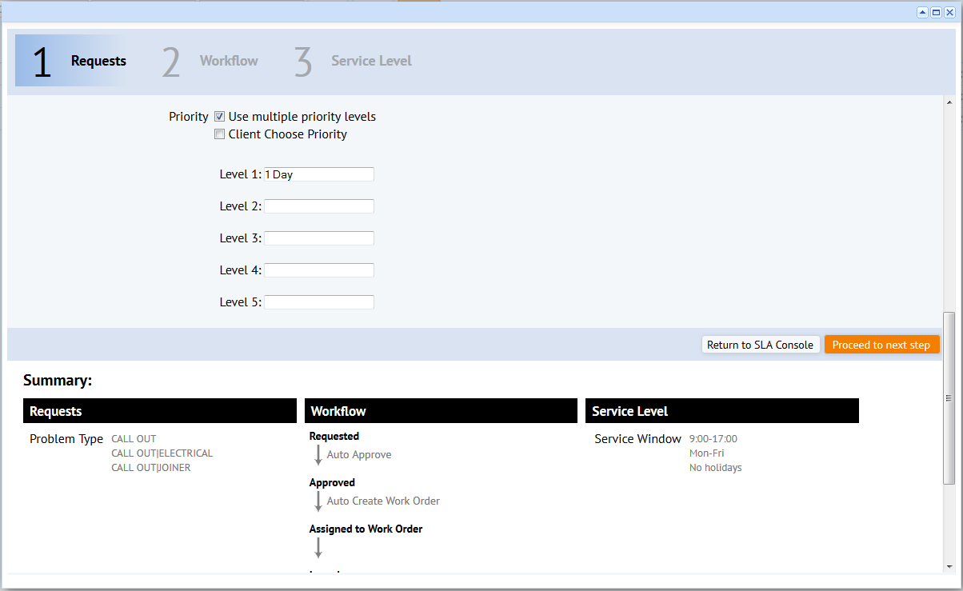

If Multiple Priority Levels have to be entered against SLA click Use multiple priority levels and then at each level enter the number of days for each priority. If customer allowed to change the priority then tick Client Choose Priority

**Example – Multiple Priority Levels**

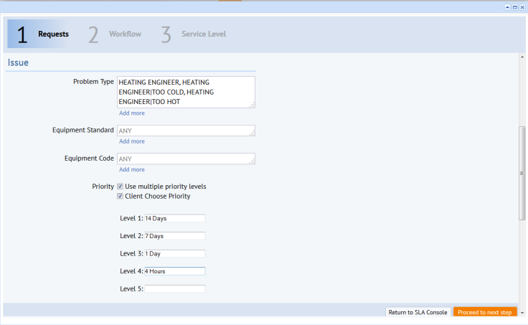

Click Proceed to next step

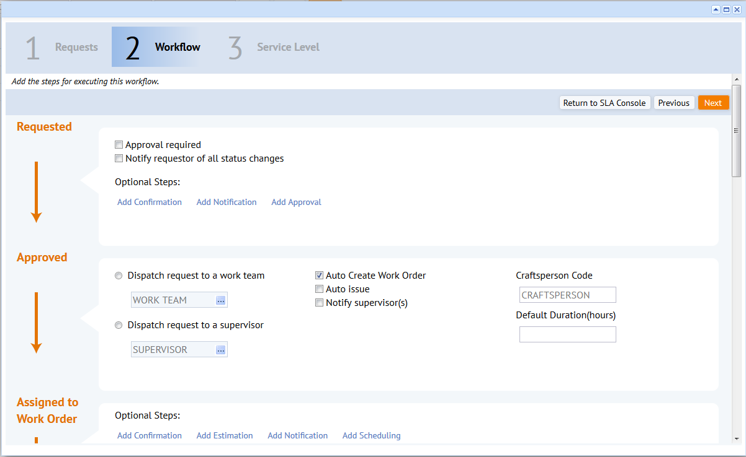

Click Approval required

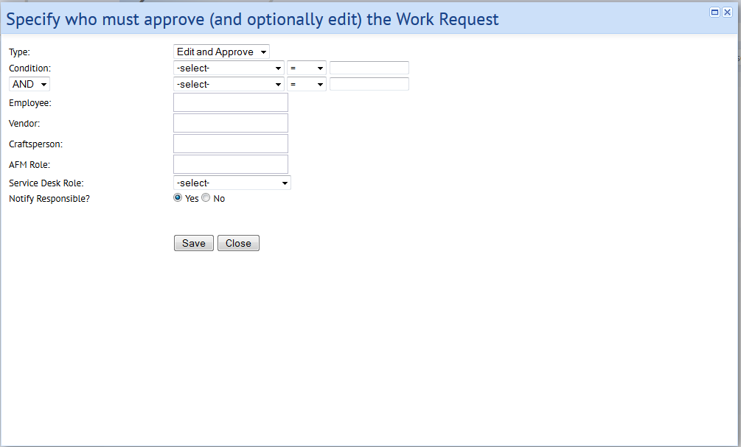

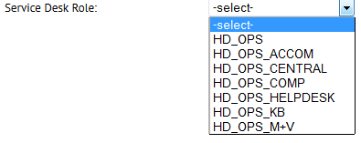

Under Service Desk Role select Team to whom the Work Order should go

Tick Notify requestor of all status changes and Dispatch request to a work team selecting Work Team from look up

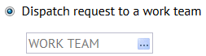

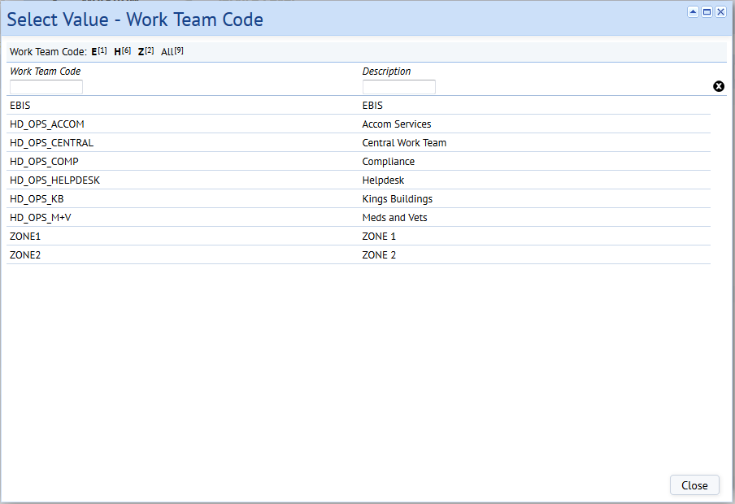

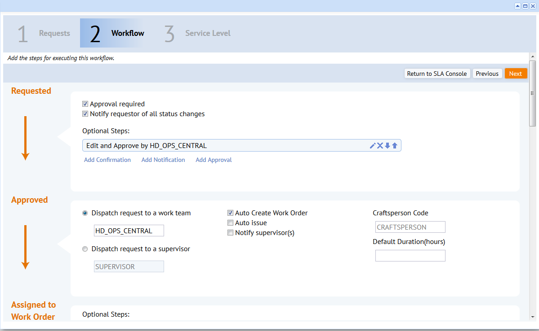

Click Next

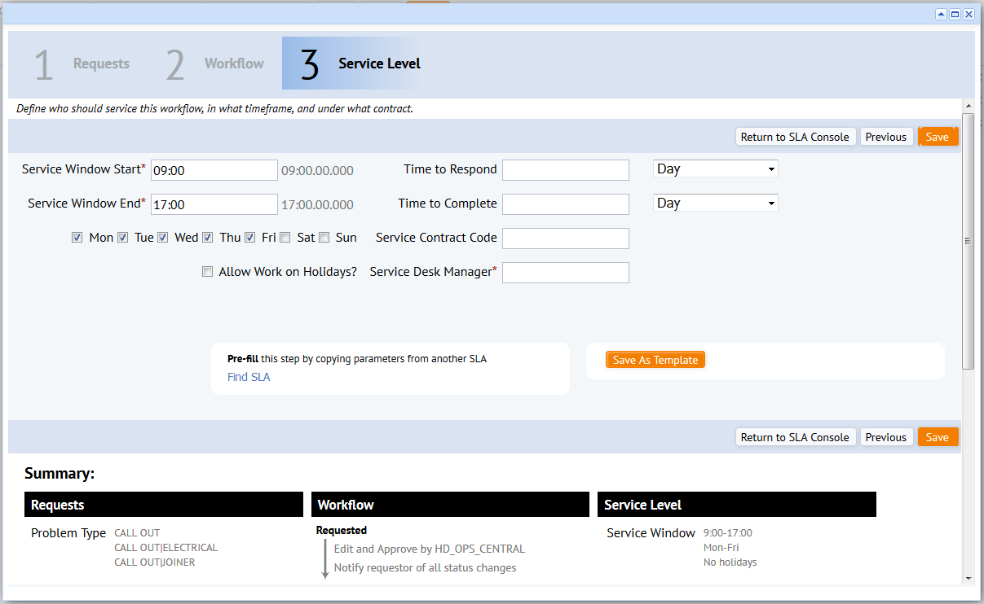

Enter Time to Respond, Time to Complete and Service Desk Manager. If you have entered more than 1 Priority Level when setting up SLA there will be various tabs on screen which require all to be completed

**Example – Multiple Priority Levels**



Service Window Start is the time the Service Level will start ie normal working day 0800

Service Window End is the time the Service Level will end ie normal working day 1700

Time to Respond should be the time that the Trades have to respond to the Work Order even if they have not carried out any works

Time to Complete is the time the Trades have to Complete the Works

Allow Work On Holidays should only be ticked if Works will be sent to Trades when the University is closed – only Call Outs will have this ticked

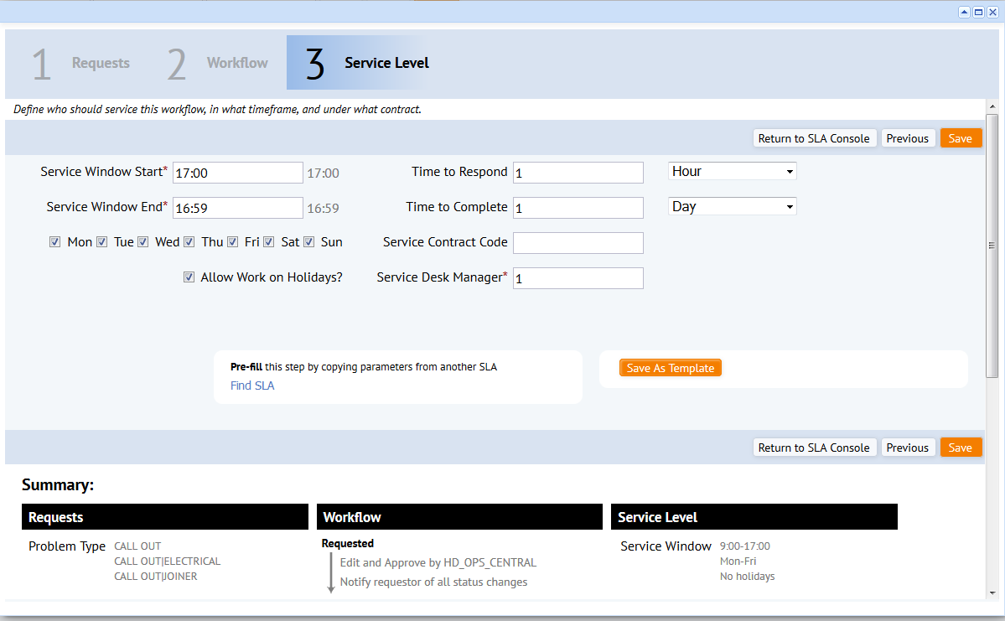

Click Save – SLA is now set up

