# Steps to run the P60 process

**After you have performed the necessary modifications to the RTI_PAY_GB_P60 database package, you can now run the P60 Archive and P60 Reporting Processes.**

First, start the HR Application in the environment you are using (DEV, TEST or LIVE) and build a valid P60 Archive for the tax year.

1. In Oracle HR, Under the menu option **UK HRMS Manager** select **Submit Processes and Reports**

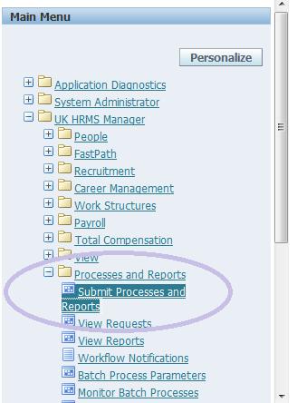

1. Choose to run a **Single Request**

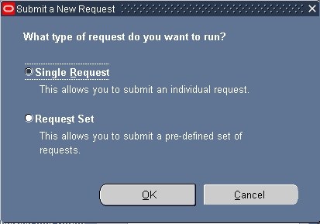

1. select the **RTI - P60 Archive Process** option from the **Name** field in the **Submit Request** screen (this **MUST** be done prior to running the P60 report itself):

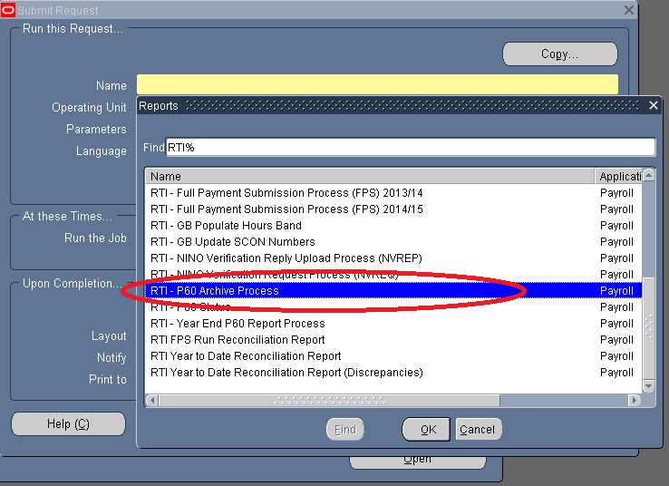

You will be prompted for a date. Input your tax-year **End Date** and click **OK**:

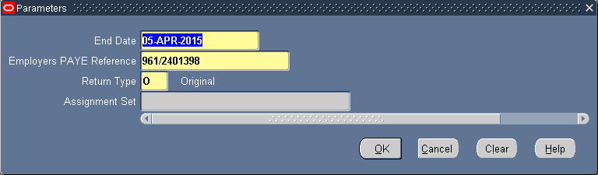

**Return Type** can be O (original) or R (replacement) – by default it’s set to O so leave it at that. **Assignment Set** accepts no value.

1. You will be returned to the main **Submit Request** screen. Click on button labelled **Options**:

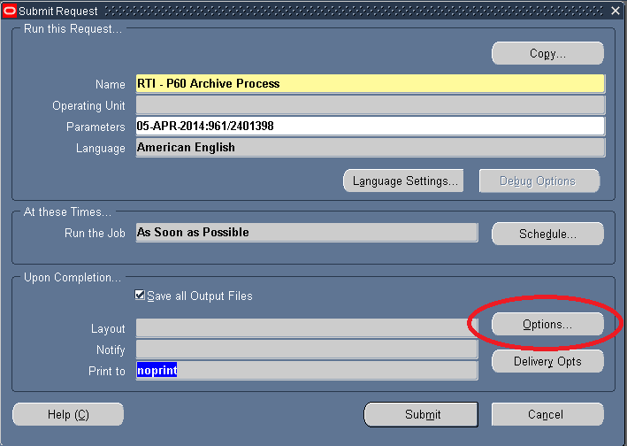

You wish to ensure that in the **Print the Output To** box the following settings are entered:

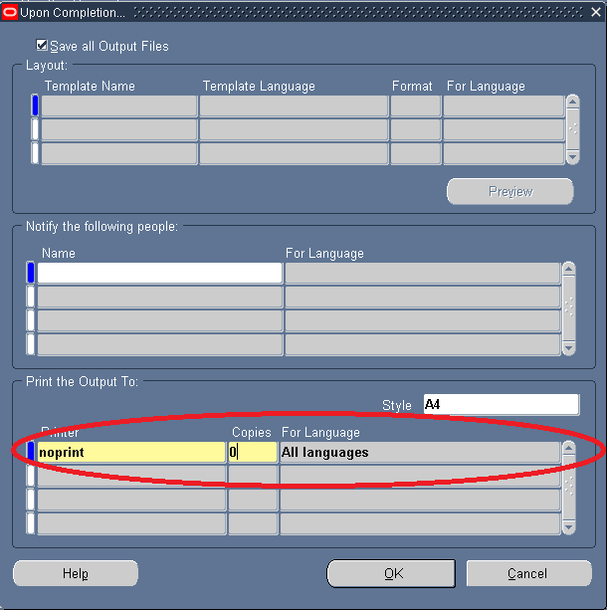

|  |  |
| --- | --- |
| **Printer** | noprint |
| **Copies** | 0 (zero) |
| **For Language** | All Languages |

1. You should change the Copies setting to 0 (zero) – it’s usually 1. Click on **OK** and you will be returned to the main screen again.

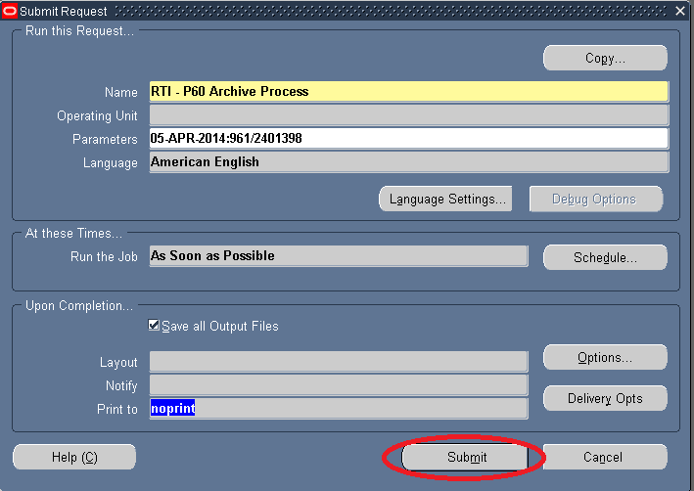

Click on the button labelled **Submit** and the Archive process will start.

**This can take a while – up to two hours in some environments. Be patient and wait …**

You should take a note of the concurrent Job’s **Request ID** for later and … 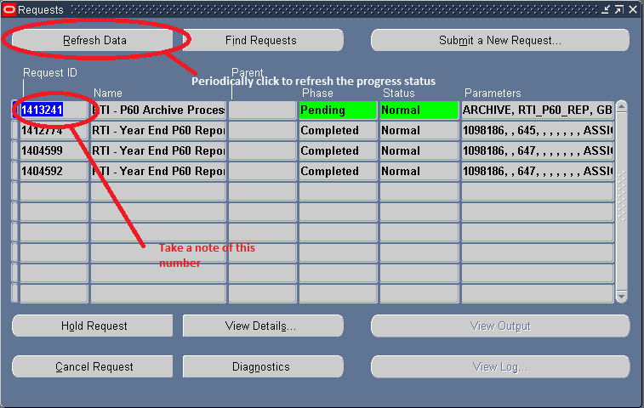

To periodically check on the progress of the job, you may click on the **Refresh Data** Button to see if the job is finished.

# Running the P60 Report Itself

**Once the RTI - P60 Archive has completed you will now be ready to run the actual P60 outputs. The Archive process is required first (in each environment, DEV, TEST or LIVE) to establish the Year-End to Year End data so that the P60 calculations may be performed and processed.**

* To run the actual P60 reports, once again as before, choose to run a **Single Request** Process:



This time we will be choosing to run the **RTI – Year End P60 Report Process**:

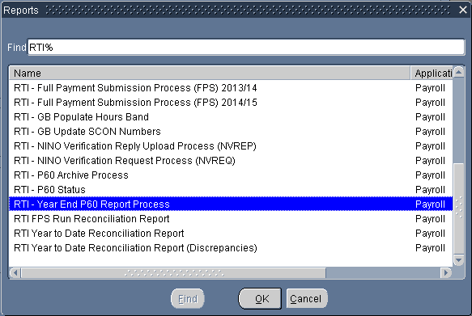

* Now choose the correct year-end **Archive End Date** from the list of options:

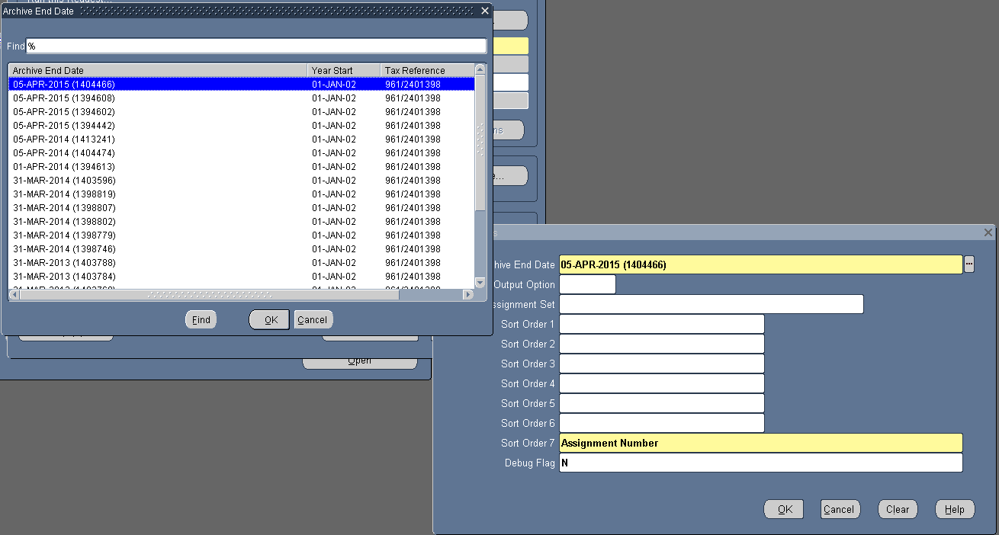

Now select the Assignment Set we wish to generate the P60’s for. In this case, we will run **Main_Payroll_P60**

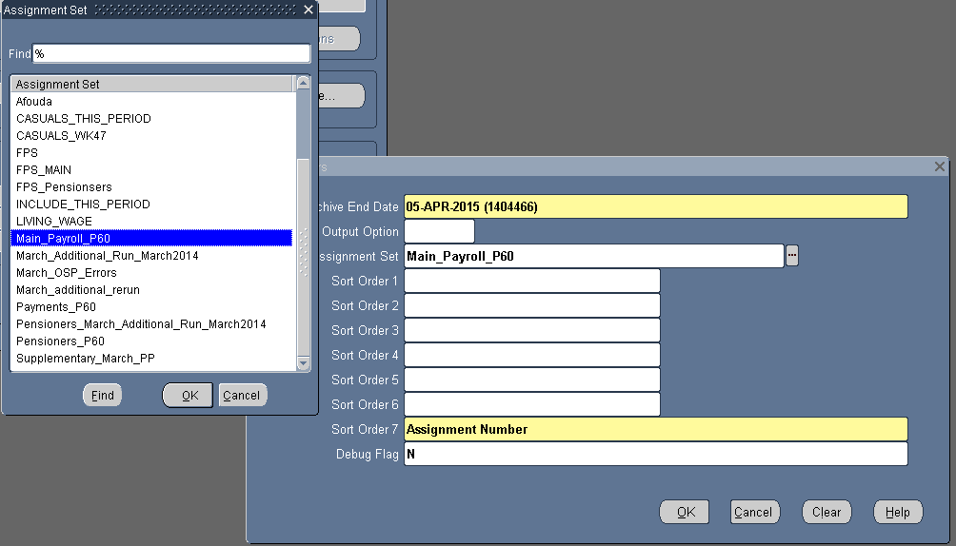

Click the **OK** button to close the assignment list dialog and **OK** again to confirm. You will be returned to the main dialog box.

* Now, click the **Options** button in the main dialog and select the correct template for the P60’s. In this case, we want **RTI – Year End P60 Report Type LE**

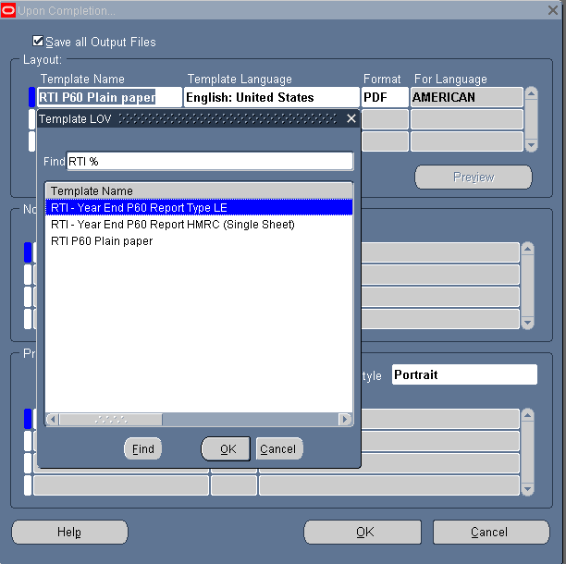

OK to confirm.

* Now we want to select the following **Print Output** options:

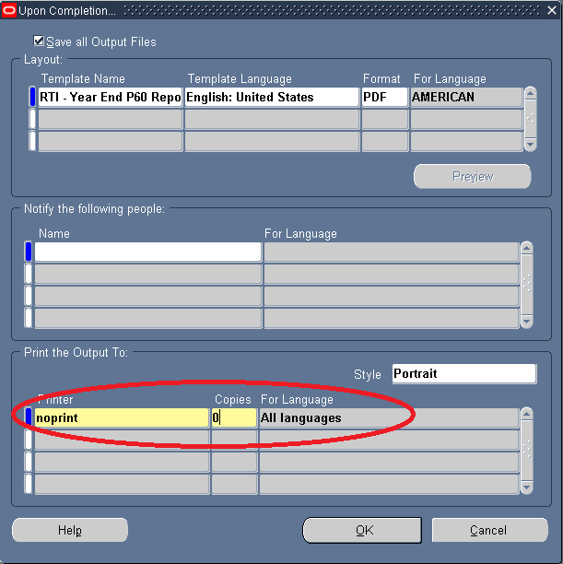

As before, choose **noprint** and set the number of **copies** to **0** (zero).

**OK** to confirm will return you to the main dialog box:

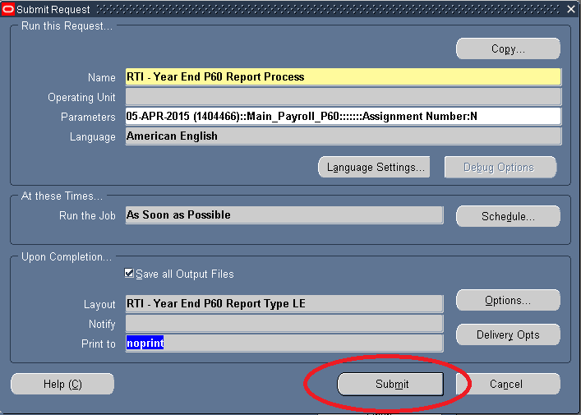

Click on the **Submit** button to start.

The process should run in about 15-20 minutes. You can check the status of the concurrent job by occasionally clicking on the **Refresh Data** button:



Be aware that when complete the P60 output will generate a PDF in your current browser session. If it does not open automatically, you can click on the **View Output button** in the HR Application which will force it to open in your default PDF viewer application.

This concludes the user notes on the P60 Archive and Report Process.

G.T Fleming  
Monday, 02 March 2015