University of Edinburgh

BI 4.1 Health check and Expansion Scoping

Document Control
Change Record

Date | Author | Version | Change Reference
11/11/2014 | Stephen Annand | 1.0 | New Document
Reviewers

Name | Position
Michael Thorp | Principal BI Consultant
Distribution

Name | Organisation
John Grzesinski | University Of Edinburgh

Contents
University of Edinburgh 1
BI 4.1 Health check and Expansion Scoping 1
Document Control 2
Introduction 4
Health check 4
Performance and Sizing 4
Current usage 4
Sizing 5
BOREP 5
Adaptive Processing Server 5
Visualization Service 5
Search Service 5
DSL Bridge Service 5
Web Intelligence (WebI) Processing Service 5
Web Application Container Service 6
Virtualization: Service Level and Performance 6
BOREP Upscaling Solution 9
Vertical Solution 9
Horizontal Solution 10
BOEXP 11
Key Platform Recommendations 12

Introduction
Influential have been requested to perform analysis with a view to configure and optimise the two-server Business Object 4.1 BI platform for:
- The Additional installation of new features (Dashboards, Crystal Reports)
- The increased use of Explorer and additional creation and usage of UNX format universes.
- To ensure optimum performance of the BI platform (BOREP and BOEXP).

Health check

Performance and Sizing

Current usage
There are currently 25,424 reports in the production system, of which it is expected that about 5000 reports will be used regularly and the rest either obsolete, duplicates, or used on the odd occasion. Small specialist developer teams for Dashboards and Crystal Reports and content will be rolled-out gradually for a small audience in the coming months.
Current Licenced user numbers
- 40 x Named Users
- 75 x Concurrent users
Total current licenced user base of 790 users however there is an expectation of growth and the projected usage is detailed to ensure future proofing of the sizing estimates.
The report size and projected future user base breaks down to the following numbers to allow correct sizing for the BI environment.
Product | Information Consumers | Business Users | Expert Users | Report Size %
 |  |  |  | Small | Medium | Large
Crystal Reports | 50 | 6 | 5 | 70 | 20 | 10
Dashboard Design | 40 | 12 | 5 | 80 | 20
Web Intelligence | 810 | 82 | 75 | 70 | 20 | 10
Total | 900 | 100 | 85
Total Concurrent Active users | 90 | 10 | 10

Sizing
The current production environment consists of 2 virtual machines serving 1 BI environment.
- BOREP- A 1 Node BI 4.1 SP2 platform installation on a virtual machine
- BOEXP- A BOREP connected Business Objects Explorer installation on a virtual machine

BOREP
The Current BOREP environment is;
- Windows Server 2008 R2 Standard SP1 virtual machine
- 64GB O/S
- 24GB RAM
- 4 Cores

Adaptive Processing Server
By default, the BI4.0 platform contains one Adaptive Processing Server (APS) per host system. The Adaptive Processing Server is a generic server that hosts multiple services responsible for processing various requests. For best performance and scalability, SAP recommends that you host important services in multiple dedicated APS containers, and then adjust the sizing parameters to answer the different memory/processor requirements.

Visualization Service
The Visualization Service (CVOM) generates graphics and charts for Web Intelligence. This service should run in one or more dedicated APS instances. 2GB of memory is recommended for this service.

The Default Adaptive Processing server (APS) has been replaced with 9 x APS in an exercise to split out and host dedicated APS for selected common service which the APS manages.

Search Service
The search service is configured for scheduled indexing to eliminate process issues relating to search.

DSL Bridge Service
The DSL Bridge service is used by Web Intelligence when it connects to UNX-format Universes. It hosts the data connectivity to the data sources. Memory is calculated based on the number of expected active concurrent users as follows:
- 0.25 GB per active concurrent user
- 8 GB minimum
If you require support for more active concurrent users, you can create additional DSL Bridge service instances.

This has been performed in line with SAP advice and Best practice.

Web Intelligence (WebI) Processing Service
It is suggested that there is a Web Intelligence Processing Service instance for every 200 active concurrent users.
University of Edinburgh has approximately 800 users possibly growing in the future to 1000 users.
This calculates with a standard concurrency of 10% to 100 active concurrent users.
This is within the recommendation for 1 x Web Intelligence Processing server Instance.

The current production environment has 2 x WebI Processing Service instances to ensure availability for processing. This is over the recommendation but will not inhibit performance.
This amount is suggested given the I/O processing that WebI usually requires. You can adjust the number of active concurrent users allowed per server by adjusting the Maximum Connections setting. In order to ensure the load on WebI servers is spread evenly among multiple instances, ensure the sum of all Maximum Connections settings is greater than or equal to the number of active concurrent users expected.
Under heavy load, the WebI Processing Server can benefit from having a maximum connection setting that is higher than the maximum number of expected concurrent connections. This is because under heavy load, the time to close a connection can increase and WebI may not be ready to accept the next connection in time.

Web Application Container Service
Web Application Container Servers (WACS) provide a platform for hosting SAP BusinessObjects Edge Series web applications. For example, a Central Management Console (CMC) can be hosted on a WACS. If you want to use .NET InfoView, and if you do not want to use a Java application server to host your CMC, then you can use WACS to host the Central Management Console (CMC).
With the current use of Apache Tomcat in the production environment the WACS is not required and is correctly Disabled and Stopped.

Virtualization: Service Level and Performance
BI4 works very well in virtualized environments. Testing has shown it performs equally well on virtualized hardware as it does on dedicated hardware. However, in order to achieve equal performance, the hardware it runs on must be dedicated to the virtual machines that the BI services run in.
SAP strongly recommends that BI virtual machines have reservations for the memory and CPUs assigned to them.
BI can be very I/O intensive when heavily loaded by users. When experiencing maximum load as defined by your sizing, all parts of the system can go from moderately loaded to very busy momentarily. If the BI hardware is being shared with other workloads in a virtualized environment, the response to bursts in activity can result in slow-downs between dependent BI services and ultimately end user response time.

It is recommended that you your system is built to target 65% utilization so that bursts in activity can be handled. Performance of both physical and virtual systems degrades when system utilization is greater than 80%.
If you are unable to secure memory and CPU reservations for your virtualized deployment, it is recommended that additional scale-out be done to provide adequate BI processing resources for peak periods. The amount of additional scaling out will depend on your IT infrastructure and performance policies.
The goal of Sizing BI4 is to have a deployment that can handle the workload needed and provide good response time for end users. If you deploy to a shared virtualized environment, extra care is needed to ensure your sizing exercise results in a system which has a Service Level and responsiveness that can be maintained.

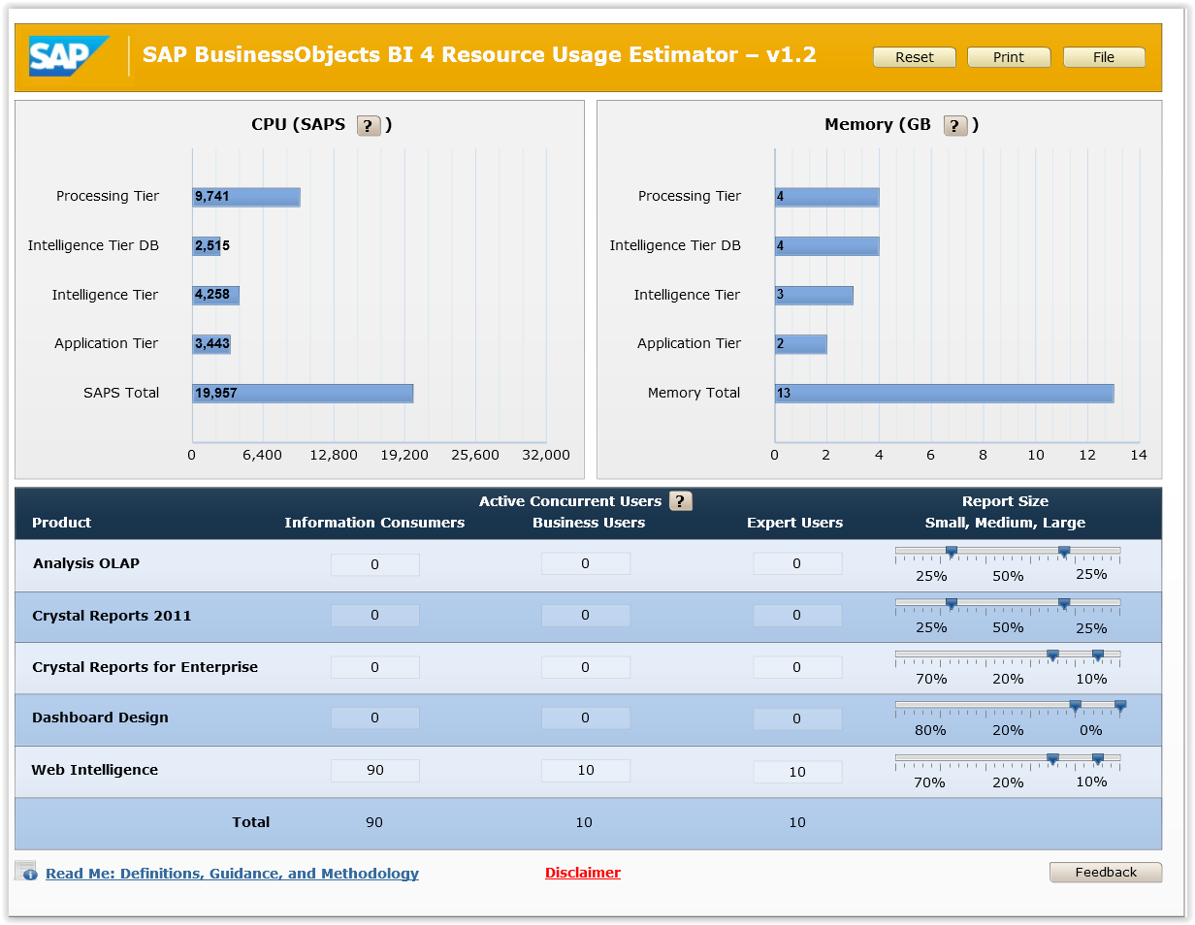
Based on the following projected usage and report size patterns;
The following sizing guidelines are recommended;

With this information added to the requirements from other required components we arrive at the following recommended sizing solution;

BI 4.1 Sizing
 |  | SAPS | Memory (GB) | Cores
Intelligence DB |  | 2515 | 4 | 2
Intelligence Tier (CMS) |  | 4258 | 3 | 3
Application Tier (Tomcat) |  | 3443 | 2 | 1
Processing Tier | Crystal Reports | 9741 | 4 | 3
Processing Tier | Dashboard Design | 9741 | 4 | 3
Processing Tier | Web Intelligence | 9741 | 4 | 3
DSL Bridge (.UNX) |  |  | 8 | 1
Visualisation Service |  |  | 2
Platform Search |  | 1000 | 2 | 0.5
Totals |  | 20957 | 25 | 10.5

The processing power is calculated and specified in a SAP processing unit called SAPS.

Sizing recommendation V’s Current specification
As the SAP best practice recommendation on sizing is based on the projected usage patterns it is advisable that the current Production environment is increased, to ensure optimum performance and adhere with Best practice guidelines, with relation to the following.

Memory
The recommendation is 25GB which is not very different from the current 24GB. 1GB less should not result in a significant loss in performance however it is recommended to raise the RAM to 25GB.
Cores
The recommendation is 10-13 Cores which is very different from the current 4 x Cores.
It is recommended that the dedicated cores are increased from the current 4 to 10-13 (12) cores and that these cores are ring-fenced on the virtual environment.

BOREP Upscaling Solution
BI 4.1 can be scaled either;
- Vertically (to increase the specification of the current environment) or
- Horizontally ( By adding more Nodes / Machines to a cluster)
As the recommendations involve upscaling the current specification this gives us 2 options for scaling.

Vertical Solution
The following solution is based on increasing the memory, cores and configuration on the current BOREP machine. This solution is limited as the core allocation and memory can only be raised to a maximum limit. This is restrictive for any future scaling in the same manner.
The upscale solution is as follows;
- Increase the current memory of the BOREP environment to 25GB
- Increase the current number of cores on the BOREP environment to 12 cores
- Create a total of 4 x Web Intelligence processing servers (these are recommended to be limited to 1 per core however 12 will be to many for the current usage and will introduce latency load balancing)
- Create server groups for batch schedule processing of reports.
- Clone the current Dashboard server services and add to server groups to ensure increased availability for Dashboard solution.

Horizontal Solution
The following solution is based on increasing the number of clustered available machines within the current BOREP environment. This solution is unlimited as the core allocation and memory can be increased exponentially across multiple machines as the processing requirement grows. This aids future scaling.
The upscale solution is as follows;
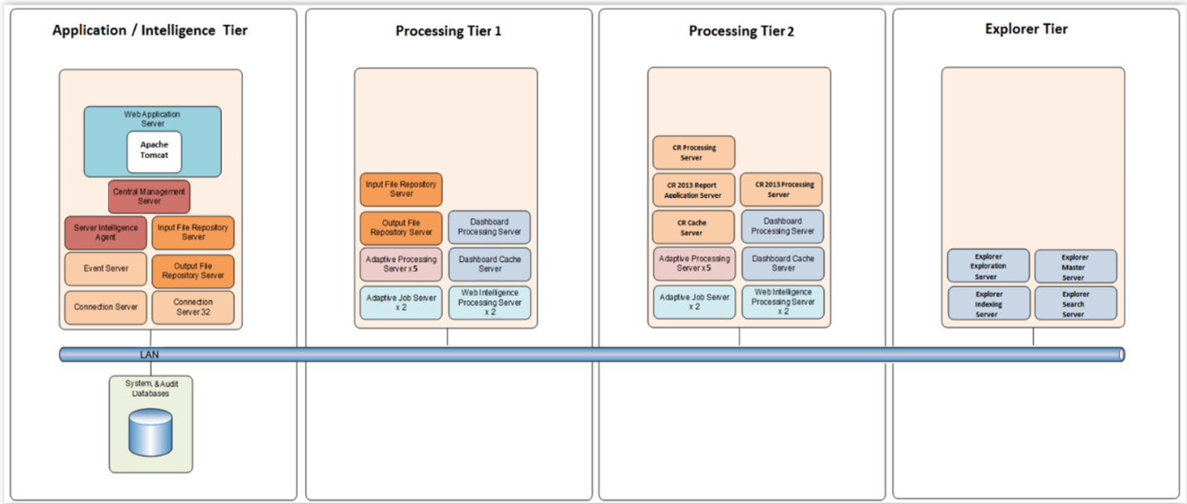
Create a new cloned environment with an Application / Intelligence Tier and 2x Processing Tiers, to add to the current Explorer Tier.

This will alleviate the individual strain on current resources by farming services to a dedicated Tier.

Scale-out Memory Expectations
As you scale out your deployment, you will need to know how much memory to allocate to each node in the cluster of machines.

The amount of memory required will depend on which services each node is running.
With 2 x processing tier the system will have greater processing performance and greater tolerance thresholds.

Tier Specifications;
Application / Intelligence Tier;
- 16 GB Ram
- 4 x Cores
- Application and Patch Disk Space 100GB
- FileStore disk space 1TB
Processing Tier 1;
- 16 GB Ram
- 8 x Cores
- Application and Patch Disk Space 100GB
- Incorporates FRS failover services with no processing overhead
Processing Tier 2;
- 16 GB Ram
- 8 x Cores
- Application and Patch Disk Space 100GB

Explorer Tier;
- 16 GB Ram
- 4 x Cores
- Application and Patch Disk Space 100GB

BOEXP
The Current BOEXP environment is;
- Windows Server 2008 R2 Standard SP1 virtual machine
- 64GB O/S
- 16GB RAM
- 4 Cores
The BOEXP machine has been sized in accordance with SAP best practice sizing and scaling.
The sizing of BOEXP does not need to be changed.

Key Platform Recommendations
Carefully monitor and analyze the performance and resource usage across the entire landscape, including the CMS repository database, the Web application tier, and any other SAP BI 4 platform servers involved in the test to identify bottlenecks in either the underlying infrastructure or server configuration.

Monitoring CPU and Memory Usage
Monitoring and recording of the basic CPU and memory usage of the machines in your deployment is also recommended. The goal is to have an average CPU usage of 60% to 65% in order to handle peaks in the range of 80%. Analyzing the historical usage of your deployment can help you determine if more resources are needed for a particular node. Similarly, if memory is frequently being fully used, you may be experiencing reduced performance and need to add more.

Dashboards Tuning
To ensure the number of job processing child processes created by the Dashboards Processing Service doesn't exceed your needs, it is recommended that you configure the Maximum Concurrent Jobs entry to match the number of users that you expect to support.

CMS Database Tuning
The CMS database performance has a significant impact on the performance of the system. The following Sybase database tuning tips are offered. These tips may apply to other database servers as well.
1. Data Cache [buffer pool]
Data cache allows efficiently reducing IO. Having a sufficient size of data cache can speed up queries.
2. Procedure Cache
Configure the Procedure Cache so frequently used database procedures are cached. This allows the database to not need to reload procedures from disk as often.
3. Lock Granularity
The CMS does a lot of reading and writing from/to the database. By default, the granularity is set to page level, which is too high. Page level locking promotes contention by the CMS when, for example, several records are stored together in a same page. One of them may be being updated but another one is being read. One of these two sessions has then to wait until other has finished.
Setting Lock Granularity to use row level locking can avoid contention and deadlock issues.
4. Parallel Processing:
This is important to set so Sybase can fully utilize all the CPU cores available on the machine.

