UAT 3 Follow up actions and Priorities

This document will set out the follow up actions to be taken resulting from the 3rd iteration of user acceptance testing for TREE. Each section will explain how the changes are to be made and the priority of these changes, priorities 1 and 2 will be made prior to go-live and put through testing. The lower priorities will be dealt with where possible and put through the testing, however when this is not possible these will be held back until after go-live and packaged either as small improvements to the service to be released as soon as possible after go-live or moved into a future phase of the project if further investigation is required.
Summary of issues and Priorities
Service Page Layout & Content | Priority 1
Search functionality | Priority 1
Refine Search | Priority 2
Overview display of the Search Results | Priority 2
Null search results message | Priority 2
Contact Form page rewording | Priority 2
Administration Interface | Priority 2

Refine Search
The feedback from the Refine Search will be resolved by the new search method. By using a combination of the new search method and the faceted search on the Search Results page we can remove all need for the Refine Your Search options to appear on the front page. By putting the refine options down the left-hand side of the Search Results page it should allow users to find them more easily and the use of check boxes and numbers allow users more visibility of the criteria. Breadcrumbs appears across the top of the Search Results page as a user refines their search using these facets and while not visually appealing currently it does allow users to see the criteria they have applied. We have included a mock-up of the Search Results page below along with how the main Search page will appear with the Refine Your Search option removed. This is a priority 2 issue as it is less important than the main search but in practice they work together so it will be resolved in iteration 4, tested fully and ready for go-live.
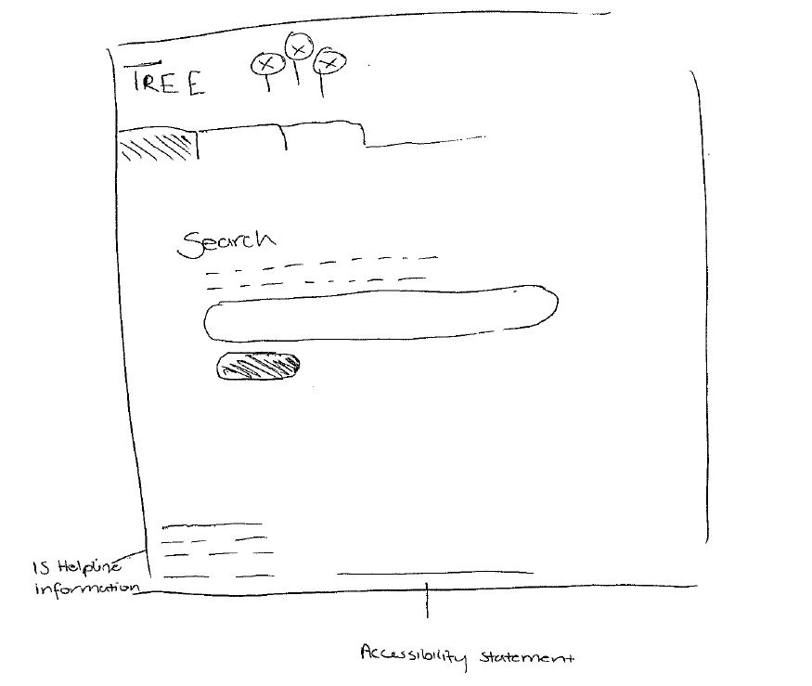
Image 1: Home Page

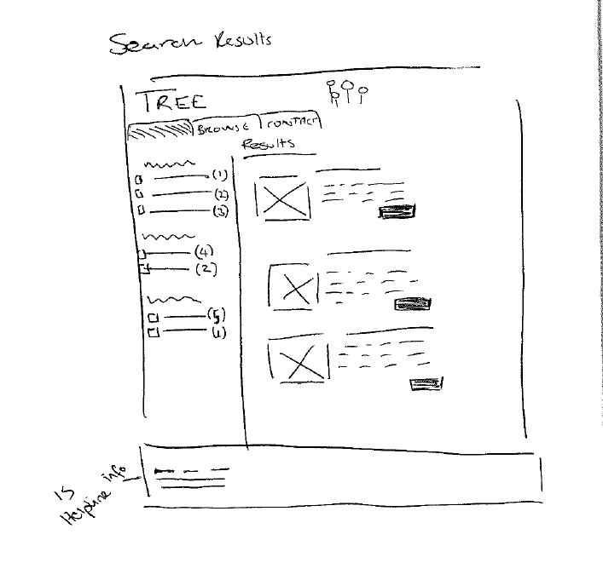
Image 2: Search Results

Overview of the Search Results
See the mock up above. Given the increased filtering ability offered by faceted search and the difficulty in deciding what categories would work best in the grid we have chosen to change approach. We will use screenshots/icons and a summary text field to help the user gain basic awareness of a service with the option to find out more information using the Read More button. It should be noted that data will be key here as well as the summaries have to offer a useful amount of information to allow a user to make a decision. This is a priority 2 issue, the grid option can be used with the new method.
Service Page Layout & Content
The Panels layout did not work here. Instead we plan to revert to a scrollable page with field groupings to aid users finding information, see the, mock up below for possible layout. We will also work on the data within the service pages. This is a Priority 1 issue as the tool mist give useful information to users in a logical format otherwise they will not use it.
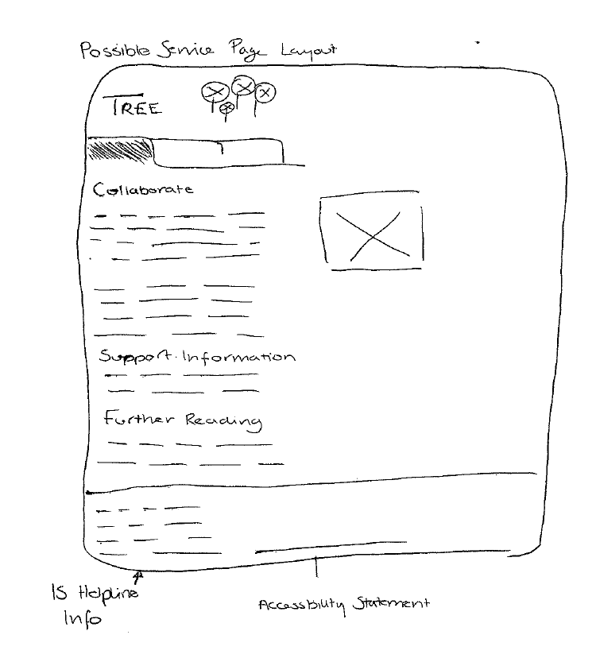
Image 3: Possible Layout for Service page

Null Searches and Null Search Results
In relation to the null searches we will use these to test the new search functionality. The search functionality will then be documented to ensure all those involved in TREE, both in the project and in the data management, know how the search is operating. This is considered priority 1 as it is key that TREE operates in a logical and consistent manner giving confidence to all those using it.
The null search results changes when we change to the new search method. We have investigated this a little and can provide text in similar manner. Due to user comments we have decided to remove the PDF from the null results and will try rewording so this will be more of a data change. There may be option extensions to the new search method that could help extend the null search results. The feedback raised over the IS Helpline email will be resolved through the inclusion of the contact information for IS Helpline on all pages, this was also raised during the Accessibility review.
This is a priority 2 issue, we will focus more on retrieving results but this page is important and will improved using the feedback for the next iteration, Any extension of the search functionality is towards the lower end of the priority scale and will only be done if the new functionality can be fully tested with users prior to go-live.
Contact Form Page
The Contact Form page can be improved by rewording the text at the top of the page, the feedback received during this round of UAT will help with this. The contact form page is considered priority 2 as the form currently works.
Administration Mode
The Administration Interface will change substantially for users through the use of new roles and permissions alongside the introduction of a text editor to help improve the input of information. The test fields will all be removed during iteration 4 as well. These changes are priority 2 with further work on the Administration interface to be investigated in future phases.

