Stage: Business Analysis

Business Requirements Document

Student Application Systems: Enhanced Student Data Feed to Accommodation Services

OTHCSG

ACS033

https://www.projects.ed.ac.uk/project/acs033

Document Version: 1.5

Date: 26/08/14
Contents
1 Document Management 3
1.1 Contributors 3
1.2 Version Control 3
2 OVERVIEW 4
2.1 Project Description 4
2.2 Objectives 4
2.3 Business Dependencies, Constraints and Assumptions 5
2.4 Legislative Impact 5
3 Current Business Process 5
3.1 Current Timing of the Feed to AS 5
3.2 MyEd – No Changes to MyEd Processes 6
4 Proposed Business Process 8
4.1 Get the Applicant Data to AS Earlier 8
4.2 Maintenance of the Data Feed 9
4.3 Clearing Down ‘Out of Use’ Records in the Kx System 9
5 FUNCTIONAL REQUIREMENTS 10
5.1 Admission Status and Applicant Data Timing 10
5.2 Modified Address Fields in EUGEX 10
5.3 Removal of Term Time Address from the Feed 11
5.4 Emergency Contact Fields to be Added 12
5.5 Kx Record Clearing 12
5.6 Domicile Feed Validation 13
5.7 Postcode 13
6 NON-FUNCTIONAL REQUIREMENTS 14
6.1 Documentation and Training 14
6.2 Archive Process 14
7 USER ACCEPTANCE TESTING 14
7.1 Acceptance Test Strategy 14
8 Document Sign Off 15

Document Management

Contributors

Role | Unit | Name
Project Manager | IS Project Services | Colin Forrest
Student System Rep | Student Systems | Duncan Scott/Andrew Crossland
Business Owner | AS | Christine Kelly

Version Control

Date | Version | Author | Section | Amendment
15/05/14 | 1.1 | CF | 3,4,5 | Clarifications
21/05/14 | 1.2 | CF | ALL | Additional Requirements added
01/07/14 | 1.3 | CF/AS | ALL
14/07/14 | 1.4 | CF/AS | ALL | Clarifications
26/8/14 | 1.5 | AC | 5 | Clarified field and column titles for address changes field, removed Emergency Contact
27/8/2014 | 1.6 | AC | 5.1,5.7 | 5.1 re-added description text.  5.7 included future selection criteria in the BRD.

OVERVIEW

Project Description

The current AS system is supplied and hosted by the 3rd party Kinetic Solutions (http://www.kineticsolutions.co.uk/solutions/9/KxResidential/benefits/). This system sits separately from the University Infrastructure. The Kx system is populated by a EUCLID Data Feed which is owned and managed by the University Student Systems department.

A current issue with the feed is that AS would like the timing of when student applicant data is delivered to the Kx System to change. AS would like to get the applicant’s data at the earliest possible opportunity which would assist them in enhancing their internal workflows and assist them in the delivery of a better service. Therefore this project will look at the Data Feed available to AS and work to amend this feed to best deliver their requirements while still maintaining data integrity for the University.

It should be noted that AS do not foresee any work on this project during their busy period of the end of June to the beginning of the 14/15 academic year.

Objectives

This project has a number of objectives:

- Allow AS to obtain applicant data at the offer stage.
- To maintain a ‘Single Copy’ of applicant information within the AS 3rd party system. No duplicates.
- Take only the central information that is necessary to facilitate the Kx feature set asked for by AS.
- Improve the prospective student experience by providing a faster, more integrated service from the University and AS.
- Improve the Applicant's experience by having sign in under the standard University EASE service.
- Take an overview of the steps required to bring AS and their 3rd party systems into line with new EU record retention regulations.

The project work will be phased. Development and Testing taking up through to September. July to September is the peak working period for AS, so the project will be required to detail the schedule for Testing to keep disruption within AS to a minimum. The system will be deployed in November.
The project will close in January when the implemented system can be signed off.

Business Dependencies, Constraints and Assumptions

There are a number of dependencies that may affect the project team’s ability to implement the project. The dependencies are:

- The BRD written by the project team is completed and signed off.
- There are Student Systems skills available to upgrade and configure the feed that supplies the 3rd party Kx Systems.
- The 3rd party Kx system utilized by AS has the capacity to accommodate the enhanced feed.

The constraints are:
- The peak period for AS stretched from the end of June into September. During this time there will be no work completed on the project. Our plan will take us to the end of Testing for this 1st phase of the project which shall be completed at the end of June.

A risk register will be used throughout the lifetime of this project – available here: Risk Register (linked here).

Legislative Impact

The upgraded feed will continue to be subject to the standard issues that govern the University:

- Data Protection
- Freedom of Information
- Records Management

Current Business Process

Current Timing of the Feed to AS

The current feed delivers applicant data to the 3rd party Kx system when the applicant status changes to both ATR and UF. Generally this process happens six weeks before the student matriculates.

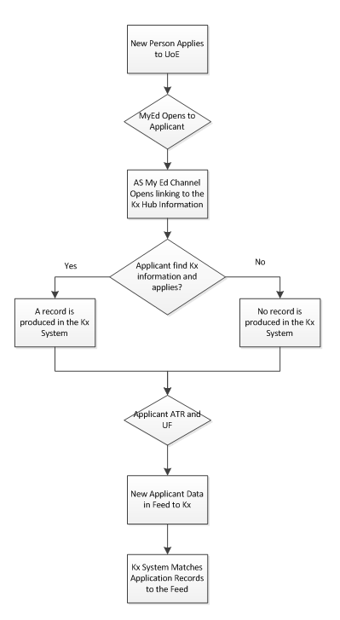
1- Current timing of the feed

MyEd – No Changes to MyEd Processes

Currently the Kx Hub is accessed by applicants through a MyEd channel. This channel is a simple link through to the third party Kx system.
This project will not make changes to the way the MyEd channel operates.

Proposed Business Process

Get the Applicant Data to AS Earlier
Fundamentally the proposed change will see the applicant data flowing to the 3rd party Kx System at an earlier stage. In this case the project proposes to feed the data to Kx when the applicant received an offer.
This will require a change to the feed and also work to be done on the part of Kx to accommodate the changes.

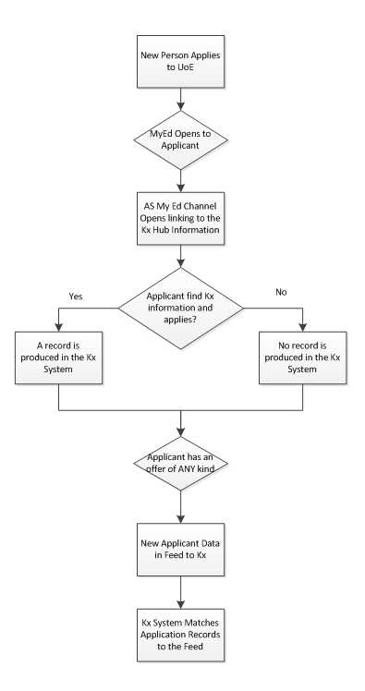

2 - Proposed timing of the feed

Maintenance of the Data Feed
Student Systems have proposed that the Data Feed to Kx should be maintained in a shared spreadsheet. We currently have a working version of this spreadsheet on the project website.

Students Systems have stated that this is in line with their management processes for other feeds.

Clearing Down ‘Out of Use’ Records in the Kx System
The University is updating its data policy with regards to the retention of applicant information. The Kx system does not currently clear out any old records and so this project will look to agree a clear down policy that is acceptable across the project team and that can be successfully applied to the 3rd party Kx System.
It should be noted that the Kx Record Database is hosted within the University infrastructure.

FUNCTIONAL REQUIREMENTS

Admission Status and Applicant Data Timing
The admission status of Applicant (whether offer or confirmed) will now be used as the measure to include Applicant details in the feed.

Field (Eugex Name) | Kx Work- new values in field ‘status’ | Student Systems
ADMIN_STATUS_DESC | Applicant Conditional Insurance  Applicant Unconditional Insurance  Applicant Conditional Firm  Applicant Unconditional Firm | Amendment required:  If SA11_STUAPP_STATUS returned = 'A'  and SA113_LATEST_REPLY_FOR_DESC is null  then set to 'Applicant'  If SA11_STUAPP_STATUS returned = 'A',  and SA113_LATEST_REPLY_FOR_DESC = 'I'  and SA111_LATEST_DESC = 'C'  then set to 'Applicant Unconditional Insurance'  If SA11_STUAPP_STATUS returned = 'A',  and SA113_LATEST_REPLY_FOR_DESC = 'F'  and SA111_LATEST_DESC = 'C'  then set to 'Applicant Conditional Firm'  If SA11_STUAPP_STATUS returned = 'A',  and SA113_LATEST_REPLY_FOR_DESC = 'I'  and SA111_LATEST_DESC = 'U'  then set to 'Applicant Unconditional Insurance'  If status returned is Applicant,  and DATE_UCAS_UF is populated  then set to 'Applicant Unconditional Firm'  else  If SA11_STUAPP_STATUS  (fields found on EUGEX.EUGEX_CONSOLIDATED_STUAPP_MV)  Note: The feed gives the highest ranked offer when there are more than one offer with an applicant

Modified Address Fields in EUGEX
The 1st three address fields are currently combined in the feed to make the feed ‘HOME_ADDRESS’. This is not an ideal situation and so the combined feed is to be broken down into HOME_ADDRESS_1, HOME_ADDRESS_2 and HOME_ADDRESS_3. As the Kx system currently has only three fields available two new fields will need to be created in the Kx system to accommodate this change.

Field with in EUGEX. EUGEX_ACCOMODATION_VW | Kx Work | Field sourced from EUGEX.EUGEX_CONSOLIDATED_STUAPP_MV
HOME_ADDRESS_1 | Amend association | sa55_home_address_1
HOME_ADDRESS_2 | Amend association | sa56_home_address_2
HOME_ADDRESS_3 | Amend association | sa57_home_address_3
HOME_TOWN | Amend association, Create new KX field
HOME_COUNTY | Amend association, Create new KX field
HOME_ADDRESS |  | Remove from feed

Removal of Term Time Address from the Feed
The term time address is to be removed for the feed.

Kx Field Name | Kx Work | Fields to be removed from EUGEX. EUGEX_ACCOMODATION_VW
termaddress1 | Kx to be notified | TERM_ADDRESS
termaddress2 | Kx to be notified | TERM_TOWN
termaddress3 | Kx to be notified | TERM_COUNTY
Termpostcode | Kx to be notified | TERM_POSTCODE
Termtelephone | Kx to be notified | TERM_TEL

Kx Record Clearing
A process will be established by Kx to clear down applicant/student data records from the AS system after 1 year.

Domicile Feed Validation
This decode is currently part of the feed and can be removed

Field (Eugex Name) | Kx Work | Student Systems
START_DOMICILE_GROUPING | None | DECODE(cod4_domicile_group_code_desc,'SCOTLAND','UK','CHANNELISLOFMAN','UK','OTHER UK','UK','ALL UK','UK','EU','EU','OVERSEAS','NON-EU','UNASSIGNABLE','NON-EU','NON-EU').  This decode will be removed.

Postcode

The requirement is for the postcode to be taken (in whatever form) in the feed if it is available.

Field (Eugex Name) | Kx Work | Student Systems
HOME_POSTCODE | None | For applications coming in from UCAS (UG courses), the postcode is validated against the list of postcodes held by Royal Mail if the applicant lives in a UK address.  The Direct Admissions form does not make use of QAS (Quick Address Software) and the postcode is not mandatory.  In EUCLID itself, the QAS software exists when amending addresses, but there is no enforcement of validation if QAS is not selected. Postcode is not mandatory in EUCLID.  However, enforcement of this validation in EUCLID Student Details and EUCLID Direct Admissions forms are not in the scope of this project

Amendments to Selection conditions for the EUGEX Accommodation view

In addition to applicants who are UF, the EUGEX.EUGEX_ACCOMODATION_VW needs to include applicants who have an offer (that has not been declined). Below is current conditionality and the new future conditionality, with changes highlighted in red.

Current Conditionality
Category | Source
Student | sa10_student_applicant = 'S'
Applicant UF and within 6 weeks | OR (sa10_student_applicant = 'A' AND sa109_uf = 'Y' AND sa115_start_within_period = 'Y')
New Entrant not yet matriculated | OR (sa10_student_applicant = 'ZN'))
 | sa43_programme_startdate > to_date('01/JAN/2005
Future Conditionality
Category | Source
Student | sa10_student_applicant = 'S' and sa106_within_grace_period = 'Y'
Applicant has an offer | OR (sa10_student_applicant = 'A' AND sa109_uf = 'Y' A ND sa115_start_within_period = 'Y' SA111_LATEST_DESC in ('C', 'U') AND SA113_LATEST_REPLY_FOR_DESC not in ('D'))
New Entrant not yet matriculated | OR (sa10_student_applicant in 'ZN','XD')
 | AND sa43_programme_startdate > to_date('01/JAN/2010'
Most Current | AND SA107_MOST_CURRENT = 'Y'

NON-FUNCTIONAL REQUIREMENTS

Documentation and Training

Requirement | Responsibility
Updated support documentation. | AS, Project Services, Student Systems, Apps Man

Archive Process
Requirement | Responsibility
Establish the Policy for Data Retention and how this should apply to the 3rd Party Kx System. | Kx, Student Systems, AS

USER ACCEPTANCE TESTING

Acceptance Test Strategy
Accommodation Systems will thoroughly test all functional requirements to ensure the system is set up and configured to BRD specification. They will be supported by the project team, in particular by Applications Management who can provide sign off of the Testing.

UAT scripts available on Moodle wiki: https://www.wiki.ed.ac.uk/display/insite/Moodle

Document Sign Off

Role | Name | Date Signed Off
Project Sponsor | Christopher Barnes | x
Business Lead | Christine Kelly | x
Business Lead/Analyst | Duncan Scott / Andrew Crossland | x
Project Manager | Colin Forrest | x
Programme Manager | Andrew Stewart | x
Apps Management | Ann Finnan | x

