How to use: Manual Hardware Import

Format of CSV files
Header row | None (we need to be able to concatenate several files in no particular order without worrying about headers appearing)
Field delimiter | | (‘Pipe’)
Enclosing | The fields must NOT be enclosed (I.e.: do NOT use single or double quotes to enclose the values of a field e.g.: …|”something”|….)
Line delimiter | \r\n (DOS line endings)
Field length | No content in a field should be longer than the specified value in the ‘Type and size of field’ column
Number format | Numbers will be inserted without any commas or other separators used for grouping of digits. For decimal numbers, a single decimal point (full stop) will be used.
Character set | US-ASCII

Fields in the CSV file
Field number | Field Name | Type and size of field | Value of Field
1 | OBJECT_ID | 60 characters | Unique user friendly name (e.g. local_unique_id (For Edinburgh +’--‘+ unique_datasupplier_id))
2 | LOCATION_LINK | Integer (1 character) | Use 2 for Configuration, Use 6 for Person
3 | PERSON | 100 characters
4 | CONFIGURATION_ID | 30 characters
5 | BUDGET_HOLDER | 60 characters
6 | OBJECT_TYPE | 30 characters | Mandatory, usage for numbering when creating objects of a certain type manually
7 | MAKE | 100 characters | E.g. Canon
8 | MODEL | 50 characters | MODEL NOT FROM PREDEFINED LIST
9 | SPECIFICATION | 60 characters | Guidelines, need to be defined
10 | SERIAL_NUMBER | 100 characters | serial number
11 | MAC_ADDRESS | 30 characters
12 | ORDER_NUMBER | 30 characters
13 | SUPPLIER | 60 characters
14 | PURCHASE_DATE | Date, written as dd/mm/yyyy
15 | WARRANTY_EXPIRES | Date, written as dd/mm/yyyy
16 | INSURED_UNTIL | Date, written as dd/mm/yyyy
17 | PURCHASE_PRICE | 8 digits, 2 decimals
18 | RESIDUAL_VALUE | 8 digits, 2 decimals
19 | DEPRECIATION | 4 digits | Amount of months
20 | STATUS | 30 characters | Use the status "Archived" to archive. Archiving information is the responsibility of the institute.
21 | IP_ADDRESS | 40 characters
22 | HOSTNAME | 50 characters
23 | NOTES | Text field, size unlimited

acc-db-at1--APPS001|2||AT||Server|Windows||||||||||||||||Accom DB DR server
acc-db-kb1--APPS001|2||KB||Server|Windows||||||||||||||||Accom DB server

Separator in the CSV files
The separator in the OBJECT_ID field should be ‘—‘ (dashdash)

Location of CSV files
The system looks for CSV files in the subdirectory:
Hardware/parts
Under the <location> directory on the database server.
Please note that ALL CSV files in this directory will be read.
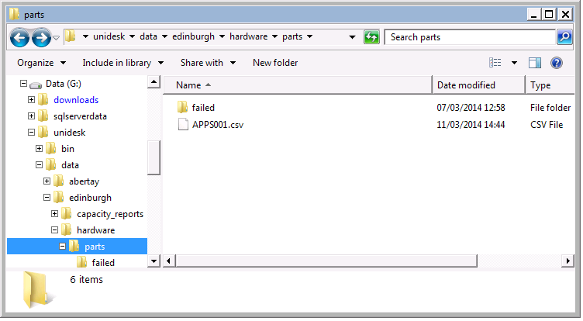

OBJECT_ID suffix
For records from Edinburgh:
All object_id fields must be of the form:
<internal object id>--<valid suffix>
Where the valid suffixes are held in the in the data base table:
Datasource | valid_suffix
MCC | APPS001

Any files where one or more records fail the suffix test will be copied into the ‘failed’ directory with a date stamp extension and a warning email will be sent. The system will still attempt to process any records in the file where the suffix is correct.

Naming of CSV files
For Edinburgh record there is another validation test:
The name of the CSV file (the part before ‘.csv’) must match the object id suffix in the file. I.e: a file containing object Ids of the form:
acc-db-at1--APPS001
acc-db-kb1--APPS001
MUST have the name
APPS001.csv

Processing of CSV files

Manually running the CSV loading
In SQL server management studio:
Open SQL server agent > Jobs
Find the Job named: ‘Import Hardware <site>’
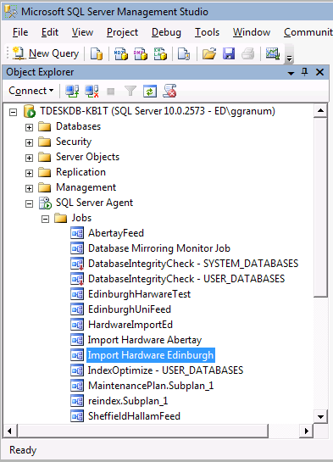
Right click this job and select ‘Start Job at Step …’ from the pop-up menu
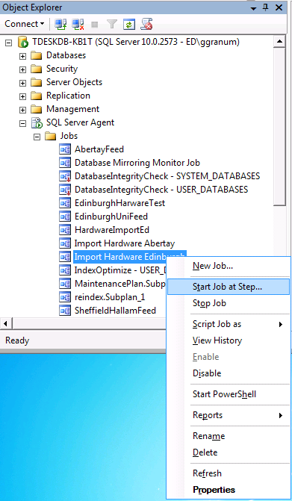
For hardware the first step should be the ‘filename=suffix test’ this step will be the highlighted one in the list.
Left click this step and press the start button, this will start the processing of the CSV files
