Stage: Systems Analysis and Design

System Design Specification

Migrate IDM to Oracle SOA Suite 11g and Upgrade Grouper
Iteration 2 – Inbound Processing

Communication

COM007

AP23-001

Document Version: 1.0

Date: 11/02/2014

Contents

1 Document Management 5
1.1 Contributors 5
1.2 Version Control 5
2 OVERVIEW 6
3 DEVELOPMENT TOOLS AND STANDARDS 7
3.1 Development Tools 7
3.2 Development Standards 7
4 SYSTEM PROCESSES 8
4.1 Database Changes 8
4.1.1 Database patching automation 8
4.1.2 Table changes 8
4.1.3 PL/SQL Changes (BRD 2.6, BRD2.8, BRD2.9, BRD 2.10) 8
4.2 VRS Changes (BRD 2.1) 8
4.3 Golden Copy Connector 8
4.3.1 EUGEX Golden Copy Connector 8
4.3.2 HR Golden Copy Connector (BRD 2.2) 9
4.4 Eugex-IDM Sync Tool (BRD 2.7) 9
4.4.1 Introduction to Sync Tool 9
4.4.2 Sync Tool Web Service 10
4.4.3 Sync Tool & IDM UI 12
4.4.4 Sync Tool & IDMInboundChangeProcess 14
4.5 SOA changes 15
4.5.1 Overview 15
4.5.2 Composite Overview (BRD 2.5, BRD 2.8, BRD 2.9) 16
4.5.3 SOA Processes – Core IDM 17
4.5.4 SOA Processes – Sync Tool 32
5 Unit testing 35
5.1 SOA Test Suites 35
USER INTERFACE 37
5.2 Transactional Interface 37
5.2.1 MyEd Interface 37
5.3 Reporting Interface 37
6 APPLICATION SECURITY 38
6.1 Authentication 38
6.2 Authorisation 38
6.3 Business Objects 38
7 DATABASE DESIGN 39
7.1 IDStore Tables 39
7.2 IDStore Views 45
8 APPLICATION INTERFACES 45

Document Management

Contributors

Please provide details of all contributors to this document.

Role | Unit | Name
Systems Analyst Designer (Owner) | IS Applications Development Team | Richard Good  Michael Sun
Development Lead | IS Applications Development Team | Richard Good
Project Manager | IS Applications  Business Services | Stephen Conlon
Analyst Developer | IS Applications Development Team | Michael Sun

Version Control

Please document all changes made to this document since initial distribution.

Date | Version | Author | Section | Amendment
11/02/14 | 1.0 | MS | All | All

OVERVIEW

This System Design Specification details the changes required for Iteration 2 of the COM007. For a general overview of this project, the iterations and others, refer to the High Level Design document.

This iteration focuses on the inbound “change” processing side of the Identity Management System. The design will focus on the following improvements:

The design is split into sections which broadly speaking cover the different application technologies involved:

- Database changes
- Sync Tool & IDM UI
- SOA SCA Processes

DEVELOPMENT TOOLS AND STANDARDS

Development Tools

- SOA 11g(BPEL, Mediator)
- Java Spring
- XML
- Oracle 11g

Development Standards

Tick the appropriate box to indicate the standards being followed for this application:

Standard | √ indicates compliance
Database Design | √
SOA Development Standards | √
Cold Fusion | n/a
Java | √
Uportal Development | n/a
Accessibility | √
Web Style Standards | √
Supported Web Browsers | √

SYSTEM PROCESSES

Database Changes
  - NOTE: The database changes must be done prior to any other build work.

Database patching automation

In order to control what is applied to the various IDM schemas, patching automation will be introduced. In this way only code applied via the IS Apps SVN repository will be applied to the database, and will therefore be auditable and properly managed.

Table changes

- All tables must be created or altered as per Section 8.

PL/SQL Changes (BRD 2.6, BRD2.8, BRD2.9, BRD 2.10)

- All packages which reference tables altered in Section 4.1.1 must be updated.
- IDSTORE_GENERATESTAFFUUN function needs to be updated in order to resolve Sequential UUN generation is not reliable issue (BRD 2.6)
- IDSTORE_IDENTITY_PACKAGE.GENERATE_IDENTITY needs to be updated in order to resolve returning users are not reactivated issue (BRD 2.8)
- IDSTORE_IDENTITY_PACKAGE.GET_ADJUSTED_ORG needs to be updated in order to resolve student POS orgunit remapping issue (BRD 2.9)
- F_GET_PRIMARY_AFFILIATION function needs to be updated in order to determine primary affiliation with respect to main assignment from HR rather than using recent start date (BRD 2.10)

VRS Changes (BRD 2.1)

There should be no changes to VRS, database table and pl/sql changes as above should not make VRS behave differently.

Incoming change that only changes Library and Card numbers does not trigger downstream notifications issue have been fixed under IDM Iteration One.

Golden Copy Connector

EUGEX Golden Copy Connector

EUGEX Connector Threshold (BRD 2.3)
IDM_CHANGE_THRESHOLD table contains threshold setting for I (Insert), U (Update), D (Delete) regardless of entity type e.g. Student, Applicant and Curriculum. This threshold is too crude to be practical used, and therefore the threshold will be further differentiated as below:

- SI - Student Insert
- SU - Student Update
- SD - Student Delete
- AI - Applicant Insert
- AU - Applicant Update
- AD - Applicant Delete
- CI - Curriculum Insert
- CU - Curriculum Update
- CD - Curriculum Delete

IDM_PROCESS_PKG packages need to be updated with respect to above settings.

EUGEX Connector Process Abort on Error (BRD 2.4)
Empty materialised view in EUGEX triggers attempted full delete and re-insert of student population, P_CHECK_PROCESS_TABLES needs to be updated to properly detect if the materialised view is empty and possibility of full delete and re-insert, hence abort the process and notify support.

EUGEX Connector Cause Grouper Timeout (BRD 2.5)
Curriculum change may cause Grouper time out due to large content in curriculum change xml, the reason for generating large curriculum changes is because IDM_POP_IDM_HOLDING_QUEUE.P_COURSE_INSERT and P_COURSE_UPDATE place all changes inside a single curriculum change xml, this needs to be updated to generate several small curriculum change xml instead, i.e. 1 curriculum change xml with 100 course changes can be converted to 5 curriculum change xml with 20 course changes in each one.

HR Golden Copy Connector (BRD 2.2)
EPP4220.OUTPUT_DETAILS needs to be updated to generate change notifications when card number in HR is changed.

Eugex-IDM Sync Tool (BRD 2.7)

Introduction to Sync Tool
Due to miscellaneous reasons e.g. database query failure, Grouper web service timeout etc., EUGEX changes sometimes fail to be applied to IDM, and therefore the IDM gets out of step with EUGEX gradually.
To address above issue, a Eugex-IDM Identity Synchronization Tool (Sync Tool) has been developed. The Sync Tool allows manual synchronisation of changes from Eugex to IDM, and the generation of notifications about those changes to services. The synchronisation will also include any necessary addition or removal from Grouper. The Design Specification can be found here and Support Document can be found here.
Currently, Sync Tool can only be run from command line manually. As part of COM007 Iteration Two, we aim to improve Sync Tool with the following enhancement:

- Make Sync Tool as a modular web service
- Integrate Sync Tool with IDM UI, and make it callable via UI
- Integrate Sync Tool with IDMInboundChangeProcess, and make Sync Tool sync data automatically

Sync Tool Web Service
Sync Tool is a command line utility, in order to make Sync Tool usable across different applications, i.e. IDM UI, IDM SOA process, and make it self-contained and modular; converting it into a web service is a good option.

NetBeans Web Service and WebLogic
Sync Tool was originally developed in NetBeans, whereas Oracle WebLogic is our server of choice for hosting web services and SOA processes. We have done RND task that proves web services developed in NetBeans can be deployed to WebLogic with proper weblogic.xml configuration files attached, i.e.

<?xml version="1.0" encoding="UTF-8"?>
<weblogic-web-app xmlns="http://xmlns.oracle.com/weblogic/weblogic-web-app" xmlns:xsi="http://www.w3.org/2001/XMLSchema-instance" xsi:schemaLocation="http://java.sun.com/xml/ns/javaee http://java.sun.com/xml/ns/javaee/web-app_2_5.xsd http://xmlns.oracle.com/weblogic/weblogic-web-app http://xmlns.oracle.com/weblogic/weblogic-web-app/1.0/weblogic-web-app.xsd">
<jsp-descriptor>
<keepgenerated>true</keepgenerated>
<debug>true</debug>
</jsp-descriptor>
<context-root>/HelloWorldWebLogicWS</context-root>
</weblogic-web-app>

Above weblogic.xml will enable a skeleton web service to be deployed to WebLogic. The weblogic.xml for Sync Tool is expected to contain more configurations that describes and configures the application; it will be further refined as when the development starts.

Make Sync Tool as Asynchronous Web Service

Sync Tool can be used to sync single or batch change(s), in case of batch change, the process time usually takes a few minutes to a few hours depends on the data size, therefore the web service need to either asynchronous or synchronous with performing the sync process on a separate thread.

By default, all java web service on WebLogic server is synchronous, to handle unexpected processing time, performing sync process on a separate thread is an easy solution.

class SyncThread extends Thread {
String parameter = "";
public SyncThread(String parameter) {
super(parameter);
this. parameter = parameter;
}
public void run() {
SyncTool.sync(parameter);
}
}

Sync Tool as Web Service Specification

Sync Insert Change

Method 1: syncEugexToIDMInsertByUUN
Parameter:
Type: the type to be processed, i.e. STU or APP
UUN: the UUN to be processed, i.e. s0198334

Operation: Sync insert change of an student/applicant from Eugex to IDM

Method 2: syncEugexToIDMInsertAll
Parameter:
Type: the type to be processed, i.e. STU or APP

Operation: This method works out entire student/applicant population to be inserted and then insert them into IDM.

Sync Delete Change

Method 1: syncEugexToIDMDeleteByUUN
Parameter:
Type: the type to be processed, i.e. STU or APP
UUN: the UUN to be processed, i.e. s0198334

Operation: Sync delete change of an student/applicant from Eugex to IDM

Method 2: syncEugexToIDMDeleteAll
Parameter:
Type: the type to be processed, i.e. STU or APP

Operation: This method works out entire student/applicant population to be deleted and then delete them from IDM.

Sync Update Change

Method 1: syncEugexToIDMUpdateByUUN
Parameter:
Type: the type to be processed, i.e. STU or APP
UUN: the UUN to be processed, i.e. s0198334

Operation: Sync update change of an individual student/applicant from Eugex to IDM

Method 2: syncEugexToIDMUpdateAll
Parameter:
Type: the type to be processed, i.e. STU or APP
Operation: This method works out entire student/applicant population to be updated and then update them in IDM.

Sync Tool & IDM UI

After Sync Tool is converted to a web service, it can be easily referenced by IDM UI.

IDM UI Sync Tool Web Service Client
Maven has made the process of generating web service stub class so easy, to generate Sync Tool web service stub class, just adding the following code snippet into pom.xml of IDM UI
<plugin>
<groupId>org.codehaus.mojo</groupId>
<artifactId>jaxws-maven-plugin</artifactId>
<version>1.10</version>
<executions>
<execution>
<goals>
<goal>wsimport</goal>
</goals>
<configuration>
<wsdlUrls>
<wsdlUrl>https://www-dev.soa.is.ed.ac.uk/IDM-wsSyncTool-context-
root/wsSyncToolServiceSoapHttpPort?WSDL</wsdlUrl>
</wsdlUrls>
<xauthFile>${basedir}/src/main/resources/authFile.properties</xauthFile>
<staleFile>${project.build.directory}/jaxws/stale/webservice.stale</staleFile>
</configuration>
<id>wsimport-generate-webservice</id>
<phase>generate-sources</phase>
</execution>
</executions>
<dependencies>
<dependency>
<groupId>javax.xml</groupId>
<artifactId>webservices-api</artifactId>
<version>1.4</version>
</dependency>
</dependencies>
<configuration>
<sourceDestDir>${project.build.directory}/generated-sources/jaxws-wsimport</sourceDestDir>
<xnocompile>true</xnocompile>
<verbose>true</verbose>
<extension>true</extension>
<catalog>${basedir}/src/jax-ws-catalog.xml</catalog>
</configuration>
</plugin>

Invoking Sync Tool Web Service from IDM UI
IDM UI will provide user interface for sync by UUN and sync ALL functions, in addition, view log function is added to let user to view Sync Tool processing logs.

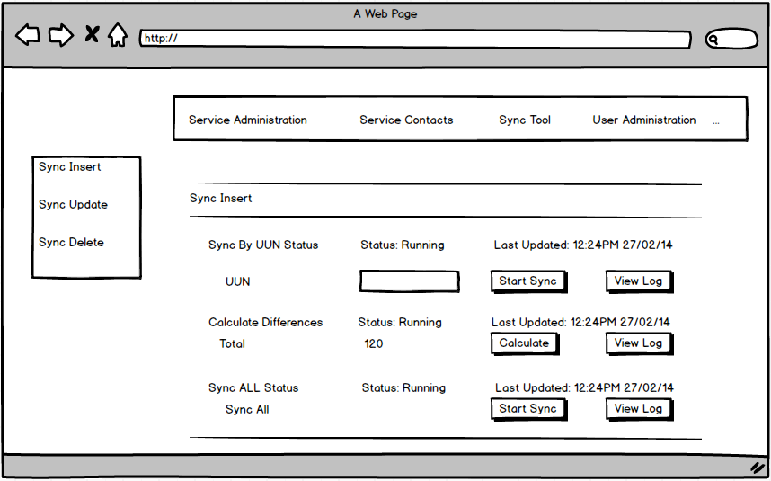

The screen must:

- Only let Super Admin and/or Sync Tool Admin to view above page.
- Provide functions for sync by UUN and sync ALL for Insert, Update, Delete changes.
- Provide functions for viewing process logs.
- Checking IDM_SYNC_STATUS table, if the process is currently running, the corresponding section (except View Log button) on the page should be greyed out, and display Status as Running and display Last Updated timestamp, if the process is not running, display Status as Ready and display Last Updated timestamp.
- Have an AJAX function which update Status and Last Updated field per min, once the process is completed, re-enable greyed out section on the page. Or auto refresh page every 5min and re-enable greyed out section on the page accordingly.
(Whether to implement functions like (1). Ajax auto refresh; (2).display a list of UUNs then let user select which one to sync, rather than let user type UUN to sync, need to be discussed)

Calculate must:
- Report total number of differences between EUGEX and IDM regarding to the change type.

Start Sync must:

- In case of sync by UUN, invoke Sync Tool syncEugexToIDMInsert/Update/DeleteByUUN method
- In case of sync ALL, invoke Sync Tool syncEugexToIDMInsert/Update/DeleteAll method
- Grey out the corresponding section (except View Log button)

View Log must:

- Load logs from IDM_SYNC_LOG table and display it in a new browser tab.

Sync Tool & IDMInboundChangeProcess
Sync Tool will be integrated with IDM IDMInboundChangeProcess SOA process as a self-healing utility.

Detailed design will be discussed under Section 4.3.4 SOA Processes – Sync Tool

SOA changes
2
IDSTORE Packages

Overview
wsIDMXmlProcessHandler Web Service
wsIDMXmlProcessHandler Service Reference
processChangeHandler
1. On receive change XML, insert it into PROCESS_INPROGRES

2. Determine which handler to handle this change, available handlers are: Group, Curriculum, Email, Identity, OrgUnit

3. Invoke change handler

4. Receive process result; update status and error info (if any)

Process Queue Reader
Grouper Web Service
Grouper
Service Reference

Identity and
Membership Handler
(Async)

Change XML:
1. ID
2. Change Type
3. Source
4. XML
5. XML
3
4

Curriculum Handler
(Async)

Sync Tool Web Service
OrgUnit
Handler

Group
Handler

Email
Handler

processSyncHandler
1. On receive UUN,
Type

2. Invoke Sync Tool
Web Service

Sync XML:
1. UUN
2. Type

Sync Tool Reference
PROCESS_ INPROGRESS

PROCESS_QUEUE
Sync Queue Reader

SYNC_QUEUE

5
PROCESS_ARCHIVE

1
PROCESS_ERROR

Composite Overview (BRD 2.5, BRD 2.8, BRD 2.9)

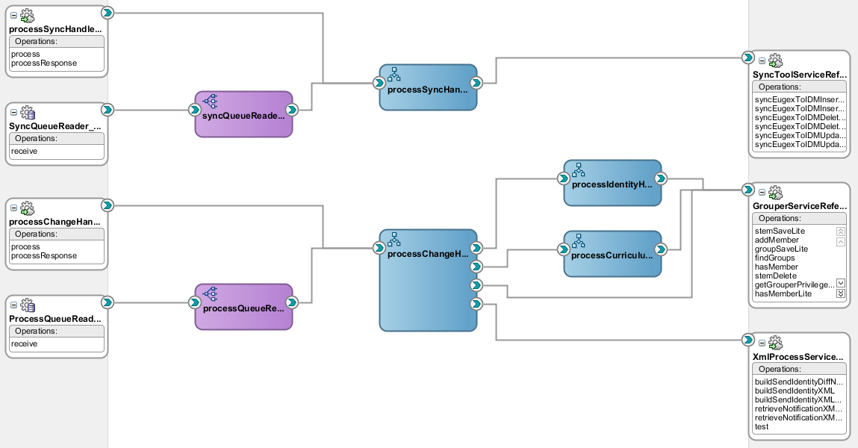

idmInboundChangeProcess composite will consist of the following components:

DBAdapter and Mediator
- ProcessQueueReader_DBAdapter
Poll V_IDM_PROCESS_QUEUE view for incoming change xml

- processQueueReaderMediator
Transform and transfer change XML to processChangeHandlerBPEL

- SyncQueueReader_DBAdapter
Poll V_IDM_SYNC_QUEUE view for failed student/applicant identities

- syncQueueReaderMediator
Transform and transfer UUN, type to processSyncHandlerBPEL

Asynchronous BPEL process
- processChangeHandlerBPEL
Parse incoming change xml from string to xml object and determine which handler to handle the change, invoke the handler accordingly.

The available handlers are

(1). The logic of Group, Email, OrgUnit handler will be included in processChangeHandlerBPEL, no separate handler BPEL will be made.

(2). Identity (includes Membership), Curriculum handlers. In case of Email and Identity handlers, XmlProcessServiceReference will be invoked to obtain sendIdentity xml before change applied and after change applied and generate notification for downstream services. GrouperServiceReference will be invoked to add identity to Grouper affiliation groups.
- processSyncHandlerBPEL
Calling Sync Tool web service to sync changes between EUGEX and IDM.

Asynchronous BPEL process
- processIdentityHandlerBPEL
Handle identity and membership change. Identity and membership changes will be handled together within processIdentityHandlerBPEL. The process will be asynchronous, as
(1). The process may take unexpected time to complete
(2). Invoking other asynchronous process i.e. GrouperServiceReference

Once processIdentityHandlerBPEL completes processing, it calls back processChangeHandlerBPEL. A timeout limit of 180 seconds will be set.

- processCurriculumHandlerBPEL
Handle curriculum change. Same as above, a timeout limit of 180 seconds will be set.

External Web Service Reference
- GrouperServiceReference
A reference that invokes Grouper Web Service. SyncMaxWaitTime is the setting that controls timeout for synchronous web services. The current value is 60 seconds; this value can be increased in order to overcome Grouper time out problem. The exact value needs to be refined when more testing is carried out. (BRD 2.5)

Synchronous BPEL Utility process
- XmlProcessServiceReference
A reference that invokes wsIDMXmlProcessHandlerService(diffcode) Web Service.

Synchronous BPEL Utility process
- SyncToolReference
A reference that invokes Sync Tool Web Service.

SOA Processes – Core IDM

A typical running scenario is outlined below, items highlighted in bold are discussed in details in later sections.

The sample scenario is, one staff insert change xml is sent from HR golden copy connector to IDM_PROCESS_QUEUE table, and idmInboundChangeProcess composite starts processing it.

- Process Queue Polling (Ref 1)
One staff insert change xml is inserted into IDM_PROCESS_QUEUE; ProcessQueueReader_DBAdapter picks up this change xml, and passes to processQueueReaderMediator, which in turn transforms and transfers to processChangeHandlerBPEL, the change xml is deleted from IDM_PROCESS_QUEUE immediately.

- processChangeHandlerBPEL onReceive Change XML (Ref 2)
On processChangeHandlerBPEL receives change xml, it immediately inserts xml string into IDM_PROCESS_INPROGRESS table, then it converts xml string to xml object; and based on Source element, it determines which handler to handle this change.

Sample Staff Insert Change xml
<Identity>
<id>f81d4fae-7dec-11d0…</id>
< changeType >I< /changeType >
< source >STAFF< /source >
< xml > <eduniTitle>DR</eduniTitle><givenName>Diggory</givenName>…</ xml >
< change_date >2013-08-16</ change_date >
< status_code >N</ status_code >
</Identity>

- processChangeHandlerBPEL Processing (Ref 2)
As the Source is STAFF, processIdentityHandlerBPEL will be used to handle the change. Before processIdentityHandlerBPEL is invoked, XmlProcessServiceReference is invoked synchronously to get sendIdentity xml, which is a current snapshot of the entire information about this identity in IDM.

- processIdentityHandlerBPEL Processing (Ref 3, 4)
processIdentityHandlerBPEL receives change as xml object from processChangeHandlerBPEL, and calls IDSTORE identity package to apply the change to IDM.

In previously IDM (SOA 10g), there is a separate Membership Handler to handle identity membership changes, in this version, the logic of Membership Handler will be merged into processIdentityHandlerBPEL. The reason is no other process is using Membership Handler and by reducing number of asynchronous process, it can help achieve better performance.

While processIdentityHandlerBPEL is processing identity changes, it will call external Grouper web service to create/update identity memberships in Grouper system, the invocation will be done via GrouperServiceReference component.

processIdentityHandlerBPEL will be asynchronous as this process may take unexpected time to complete and it calls Grouper web service which may also take unexpected time to complete, the time out limit for invoking Grouper web service is 120 seconds, the time out limit for processIdentityHandlerBPEL is 180 seconds.

Once processIdentityHandlerBPEL completes processing, it will call back processChangeHandlerBPEL with process results, if processIdentityHandlerBPEL or grouperServiceReference times out, it will indicate timeout and processChangeHandlerBPEL will mark the change as X.

- processChangeHandlerBPEL Receiving Callback (Ref 2)
processChangeHandlerBPEL will invoke XmlProcessServiceReference to compute sendIdentity xml after change has applied and generate downstream notifications accordingly.

- processChangeHandlerBPEL Finalizing Processing (Ref 2)
As this change is an identity insert change, processChangeHandlerBPEL will call GrouperServiceReference to add this staff to Grouper affiliation group. If all above succeeds, processChangeHandlerBPEL updates this change in IDM_PROCESS_INPROGRESS as C (completed). In case of error, the status will be mark as X and appropriate error message will be logged to IDM_PROCESS_ERRORS table.

- processChangeHandlerBPEL Inserting Into Sync Queue on Error (Ref 5)
If the change is with source UCAS APPLICANT, ONLINE APPLICANT or STUDENT, in case of error of processing this change by processChangeHandlerBPEL, the UUN and type (STU or APP) will be logged to SYNC_QUEUE table.

Process Queue Polling (Ref 1)

A DBAdaptor with a Mediator will be constantly polling new changes from V_IDM_PROCESS_QUEUE at certain frequency; it is defined as

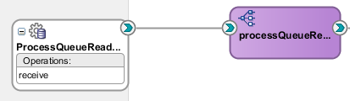

DBAdaptor name: processQueueReader_DBAdapter
Polling Source: V_IDM_ PROCESS _QUEUE
After Read: Delete row(s) that were read
Polling Frequency: 5 seconds
Database Rows per XML Document: 1 (to be confirmed)
Database Rows per Transaction: 10 (to be confirmed)

Mediator name: processQueueReaderMediator
After a new change xml is picked up by DBAdaptor, it will be forwarded to processChangeHandlerBPEL process and the change xml will be deleted from IDM_PROCESS_QUEUE immediately.

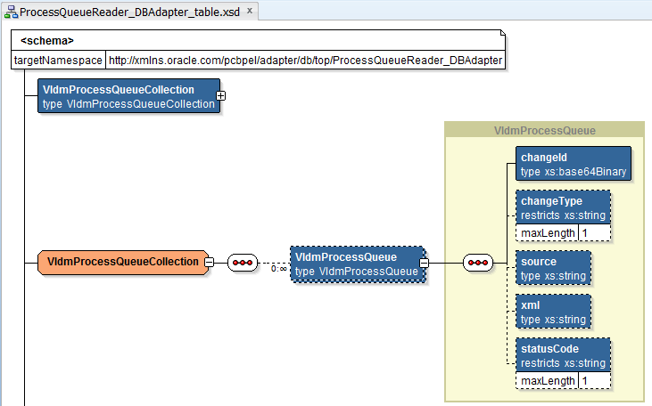

processChangeHandlerBPEL (Ref 2)

BPEL Process Name: processChangeHandlerBPEL
Namespace:
http://xmlns.ed.ac.uk/idm/idmInboundChangeProcess/processChangeHandlerBPEL
Service Name: processChangeHandlerBPEL_client
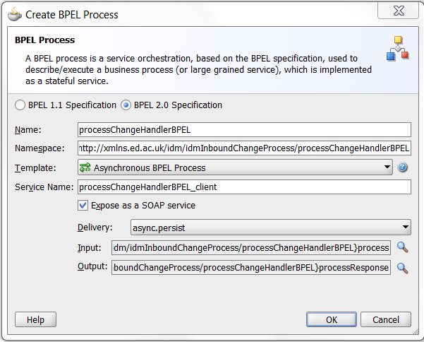

Process Flow:

- Receive Input – receive change xml (as string) from processQueueReaderMediator
- Parse XML – parse xml from string to xml object
- Determine Handler – base on Source element, determine which handler to use
- Invoke Handler –
(1). If the source is identity (UCAS APPLICANT, ONLINE APPLICANT, STUDENT, ALUMNI, STAFF, VISITOR, EVISITOR), processIdentitiyHandler will be called;
(2). If the source is curriculum (CURRICULUM), processCurriculumHandler will be called;
(3). There are no separate BPEL handlers for email(EDDIR), group(IDM AGING), orgunit(ORG HIERARCHY) changes, these changes will be handled in processChangeHandler directly, the reason is we try to reduce the number of asynchronous BPEL whenever is possible, this will improve runtime performance.
(4). In case of identity or email changes, XmlProcessService. buildSendIdentityXML will be called to produce a snapshot of identity information(sendIdentity XML) before change applied, after change applied, buildSendIdentityDiffNotificationXML will be called to produce notification to downstream services.
(5). In case of identity Insert change, GrouperServiceReference will be called to add this identity to affiliation group in Grouper (GrouperServiceReference .addMemberLite).
- Update Change Status – based on the results from above steps, the change status will be mark as Applied or as Error in DM_PROCESS_INPROGRESS table and in case of Error, errors details will also be logged to IDM_PROCESS_ERROR table.
- Email, Group, Orgunit Handlers – even though there is no separate handler BPEL process for email, group(aging), orgunit changes, it worth outline the function on how to handle these changes as below:
- Email Change – Available change types are I, U, D, by calling idstore_email_pkg to insert, update, or delete email addresses accordingly.
- Group (Aging) Change - Available change types are I, D, it calls Grouper to AddMember or DeleteMember accordingly.
- Orgunit Change – Available change types are FOLDER, I, U, D, FOLDER change type is not used from inbound process queue prospective, it will be used only as a utility web service to create folders in Grouper,
(1). In case of Insert change, CreateOrgunitAsFolder, CreateGroup, AddMemberToGroup
(2). In case of Update change, CreateOrgunitAsFolder, CreateGroup, AddMemberToGroup, DeleteMemberFromOldGroup, DeleteOldGroup
(3). In case of Delete change, DeleteGroup, DeleteFolder

- Schema attached as below

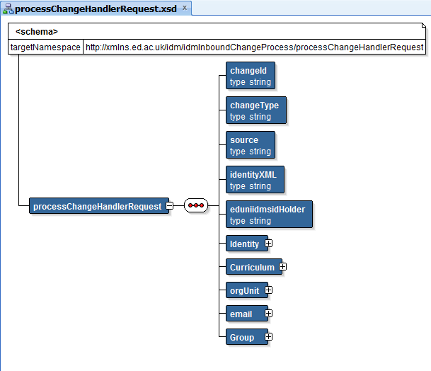

processIdentityHandlerBPEL (Ref 3)

BPEL Process Name: processIdentityHandlerBPEL
Namespace:
http://xmlns.ed.ac.uk/idm/idmInboundChangeProcess/processIdentityHandlerBPEL
Service Name: processIdentityHandlerBPEL_client
Expose as a SOA service: no
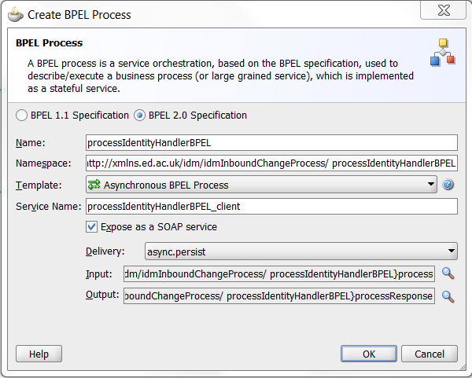

- Receive Input – receive identity xml from processChangeHandler
- Handle Identity Change –
(1). If changeType is I, create this core identity, address, email address by using idstore_identity_pkg. A web service call to Grouper is required to add this identity to appropriate group.
(2). If changeType is U, and the change is sent by its primary affiliation, update this core identity, address, email address. A web service call to Grouper is required to alter this identity’s group membership.
(3). If changeType is U, and the identity already exists, add this new affiliation, if adding new affiliation results of primary affiliation change, update core identity, address, email address, otherwise only new affiliation is added, no update to identity should be performed.
(4). If changeType is D, mark this identity as ready for aging by calling idstore_identity_pkg.remove_identity.
- Callback processChangeHandler – on successful handling identity change, call back processChangeHandler with reponseCode success and eduniidmsid that has been dealt with.

- Schema attached as below

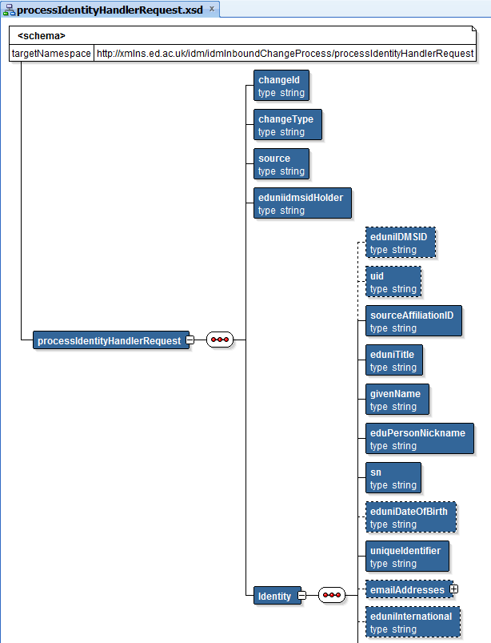

processCurriculumHandlerBPEL (Ref 3)

BPEL Process Name: processCurriculumHandlerBPEL
Namespace:
http://xmlns.ed.ac.uk/idm/idmInboundChangeProcess/processCurriculumHandlerBPEL
Service Name: processCurriculumHandlerBPEL_client
Expose as a SOA service: no

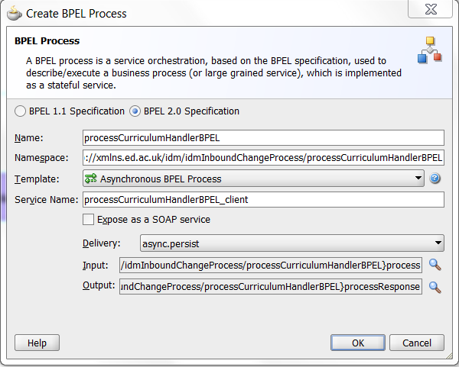

- Receive Input – receive curriculum xml from processChangeHandler, determine whether this is a Course change or Pos change
- Handle Curriculum Pos Change –
(1). In case of Pos Insert change, createPosAsFolder, createPosAsGroup, addPosAsMemberOfOrgunitDN
(2). In case of Pos Update change, createPosAsFolder, deleteOldPos, createPosAsGroup, addPosAsMemberOfOrgunitDN
(3). In case of Pos Delete change, deletePos
- Handle Curriculum Course Change –
(1). In case of Course Insert change, createCourseAsFolder, createCourseAsGroup, addCourseAsMemberOfOrgunitDN
(2). In case of Course Update change, createCourseAsFolder, deleteOldCourse, createCourseAsGroup, addCourseAsMemberOfOrgunitDN
(3). In case of Course Delete change, deleteCourse
(4). In case of Course Add Member change, addMembersToCourse
(5). In case of Course Delete Member change, deleteMembersFromCourse

- Callback processChangeHandler – on successful handling curriculum change, call back processChangeHandler with reponseCode success.
- Schema attached as below

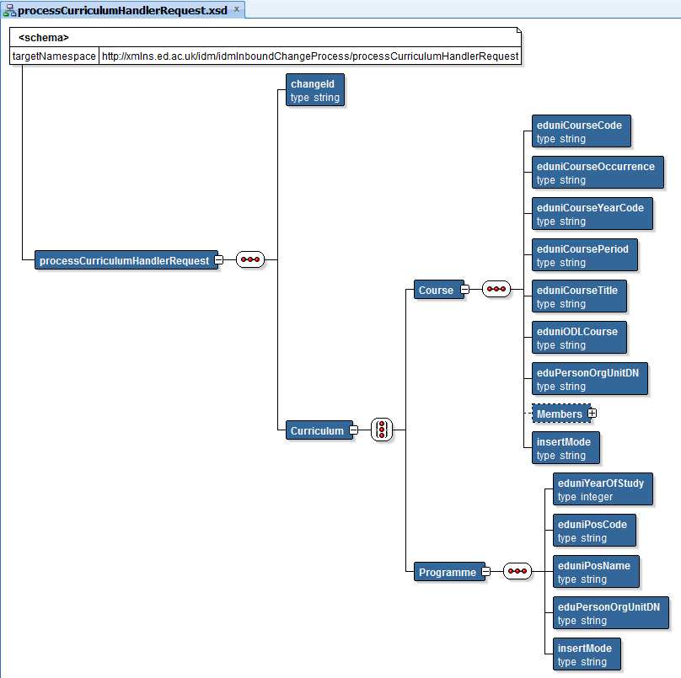

XmlProcessServiceReference (Ref 3)

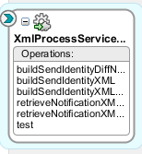

XmlProcessServiceReference is the web service Reference to XmlProcessWebService (diffCode); it will be called by BPEL processes to produce downstream notifications. There are 2 methods and both are used in processChangeHandlerBPEL

buildSendIdentityXML

Request Parameter:
- /ns28:buildSendIdentityXMLElement/ns28:eduniidmsid= /ns1:request/ns1:email/ns1:uid, either eduniidmsid or idstoreuid is accepted

Operation: It builds sendIdentity xml for the identity; sendIdentity xml is the xml that captures all information about this identity in IDM.

buildSendIdentityDiffNotificationXML

Request Parameter:
- /ns28:buildSendIdentityDiffNotificationXMLElement/ns28:sendIdentity= /ns1:request/ns1:identityXML
- /ns28:buildSendIdentityDiffNotificationXMLElement/ns28:eduniidmsid=ws_identitySourceHandler_OutputVariable
- /ns28:buildSendIdentityDiffNotificationXMLElement/ns28:sourceChangeId=/ns38:OutputParameters/ns38:GET_CHANGEID_DECODED
- /ns28:buildSendIdentityDiffNotificationXMLElement/ns28:source= /ns1:request/ns1:source
- /ns28:buildSendIdentityDiffNotificationXMLElement/ns28:insertMode= /ns1:request/ns1:changeType

Operation: It compares sendIdentity xml before identity is changed with the sendIdentity xml after identity is changed and produces downstream notifications as defined in https://www.wiki.ed.ac.uk/display/insite/IDM+Notifications

GrouperServiceReference (Ref 3)

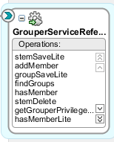

GrouperServiceReference is the web service Reference to Grouper Web Services; it will be called by BPEL processes to perform group and membership changes in Grouper system, methods are listed as below:

4.3.3.6.1 processChangeHandlerBPEL

(1). addMemberLite
Request Parameter:
Assign_addMemberToAffiliationGroup
- clientVersion = 'v1_5_000'
- subjectId = ws_identitySourceHandler_OutputVariable
- groupName = concat("affiliations:",bpws:getVariableData('holder','payload','/ns1:request/ns1:Identity/ns1:sourceAffiliation'))

Operation: Add single member to group

4.3.3.6.2 MembershipChangeHandler

(1). deleteMemberLite:
Request Parameter:
Assign_wsdl_removeFromGroup
- clientVersion = 'v1_5_000'
- subjectId = /ns2:membership/ns2:eduniidmsid

Operation: Delete single member from group

4.3.3.6.3 CurriculumSourceHandler

(1). groupDeleteLite
Request Parameter:
Assign_Idpath
- groupName = courseIdpath
- clientVersion = 'v1_5_000'
- actAsSubjectId = 'GrouperSystem'
- includeGroupDetail = 'T'

Operation: Delete group

(2). stemSaveLite
Request Parameter:
Assign_CreateYearCodeAsFolder
- clientVersion = 'v1_5_000'
- actAsSubjectId = 'GrouperSystem'
- stemName = concat("courses:",bpws:getVariableData('inputVariable','payload','/ns1:Curriculum/ns1:Course/ns1:eduniCourseYearCode'))

Operation: Create a new folder

(3). getGroupsLite
Request Parameter:
Assign_GetGroupLite
- clientVersion = 'v1_5_000'
- actAsSubjectId = 'GrouperSystem'
- subjectId = coursepath

Operation: Get group info

(4). deleteMemberLite
Request Parameter:
Assign_DeleteMemberLite
- clientVersion = 'v1_5_000'
- actAsSubjectId = 'GrouperSystem'
- subjectId = /ns5:getGroupsLiteResponse/ns5:return/ns5:wsSubject/ns5:id
- groupName = /ns5:getGroupsLiteResponse/ns5:return/ns5:wsGroups[1]/ns5:name

Operation: Delete single member from group

(5). groupSaveLite
Request Parameter:
Assign_Idpath
- clientVersion = 'v1_5_000'
- groupName = courseIdpath
- actAsSubjectId = 'GrouperSystem'
- displayExtension = /ns1:Curriculum/ns1:Course/ns1:eduniCourseTitle

Operation: Create new group

(6). addMemberLite
Request Parameter:
Assign_AddCourseAsMemberOfOrgunitDN
- clientVersion = 'v1_5_000'
- actAsSubjectId = 'GrouperSystem'
- groupName = orgunitIdpath
- courseUuid = /ns5:getGroupsLiteResponse/ns5:return/ns5:wsSubject/ns5:id
- subjectId = courseUuid

Operation: Add single member to group

(7). addMember
Request Parameter:
Assign_Idpath
- /ns5:addMember/ns5:wsGroupLookup/ns5:groupName = courseIdpath
- clientVersion = 'v1_5_000'
- for each – subjectLookups.subjectId = Curriculum.Members.Identity.eduniIdmsID

Operation: Add a batch of members to group

(8). deleteMember
Request Parameter:
- /ns5:deleteMember/ns5:wsGroupLookup/ns5:groupName = courseIdpath
- clientVersion = 'v1_5_000'
- for each – subjectLookups.subjectId = Curriculum.Members.Identity.eduniIdmsID

Operation: Delete a batch of members from group

4.3.3.6.4 OrgunitHandler

(1). stemSaveLite
Request Parameter:
Assign_Folder
- clientVersion = 'v1_5_000'
- actAsSubjectId = 'GrouperSystem'
- stemName = concat(bpws:getVariableData('Invoke_GetUnitparentByOrgunitdnDBAdapter_OutputVariable','OutputParameters','/ns8:OutputParameters/ns8:GET_UNITPARENT_BY_ORGUNITDN'),":",bpws:getVariableData('inputVariable','payload','/ns2:IntOrgUnit/ns2:orgUnit/ns2:eduPersonOrgUnitDN'))
- displayExtension = /ns2:IntOrgUnit/ns2:orgUnit/ns2:shortDescription

Operation: Create a new folder

(2). groupSaveLite
Request Parameter:
Assign_insert
- clientVersion = 'v1_5_000'
- groupName = concat(bpws:getVariableData('Invoke_GetUnitparentByOrgunitdnDBAdapter_OutputVariable','OutputParameters','/ns8:OutputParameters/ns8:GET_UNITPARENT_BY_ORGUNITDN'),":",bpws:getVariableData('inputVariable','payload','/ns2:IntOrgUnit/ns2:orgUnit/ns2:eduPersonOrgUnitDN'),":",bpws:getVariableData('inputVariable','payload','/ns2:IntOrgUnit/ns2:orgUnit/ns2:eduPersonOrgUnitDN'))
- displayExtension = /ns2:IntOrgUnit/ns2:orgUnit/ns2:shortDescription
- description = /ns2:IntOrgUnit/ns2:orgUnit/ns2:longDescription
- actAsSubjectId = 'GrouperSystem'

Operation: Create a new group

(3). getMemberLite
Request Parameter:
Assign_GetMembersLite
- clientVersion = 'v1_5_000'
- groupName = concat(bpws:getVariableData('Invoke_getCurrentUnitParentByOrgunitdnDBAdaptor_GetUnitparentByOrgunitdnDBAdapter_OutputVariable','OutputParameters','/ns8:OutputParameters/ns8:GET_UNITPARENT_BY_ORGUNITDN'),":",bpws:getVariableData('inputVariable','payload','/ns2:IntOrgUnit/ns2:orgUnit/ns2:eduPersonOrgUnitDN'))
- memberFilter = 'All'
- actAsSubjectId = 'GrouperSystem'
- includeGroupDetail = 'F'
- includeSubjectDetail = 'F'

Operation: Get a single member info

(4). addMember
Request Parameter:
Assign_AddMembers
- /ns6:addMember/ns6:clientVersion = 'v1_5_000'
- /ns6:addMember/ns6:actAsSubjectLookup/ns6:subjectId = 'GrouperSystem'
- /ns6:addMember/ns6:replaceAllExisting = 'T'
- /ns6:addMember/ns6:wsGroupLookup/ns6:groupName = concat(bpws:getVariableData('Invoke_GetUnitparentByOrgunitdnDBAdapter_OutputVariable','OutputParameters','/ns8:OutputParameters/ns8:GET_UNITPARENT_BY_ORGUNITDN'),":",bpws:getVariableData('inputVariable','payload','/ns2:IntOrgUnit/ns2:orgUnit/ns2:eduPersonOrgUnitDN'),":",bpws:getVariableData('inputVariable','payload','/ns2:IntOrgUnit/ns2:orgUnit/ns2:eduPersonOrgUnitDN'))
- /ns6:addMember/ns6:params/ns6:paramName = 'IGNORE'
- /ns6:addMember/ns6:params/ns6:paramValue = 'IGNORE'
- For each subjectLookups.subjectId = getMembersLiteResponse.wsSubjucts.id
- replaceAllExisting = notset

Operation: Add a batch of members to group

4.3.3.6.5 GroupHandler

(1). deleteMember
Request Parameter:
Assign_RemoveMember
- clientVersion = 'v1_5_000'
- actAsSubjectLookup = 'GrouperSystem'
- /ns3:deleteMember/ns3:wsGroupLookup/ns3:groupName = /ns1:Group/ns1:idPath
- For each subjectLookups.subjuectId= Members.Identity.eduniIdmsID
- For each subjectLookups.subjuectIdentifier = Members.Identity.eduniIdmsID

Operation: Delete a batch of members from group

(2). addMember
Request Parameter:
Assign_AddMember
- clientVersion = 'v1_5_000'
- /ns3:addMember/ns3:actAsSubjectLookup/ns3:subjectId= 'GrouperSystem'
- /ns3:addMember/ns3:wsGroupLookup/ns3:groupName = /ns1:Group/ns1:idPath
- For each subjectLookups.subjuectId= Members.Identity.eduniIdmsID
- For each subjectLookups.subjuectIdentifier = Members.Identity.eduniIdmsID

Operation: Add a batch of members to group

SOA Processes – Sync Tool

Sync Tool is integrated with processChangeHandlerBPEL as the following
- processChangeHandlerBPEL logs failed STU and APP changes to SYNC_QUEUE
- processSyncHandlerBPEL de-queues SYNC_QUEUE and invoke Sync Tool web service to process the change.

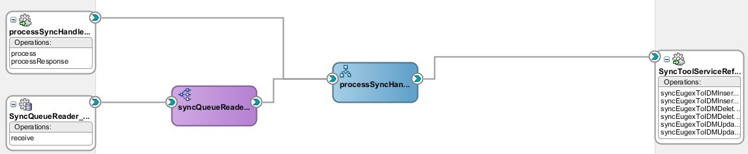

Sync Queue Polling

A DBAdaptor with a Mediator will be constantly polling new changes from V_IDM_SYNC_QUEUE at certain frequency; it is defined as

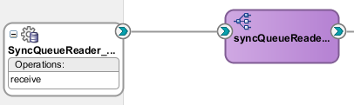

DBAdaptor name: syncQueueReader_DBAdapter
Polling Source: V_IDM_SYNC_QUEUE
After Read: Logical delete row(s) that were read
Polling Frequency: 60 seconds
Database Rows per XML Document: 1 (to be confirmed)
Database Rows per Transaction: 10 (to be confirmed)

Mediator name: syncQueueReaderMediator

Sync Queue Processing
BPEL Process Name: processSyncHandlerBPEL
Namespace:
http://xmlns.ed.ac.uk/idm/idmInboundSyncProcess/processSyncHandlerBPEL
Service Name: processSyncHandlerBPEL_client

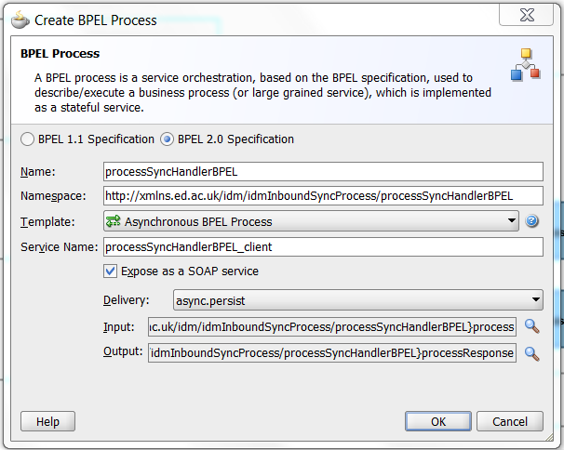

Process Flow:

- Receive Input – receive UUN and type from syncQueueReaderMediator
- Invoke Sync Tool Web Service – pass UUN and type to Sync Tool Web Service
- Sync Tool Processing – Sync Tool processes the UUN, it also handles all the error handling/logging.

Sync Tool Web Service Reference

A web service Reference will be created which refers to all methods specified in Section 4.2.2.4 Sync Tool Web Service Specification

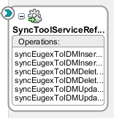

Unit testing

SOA Test Suites

For each of Source and Change type, sample process queue change xml will be constructed and unit test will be created:

Source:

Identity Change
- STUDENT
- STAFF
- UCAS APPLICANT
- ONLINE APPLICANT
- EVISITOR
- VISITOR
- ALUMNI

Curriculum
- CURRICULUM

Orgunit
- ORG HIERARCHY

Email
- EDDIR

Aging
- IDM AGING

Change Type:
- Insert (I)
- Update (U)
- Delete (D)

Unit Test Initiate:

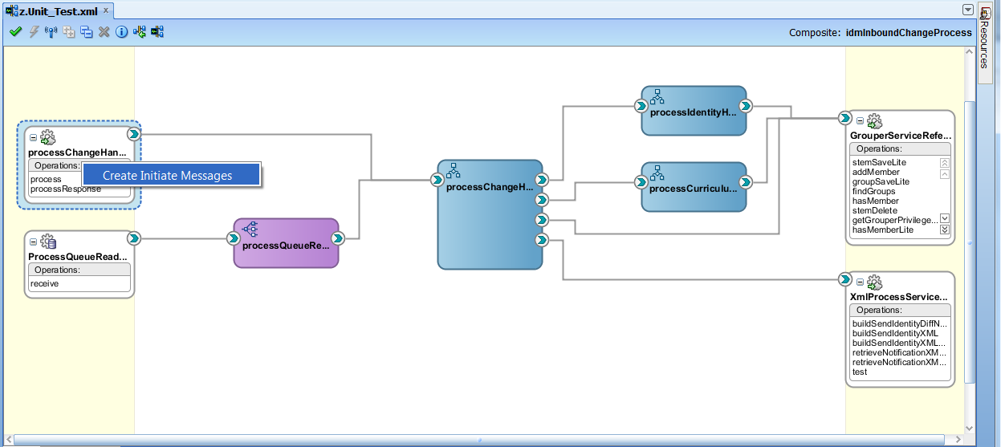

Unit Test Result:
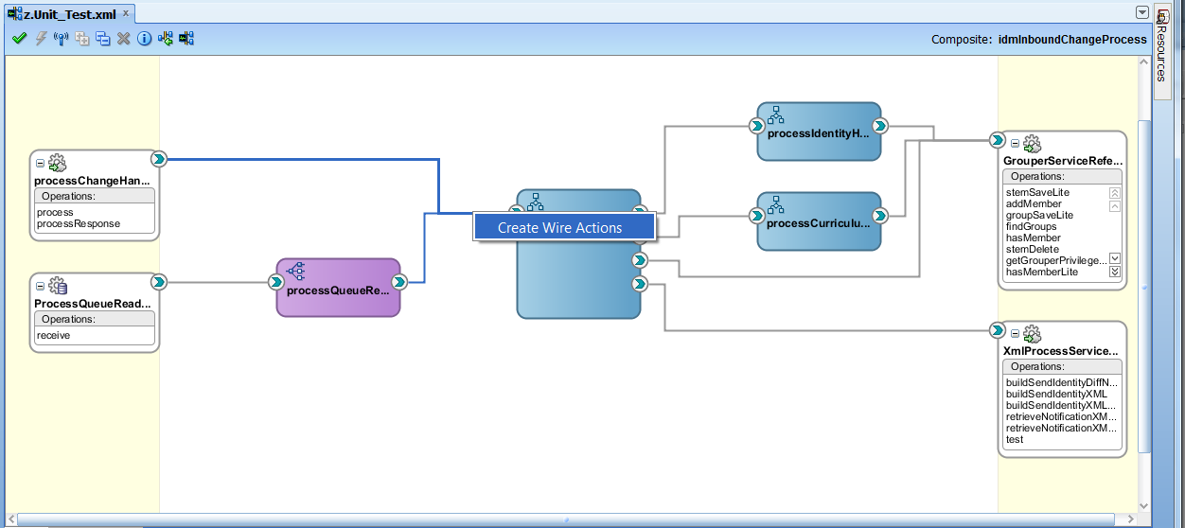

Complete sets of xml will be added in the following section while further development is carried out.

USER INTERFACE

Transactional Interface

This project has no transactional interface to describe.

MyEd Interface

This project delivers no integration with MyEd.

Reporting Interface

This project will deliver no extra reporting functionality.

APPLICATION SECURITY

Authentication
idmInboundChangeProcess is only accessible by DBAdapter, all BPEL processes except processChangeHandlerBPEL in idmInboundChangeProcess composite do not have public accessible end points, they are protected by SOA infrastructure by default, and therefore no authentication and authorisation are required.

processChangeHandlerBPEL process is required to have an end point(processChangeHandlerBPEL_client) in order to perform unit testing, therefore the following authentication policy is required:

oracle/wss_http_token_service_policy

The above also applies to processSyncHandlerBPEL

Authorisation
The following authorisation policy is required to protect processChangeHandlerBPEL
uoe/idmInbountChangeProcess_authorization

The above also applies to processSyncHandlerBPEL

Business Objects
No business objects are required.

DATABASE DESIGN

IDStore Tables
The following tables should be altered in the IDSTORE schema.

IDSTORE_ADDRESSES

Column Name | Old Data Type | New Data Type | Description
eduniidmsid | nvarchar2(36) | varchar2(36)
addrtype | nvarchar2(8) | varchar2(8)
eduniaddrline1 | nvarchar2(128)
eduniaddrline2  eduniaddrline3  eduniaddrline4  eduniaddrline5  eduniaddrline6  primaryaddress  datemodified | nvarchar2(128)  nvarchar2(128)  nvarchar2(128)  nvarchar2(128)  nvarchar2(128)  nvarchar2(1)  date | varchar2(1)

IDSTORE_AFFILIATION

Column Name | Old Data Type | New Data Type | Description
affiliationid | nvarchar2(35) | varchar2(35)
eduniidmsid | nvarchar2(36) | varchar2(36)
edupersonscopedaffiliation | nvarchar2(35) | varchar2(35)
eduniaffiliationstatus | nvarchar2(1) | varchar2(1)
eduniaffilistartdate  eduniaffilienddate  datemodified  agingstagedate  sourceaffiliationid  title  eduniinternational  affiliationuid  affiliationuniqueidentifier  aging_prematurely | date  date  date  date  varchar2(35)  varchar2(128)  varchar2(1)  nvarchar2(64)  nvarchar2(16)  varchar2(1) | nvarchar2(128)  varchar2(16)

IDSTORE_AFFILIATIONTYPES

Column Name | Old Data Type | New Data Type | Description
affiliationtypename | nvarchar2(100) | varchar2(100)
affiliationtypestatusid | nvarchar2(35) | varchar2(35)
date_modified | date
affiliationtypecode | nvarchar2(16) | varchar2(16)

IDSTORE_EMAILADDRESSES

Column Name | Old Data Type | New Data Type | Description
eduniidmsid | nvarchar2(36) | varchar2(36)
mailtype | nvarchar2(16) | varchar2(16)
mail | nvarchar2(128) | varchar2(16)
datemodified | date

IDSTORE_IDENTITY

Column Name | Old Data Type | New Data Type | Description
eduniidmsid | nvarchar2(36) | varchar2(36)
edunititle | nvarchar2(16)
givenname | nvarchar2(64)
edupersonnickname  sn  edunidateofbirth  eduniidstatus  uniqueidentifier  idstoreuid  eduniinitialpassword  uidnumber  edunicardnumber  edunilibrarynumber  datemodified | nvarchar2(64)  nvarchar2(64)  date  nvarchar2(1)  nvarchar2(16)  nvarchar2(64)  nvarchar2(16)  number(38)  nvarchar2(64)  nvarchar2(64)  date | varchar2(1)  varchar2(16)  varchar2(64)  varchar2(16)  varchar2(64)  varchar2(64)

IDSTORE_IDENTITY_STATUSES

Column Name | Old Data Type | New Data Type | Description
edunistatuscode | nvarchar2(1) | varchar2(1)
edunistatusdescription | nvarchar2(64) | varchar2(64)
datemodified | date

IDSTORE_ORG_ADDRESSES

Column Name | Old Data Type | New Data Type | Description
unit_code | varchar(6)
unit_address_line_1 | varchar2(1000)
unit_address_line_2 | varchar2(1000)
unit_address_line_3 | varchar2(1000)
unit_address_line_4 | varchar2(1000)
unit_postcode | varchar2(20)

IDSTORE_ORGUNITS

Column Name | Old Data Type | New Data Type | Description
affiliationid | nvarchar2(35) | varchar2(35)
orgunitmapid | nvarchar2(35) | varchar2(35)
edupersonorgunitdn | nvarchar2(8) | varchar2(8)
datemodified | date

IDSTORE_RECONCILE_ID_GROUP

Column Name | Old Data Type | New Data Type | Description
eduniidmsid | nvarchar2(36) | varchar2(36)
group_name | nvarchar2(36) | varchar2(36)
grporigin | nvarchar2(1) | varchar2(1)
datemodified | date

IDSTORE_RECONCILE_IDENTITY

Column Name | Old Data Type | New Data Type | Description
eduniidmsid | nvarchar2(36) | varchar2(36)
edunititle | nvarchar2(16) | varchar2(16)
givenname | nvarchar2(64)
edupersonnickname | nvarchar2(64)
sn | nvarchar2(64)
edunidateofbirth | date
eduniidstatus | nvarchar2(1) | varchar2(1)
uniqueidentifier | nvarchar2(16) | varchar2(16)
idstoreuid | nvarchar2(64)
eduniinitialpassword | nvarchar2(16) | varchar2(16)
uidnumber | number(38)
edunicardnumber | nvarchar2(64) | varchar2(64)
edunilibrarynumber  datestored | nvarchar2(64)  date | varchar2(64)

IDSTORE_RECONCILED_ADDR

Column Name | Old Data Type | New Data Type | Description
reconcile_id | nvarchar2(35) | varchar2(35)
addrtype | nvarchar2(116) | varchar2(8)
eduniaddrline1 | nvarchar2(128)
eduniaddrline2  eduniaddrline3  eduniaddrline4  eduniaddrline5  eduniaddrline6  primaryaddress  datemodified | nvarchar2(128)  nvarchar2(128)  nvarchar2(128)  nvarchar2(128)  nvarchar2(128)  nvarchar2(1)  date | varchar2(1)

IDSTORE_RECONCILED_AFFILS

Column Name | Old Data Type | New Data Type | Description
reconcile_id | nvarchar2(35) | varchar2(35)
source_eduniidmsid | nvarchar2(36) | varchar2(36)
target_eduniidmsid | nvarchar2(36) | varchar2(36)
affiliation_id  date_applied | nvarchar2(35)  date | varchar2(35)

IDSTORE_RECONCILED_EMAILADD

Column Name | Old Data Type | New Data Type | Description
reconcile_id | nvarchar2(35) | varchar2(35)
mailtype | nvarchar2(16) | varchar2(16)
mail | nvarchar2(128) | varchar2(128)
date_applied | date

IDSTORE_RECONCILED_GROUPS

Column Name | Old Data Type | New Data Type | Description
reconcile_id | nvarchar2(35) | varchar2(35)
source_eduniidmsid | nvarchar2(36) | varchar2(36)
target_eduniidmsid | nvarchar2(36) | varchar2(36)
group_name  already_in_group  date_applied | varchar2(1024)  varchar2(1)  date

IDSTORE_RECONCILED_IDENTITIES

Column Name | Old Data Type | New Data Type | Description
reconcile_id | nvarchar2(35) | varchar2(35)
source_eduniidmsid | nvarchar2(36) | varchar2(36)
target_eduniidmsid | nvarchar2(36) | varchar2(36)
edunititle  givenname  edupersonnickname  sn  edunidateofbirth  uniqueidentifier  idstoreuid  eduniinitialpassword  uidnumber  edunicardnumber  edunilibrarynumber  date_applied | nvarchar2(16)  nvarchar2(64)  nvarchar2(64)  nvarchar2(64)  date  nvarchar2(16)  nvarchar2(64)  nvarchar2(16)  number(38)  nvarchar2(64)  nvarchar2(64)  date | varchar2(16)  varchar2(16)  varchar2(16)  varchar2(64)  varchar2(64)

IDSTORE_STUDENTCOURSES

Column Name | Old Data Type | New Data Type | Description
orgunitmapid | nvarchar2(35) | varchar2(35)
edunicoursecode | nvarchar2(16) | varchar2(16)
edunicourseoccurrence | varchar2(6)
edunicourseyearcode  edunicourseperiod  datemodified  eduniodlcourse | varchar2(12)  varchar2(6)  date  nvarchar2(1) | varchar2(1)

IDSTORE_STUDENTPOS

Column Name | Old Data Type | New Data Type | Description
orgunitmapid | nvarchar2(35) | varchar2(35)
eduniposcode | nvarchar2(16) | varchar2(16)
eduniyearofstudy | number(38)
edunigraduationdate | date
datemodified | date
edunisessionyear | varchar2(9)
eduniodlprogramme | nvarchar2(1) | varchar2(1)

IDSTORE_UNIXGID

Column Name | Old Data Type | New Data Type | Description
groupname | varchar2(1024)
gid | number

IDSTORE_UUNEXCLUSIONLIST

Column Name | Old Data Type | New Data Type | Description
idstoreuid | nvarchar2(64) | varchar2(36)
edunireason | nvarchar2(255) | varchar2(255)
eduniexcludedby | nvarchar2(64)
datemodified | date

IDM_SYNC_INSERT_QUEUE

Column Name | Old Data Type | New Data Type | Description
uun | varchar2(32)
status | varchar2(16)
type | varchar2(16)
message  datemodified  logic_delete | varchar2(1024)  date  varchar(1) |  | new field

IDM_SYNC_DELETE_QUEUE

Column Name | Old Data Type | New Data Type | Description
uun | varchar2(32)
status | varchar2(16)
type | varchar2(16)
message  datemodified  logic_delete | varchar2(1024)  date  varchar(1) |  | new field

IDM_SYNC_UPDATE_QUEUE

Column Name | Old Data Type | New Data Type | Description
uun | varchar2(32)
status | varchar2(16)
type | varchar2(16)
message  eugex  idm  datemodified  logic_delete | varchar2(4000)  varchar2(4000)  varchar2(4000)  date  varchar(1) |  | new field

IDM_SYNC_UPDATE_STATUS

Column Name | Old Data Type | New Data Type | Description
sync_name | varchar2(60)
type | varchar2(16)
is_running | varchar2(1)
Last_run_date | date

IDStore Views
The following views needs to be created in the IDSTORE schema.

V_IDM_SYNC_ QUEUE

This view is a union of IDM_SYNC_INSERT_QUEUE, IDM_SYNC_UPDATE_QUEUE and IDM_SYNC_DELETE_QUEUE

Column Name | Old Data Type | New Data Type | Description
uun | varchar2(32)
status | varchar2(16)
type | varchar2(16)
message  datemodified  logic_delete | varchar2(1024)  date  varchar(1)

IDStore PL/SQL Packages
IDStore PL/SQL Package has been examined and the usage of the API can be found here. Redundant procedures and functions will be removed as when development starts.

IDMEngine Tables

IDM_PROCESS_QUEUE

Column Name | Old Data Type | New Data Type | Description
change_id | raw(16) | varchar2(16)
change_type | varchar2(1)
source | varchar2(50)
xml  status_code  errcount  change_date date_created  idstoreuid  date_sent  date_applied  date_modified | clob  varchar2(1)  number(38)  date  nvarchar2(64) | nclob  date  date  date | new field  new field  new field

IDM_PROCESS_INPROGRESS

Column Name | Old Data Type | New Data Type | Description
change_id |  | varchar2(16)
change_type |  | varchar2(1)
source |  | varchar2(50)
xml  status_code  errcount  change_date date_created  idstoreuid  date_sent  date_applied  date_modified |  | nclob  varchar2(1)  number(38)  date  nvarchar2(64)  date  date  date

IDM_PROCESS_ERRORS

Column Name | Old Data Type | New Data Type | Description
change_id | raw(16) | varchar2(16)
error_datetime | date
error_code | varchar2(100)
error_description | varchar2(4000)

IDM_CHANGE_ARCHIVE

Column Name | Old Data Type | New Data Type | Description
change_id  change_type  source  xml  change_date date_created  idstoreuid | raw(16)  varchar2(1)  varchar2(50)  clob  date  nvarchar(64) | varchar2(16)  nclob
date_sent |  | date | new field
date_applied |  | date | new field
date_modified |  | date | new field

IDMEngine Views

V_IDM_PROCESS_ QUEUE

Column Name | Old Data Type | New Data Type | Description
change_id | raw(16) | varchar2(16)
change_type | varchar2(1)
source | varchar2(50)
xml  status_code  errcount  change_date date_created  idstoreuid  date_sent  date_applied  date_modified | clob  varchar2(1)  number(38)  date  nvarchar2(64) | nclob  date  date  date | new field  new field  new field

IDMEngine PL/SQL Packages
IDMEngine PL/SQL Package needs to be updated due to the change of above tables, views.

APPLICATION INTERFACES

N/A

