COM007 – IDM Migration and Grouper Upgrade
Meeting to be held
Monday, 9th December 2013
3:00 – 4:00
Cheviot Room, Charles Stewart House

AGENDA
Item

- Welcome and Introduction.
- Project Review (Stevie Conlon)
- Project Progress(Stevie Conlon)
- Project plan (Stevie Conlon)
- Project risk update (Stevie Conlon)
- Agree date and format of next meeting (All)

In attendance
Stuart McFarlane, Karen Osterburg, Dave Berry, Susan McLaren, Graeme Wood, Adam Wadee, Stevie Conlon, Richard Good
Apologies

Project Team in attendance

PROJECT OVERVIEW
An additional phase of the project has been added as follows , the Phases will now comprise of
1.Migrate Push services IDM.(ARCHIVE, Central Auth, CCD, DIALUP, EASE, FORUMS,LAPLAN, MyEd, PEBBLEPD, StaffMail, Unix timeshare, VPN, WIKI, WIRELESS)
2. Migrate Inbound services. (Golden Copy Connectors).
2.5 Additional Phase to add email provisioning to IDM.
3. Pull services IDM.(WEBCT, UNIDESK, Timetabling, OLL, LEARN, HR,Exchange, eTime, ECA, eRecruitment , Active Directory)
4. Grouper. The version of Grouper will be upgraded after assessment of the benefits the available versions will bring.

High Level Plan with Testing dates. 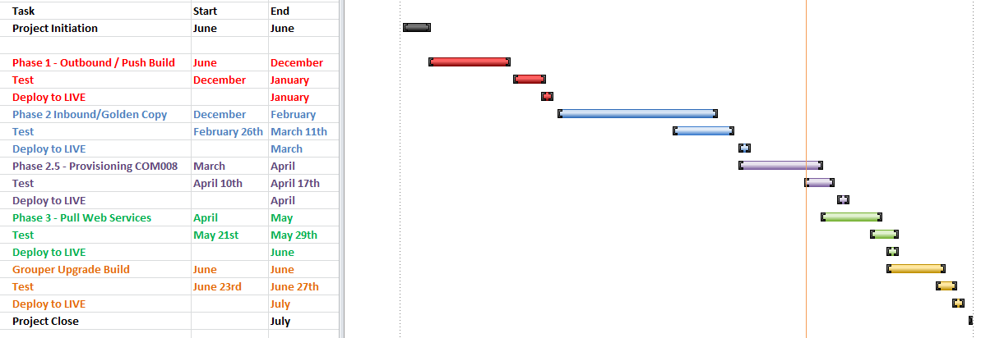

Detailed Milestones – Link to Milestones – to update

Project Schedule.
The project milestones are running late. The build for Phase 1 – add detail - took longer than expected which meant the build was not completed in time before the main developer had their 3.5 week annual vacation. Some peer testing was completed during this vacation time but it will affect the project schedule. Additional delay has also been incurred in building the new environment for the new UI and this is now reflected in the plan above.

The addition of Phase 2.5 will also affect the project schedule by moving following phases out by the duration of the main development work, circa 25 days.

Achievements to Date.
- High Level Design Produced for all Phases 1 through 4 produced and circulated and signed off.
- Business Requirements Documents (BRD) for Phases 1, 2 and 3 written and circulated.
- BRD for Phase 1 signed off.
- Phase 4 Grouper Version Evaluation and recommendation completed
- Detailed Development Design for Phase 1 circulated and reviewed.
- Development build design work started.
- Complete sign off of detailed Phase 1 Design.
- Sign Off BRD for Phase 2
- Complete build of Phase 1 deliverables

Next Steps.

- Test Phase 1 Deliverables
- Deploy Phase 1 Deliverables
- Complete Detailed Phase 2 Design.
- Sign Off BRD for Phase 3
- Complete build of Phase 2 deliverables.

IS Apps Staff Resource
Summary (to 29-11-2013)
158 days effort delivered by IS Apps to Date .Total Budget for Project 361 days. (This includes the transfer of days from COM008)
At this point in the project we are currently circa 30 days over, attributable to 10 days training, additional efforts in completing development on Phase1, environmental builds and troubleshooting development server problems for the new VM and completing the BRD for Phase 2.
Days have been applied across all four phases of the project with effort on the analysis and specification work.
Development work is progressing on Phase 1 where the dates for moving to TEST and LIVE are known.
Additional environmental build and load testing work has been re-estimated on the basis of detailed design being available and this has resulted in a potential additional 72 days to be added to the budget at worst case. Re-estimating will take place over the next few weeks at the build review for Phase 1. Estimates are expected to come down but exact figures will not be available until then.

Risks.
Commentary
Some risks have been closed. The ITS095 project risk is now closed as the new environments have been created and DR tested

Title | Impact | Probability | Status | Risk Owner
Availability of DEV Tech staff to Contribute to the project | High | Medium | Open | Iain Fiddes | AMBER
Availability of Development team staff to Contribute to the project | High | Low | Open | Richard Good | AMBER
Grouper Version currently unsupported by development Community | Medium | Medium | Open | Chris McKay | AMBER
Service Management Availability | High | Medium | Open | Chris McKay | AMBER
Budget Review | High | Medium | Open | Stephen Conlon | AMBER
Developing on New Technology | High | Medium | Open | Stephen Conlon | AMBER
Business Area Availability and System Usage Cycles | Medium | High | Open | Stephen Conlon | GREEN
Impact of project WEB004 - WIKI Upgrade | Medium | Low | Closed | Adam Wadee | GREEN
Impact of project COM008 - Migrate staff email users to Office 365. | Medium | High | Closed | Adam Wadee | GREEN
SOA upgrade project does not complete | High | Low | Closed | Stephen Conlon | AMBER

Notes and Guidance:
Probability - we use the categories LOW, MEDIUM, HIGH and CRITICAL. This assessment is based on the collective judgement of the Project Manager and Risk Owner and is informed by risk assessment on other similar projects. There is no corresponding % based probability.
Probability Category | Numeric Score
LOW | 1
MEDIUM | 2
HIGH | 3
CRITICAL | 4
For probability we will also often consider when the risk might occur as some risks may be predicted to be further away in time than others. For example in a procurement project there may be a risk that more suppliers will bid than has been planned for resulting in additional work and cost for the project. This risk will only occur or not when the bids are in - depending on the stage of the project this may be soon or some time away. This is sometimes called the risk proximity. Proximity can be used to ensure that attention is focused on the most immediate risks
Impact - is the effect or result of the risk actually happening and takes into account the effects on: time/schedule, cost, quality, scope, benefits and people. For impact we use the categories LOW, MEDIUM, HIGH and CRITICAL. This assessment is based on the collective judgement of the Project Manager and Risk Owner and is informed by risk assessment on other similar projects. There is no corresponding cash value or other measurement of impact.
Impact Category | Numeric Score
LOW | 1
MEDIUM | 2
HIGH | 3
CRITICAL | 4
Risk Response/Mitigation - suitable responses are aimed at reducing the impact, probability or both. Typical responses break into broadly four types:
- Remove/Prevent/Avoid - terminate the risk by putting in place counter measures which stop the risk from occurring or prevent it from having any impact e.g. by doing thing differently, using different resources etc.
- Reduce - take action to control the risk by reducing the likelihood or limiting the impact to acceptable levels
- Transfer - transfer the risk to a third party e.g. via a specialist insurance arrangement with a third party. This response is relatively rare in practice.
- Retain/Accept/Monitor - tolerate the risk, e.g. because nothing cost effective can be done to mitigate, or the probability and impact are already at an acceptable level
Risk Profile RAG Status | Recommended Minimum Actions
GREEN | Project Manager and risk owner continue to monitor
AMBER | Project Manager and risk owner to review and escalate if required
RED | Project Manager and risk owner to review, recommend further mitigation actions and escalate to Project Sponsor and Project Board for further review and approval

