Stage: Business Analysis

Business Requirements Document

Student Marketing Services Infrastructure Migration

UG Degree finder and Admin Enhancements

[PROGRAMME NAME]

SSG003

[ANNUAL PLAN NUMBER]

Document Version: 0.4

Date: 21/03/13
Contents
Student Marketing Services Infrastructure Migration 1
1 Document Management 4
1.1 Contributors 4
1.2 Version Control 4
2 OVERVIEW 5
2.1 Project Description 5
2.2 SSG003 Objectives 5
2.3 Business Dependencies and Constraints 5
2.4 Legislative Impact 6
3 CURRENT PROCESSES 7
4 PROPOSED PROCESSES 10
5 BUSINESS REQUIREMENTS 11
5.1 Functional Requirements 11
1. Undergraduate Admin system 11
2. College record new fields 11
3. Subject record new fields 11
4. Programme record new fields 13
5. Degree finder Introduction interface – Search options 15
6. Degree finder Search Results – Search box 18
7. Degree finder Search Results - Meta Subjects 19
8. Degree finder Search Results – A-Z All Programmes 20
9. Degree finder Search Results - A-Z Programmes with Study Abroad 21
10. Degree finder Search Results - Browse by School 23
11. Subject interface 24
12. Subject Calls to Action 27
13. Degree Programme Interface 29
14. Programme Calls to Action 39
15. Bulk Editing Programmes 41
16. Database Instances 42
5 Non-Functional Requirements 42
6 PROPOSED PROCESSES 44
6.1 Business Process Description 44
6.2 Business Process Maps 44
6.3 Proposed System Context Diagram 44
7 DATA REQUIREMENTS 44
8 USER ACCEPTANCE TESTING 45
8.1 Acceptance Test Strategy 45
8.2 Test Scenarios and Acceptance Criteria - High Level 45
1. Undergraduate Admin system 45
2. College record new fields 45
3. Subject record new fields 46
4. Programme record new fields 47
5. Degree finder Introduction Interface – Search options 49
6. Degree finder Search Results – Search box 53
7. Degree finder Search Results - Meta Subjects 56
8. Degree finder Search Results – A-Z All Programmes 57
9. Degree finder Search Results - A-Z Programmes with Study Abroad 59
10. Degree finder Search Results - Browse by School 61
11. Subject interface 63
12. Subject Calls to Action 69
13. Degree Programme Interface 73
14. Programme Calls to Action 91
15. Bulk Editing Programmes 95
16. Bulk Publishing 98
17. Database Instances 99
9 TRAINING 99
10 Document Sign Off 99
11 Appendix A: CAM UG Brief – proposed processes 100
18. Search results interface 104
19. Meta subject interface 106
20. Subject interface 107

Document Management

Contributors

Role | Unit | Name
Business Analyst (Owner) | IS Project Services | Sue Woodger
Project Manager | IS Project Services | Maurice Franceschi
Business Area Manager | CAM | Ailsa Vamplew
Systems Analyst Designer | Development Technology team | Neil Grant
Systems Analyst Designer | Development team | Mike McMonagle
Applications Management | Applications Management | Andrew Hobden

Version Control

Date | Version | Author | Section | Amendment
28/01/13 | 0.1 | SW |  | First draft
14/02/13 | 0.2 | SW | ALL | Ailsa’s comments on first draft
21/02/13 | 0.2 | SW | 3.6 | Update from Ailsa on parent subject
15/03/13 | 0.3 | SW | All | Review of v0.2 with Ailsa
21/03/13 | 0.4 | SW | 4.1.9, 4.1.10, 4.1.13, 5, 5.1, 6.1, 7, 7.1, 8.1, 9.1, 10.1, 11.1, 13.1, 13.4 – 13.4.1-3, 13.4.7.4, 13.5.8.2, 13.7.1.1, 13.7.2.3, 13.7.2.4, 17.1 | Update from signoff meeting 18/03/013
25/03/13 | 0.4 | SW | 3.1.2.1, 4.1.4.1, 4.1.13, 11.1, 12.5.2 | Some updates missing and 4.1.13 removed

OVERVIEW

This project delivers a number of essential enhancements to the applications used for the publishing of the Degree finder in the UG prospectus.

The enhancements to UG will only take place once the UG Degree finder output code has been ported over to the new infrastructure and an admin system has been built for prospectus data and both developments have been signed-off.

This BRD covers enhancements to both the Degree finder code and the UG admin system

Project Description

Undergraduate Enhancements
The enhancements will cover:
- Introducing alternate designs to reduce interface length by grouping content into tabs and panels
- Improving the existing search to return better and more focused results
- Enhancing subject data – adding new fields
- Enhancing programme interface data – adding new fields and pulling information from parent subject and school
- Enhancing content – highlighting calls to action, adding functionality, increasing cross-promotion, adding related links to wider prospectus content
- Consolidating the navigation path into three levels (should take user to the appropriate interface):
1. Degree finder introduction
2. Subject
3. Degree programme
- Display of content is conditional on data

Plus carried over from Port
- Bulk edit function
- Adding new fields to database if cannot be done in Port
- Giving CAM ability to edit two databases at one time for part of the year

SSG003 Objectives
- Development of UG and PG systems and databases to improve information provision for potential students

Business Dependencies and Constraints
If any of the following break, the UG prospectus interfaces will not display properly:

- Euclid (Feeds)
- Proxy in
- Fees (Fees information about selected programmes)
- DPS (Degree programme specification)
- KIS widget (Key Information Set)
- Ease (cannot update interfaces without Ease authentication)
- Polopoly (required to display prospectus web interfaces)
- Server based permissions (cannot access file server space if broken)

Legislative Impact

Freedom of Information

- Need to keep previous iterations. University’s data retention policy dictates that prospectus information should be kept for 7 years. Request can be made through support call for previous years and through the system going forward.

Data Protection
- The admin system does not store personal info – just staff details.
- There are no cookies issues.

CURRENT PROCESSES
These screenshots capture the current method of searching for a degree. They are included as an example of how the Degree finder currently performs and as a benchmark to measure improvement.

Degree finder Introduction Interface
Search on all subjects:
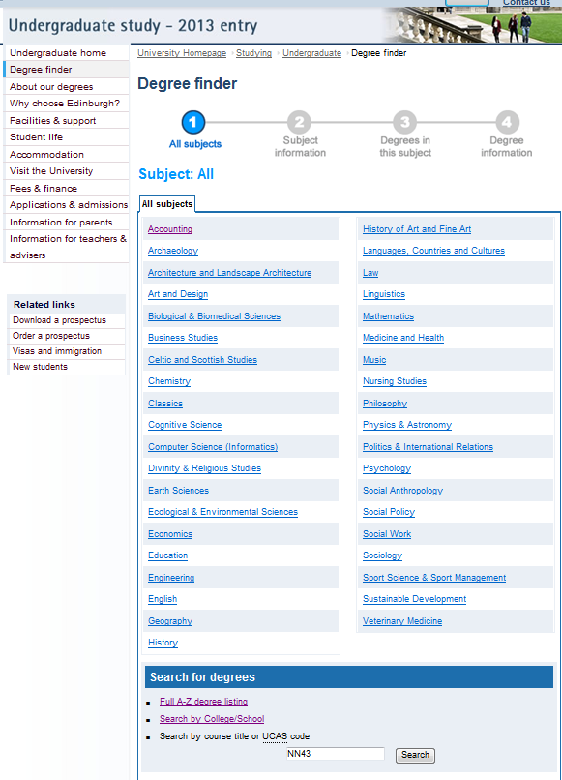
Or by filtered searches:
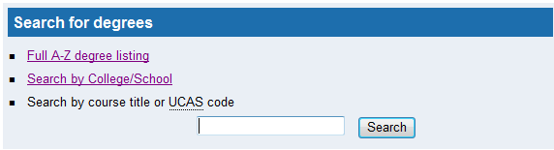

Selecting Full A-Z degree listing
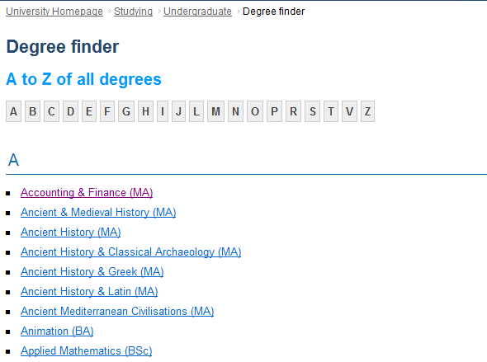

Selecting Search by College/School

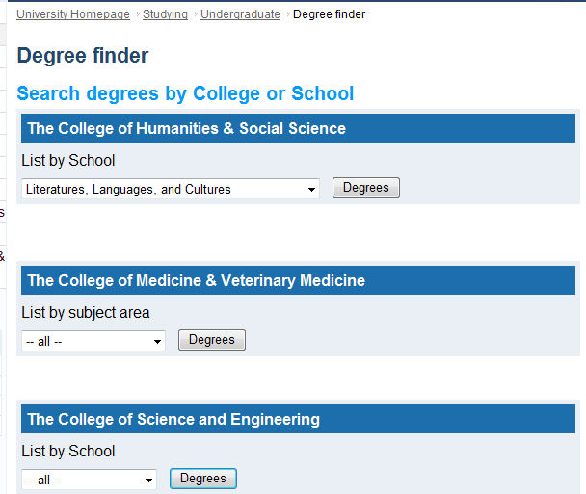

Selecting Search by Course title or UCAS Code. Entering Accounting in the text box brings up list of degree with Accounting on title
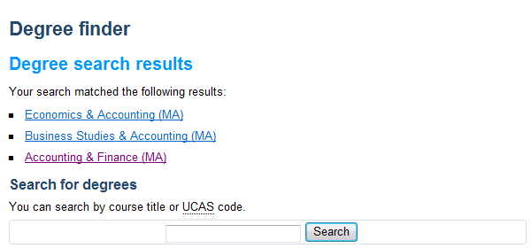

Selecting Search by Course title or UCAS Code. Entering a UCAS code (e.g. NN43) in the text box brings up the degree link the code refers to


PROPOSED PROCESSES

n/a

BUSINESS REQUIREMENTS

Functional Requirements
Specify the category for each requirement, using the following abbreviations:
M = mandatory; HD = highly desirable; D = desirable

Note: Any term like {name} is the field in the database that the data should be pulled form

Undergraduate Admin system

ID | Requirement | Category | Resp for testing
1.1 | Access to the system will be EASE authenticated | M | AV

College record new fields

ID | Requirement | Category | Resp for testing
2.1 | New fields require to be added to the Colleges table in the database. All fields are free text except where highlighted.  Note that in the free text fields CAM will be able to use their current markup. | M | AV
2.1.1 | - English language requirements to display on output | M | AV

Subject record new fields

ID | Requirement | Category | Resp for testing
3.1 | New fields require to be added to the Subjects table in the database. Some fields were added to the Admin but now need to be added to the output  All fields are free text except where highlighted.  Note that in the free text fields CAM will be able to use their current markup. | M | AV
3.1.1 | - Admissions field to display on output: feeds to the output for each programme within the parent subject  Note:  See req 13.7: Pulls information from {admissions} from parent subject  Field added in UG Admin brd but not output. | M | AV
3.1.2 | - Keywords: a list of comma separated keywords for the subject. Requires to be linked to the programmes in the front end | M | AV
3.1.2.1 | - CAM need the ability in the admin to add keywords to a subject | M | AV
3.1.3 | - Meta description to display on output: contains the meta description for the subject.  Note:  Field added in UG Admin brd but not output. | M | AV
3.1.4 | - English Language requirement to display on output:  Note:  Field added in UG Admin brd but not output. | M | AV
3.1.5 | - Info sheet : this field will contain a link to a PDF file in the Polopoly media bank. Requires text and links to be added to the front end. Needs to be able to support multiple entries.  Note:  Field added in UG Admin brd but not output.  Was called Subject Info sheet in Admin BRD – CAM happy for it to be called Info Sheet  Media Bank  The media bank is the standard repository within the Polopoly CMS for storing documents and images that are published through the CMS. It's accessible through the 'Common' directory in the Polopoly content tree. CAM store and serve PDF's from here. However, all they need to do is enter a URL in the field for info sheet such as http://www.ed.ac.uk/polopoly_fs/1.44121!/fileManager/Accounting.pdf which identifies the file in the media bank. | M | AV
3.1.6 | - Parent Subject: CAM will be able to choose from a dropdown list of all meta subjects  Note:  Field added in UG Admin brd but requires to be a dropdown list  Was called meta (parent subject in port brd but confirmed by CAM that it should just be called parent subject | M | AV
3.1.6.1 | Subjects can have more than one parent subject  Note:  In the UG Admin BRD (Reference 4.3.1.4 in UG Amin brd) it was thought that each subject will only have one parent subject. However it has since been discovered that some subjects require more than one parent subject so the requirement should be updated | M | AV
3.1.7 | - Abroad detail to display on output  Note:  Field added in UG Admin brd but not output. | M | AV

Programme record new fields

ID | Requirement | Category | Resp for testing
4.1 | New fields require to be added to the Programmes table in the database. All fields are free text except where highlighted.  Note that in the free text fields CAM will be able to use their current markup. | M | AV
4.1.1 | - Accreditation to display on output  If content is present will appear on programme interface output  Note:  Field added in UG Admin brd but not output. | M | AV
4.1.2 | - Placements to display on output  If content is present will appear on programme interface output  Note:  Field added in UG Admin brd but not output. | M | AV
4.1.3 | - Protecting Vulnerable Groups: should be a Y/N field to display on output  If set to ‘Y’ for a programme record, default text to appear on programme interface output.  The default text should read: All successful applicants will be required to complete a Protecting Vulnerable Groups (PVG) criminal record check before starting the programme. In addition, all applicants who don’t live in the UK, or who have spent more than a year abroad, will need to provide equivalent verification from the relevant national authority.  Note:  Field added in UG Admin brd but not output. | M | AV
4.1.4 | - Keywords : a list of comma separated keywords for the programme to display on output | M | AV
4.1.4.1 | - CAM need the ability in the admin to add keywords to a programme | M | AV
4.1.5 | - English Language requirements to display on output  Note:  Field added in UG Admin brd but not output. | M | AV
4.1.6 | - Duration to display on output  Note:  Field added in UG Admin brd but not output. | M | AV
4.1.7 | - Study abroad: should be Y/N to display on output  Note:  Field added in UG Admin brd but not output. | M | AV
4.1.8 | - Abroad detail to display on output  Note:  Field added in UG Admin brd but not output. | M | AV
4.1.9 | - Applications: Other application to display on output  Note:  Field added in UG Admin brd but not output. | M | AV
4.1.10 | - Other Entry Requirements to display on output  Note:  Field added in UG Admin brd but not output. | M | AV
4.1.11 | - Related subject  Was an HD in port. May have been added already?  Note:  This field is already in database - but now functioning differently, i.e. in different table, so needs specified as a new field for programmes  Note:  Also currently this is not a tickbox field - the data is held in the related subjects table, which has to be manually updated to link ids for subject s and programmes - CAM but would like to be able to admin it from the programme | M | AV
4.1.12 | - IFP (International Foundation Programme) – should be a Yes/No field  Note:  New field. Not in UG Admin BRD as was expected to be included in Euclid feed – Euclid confirmed that the field will not be included in the feed | M | AV

Degree finder Introduction interface – Search options
Improved search and browse functionality is to be added to the Degree finder introduction interface. Degree finder current interface is at http://www.ed.ac.uk/studying/undergraduate/degrees

The page headings for all sections going forward are set by Polopoly and are outside the proxied content.

ID | Requirement | Category | Resp for testing
5.1 | Tab Heading: Degree finder  Page Heading H1: Degree finder  Note:  A mockup of this interface can be found in CAM Enhancements brief (see Appendix A) | M | AV
5.2 | The search tool should index:  Note:  CAM said that the search tool could be developed from the existing search which only indexes the title and UCAS code for programme
5.2.1 | - Subject | M | AV
5.2.1.1 | - By Keywords | M | AV
5.2.1.2 | - By Subject | M | AV
5.2.2 | - Programmes | M | AV
5.2.2.1 | - By Keywords | M | AV
5.2.2.2 | - By Title | M | AV
5.2.2.3 | - By UCAS Code | M | AV
5.3 | The layout on the Degree finder introduction interface should be redeveloped to include 4 sections:  - General search  - Browse by Subjects  - Browse by A-Z  - Browse by School | M | AV
5.4 | Heading H2: Search  This will be a general search section | M | AV
5.4.1 | - Introduction  Text will read: You can search by UCAS code, programme name, subject or keywords. | M | AV
5.4.2 | - Search box  Note:  Search box is a free text search which will index for subject – keywords and subject and for programme - keywords, title and UCAS code. | M | AV
5.4.2.1 | - If search term is not found then user should still be taken to Search result interface (Heading: No results found) with the following error message:  “Sorry, we couldn't find any results for that search term.  We suggest you try a different search term, or try browsing by subject or school.” | M | AV
5.4.3 | - Search option | M | AV
5.4.3.1 | - Choosing the search option should return search results interface (See section 7) | M | AV
5.5 | Heading H2: Browse by Subjects  This section will let user browse by subject | M | AV
5.5.1 | - Introduction  Text will read: Please choose your area of interest. | M | AV
5.5.2 | - A list of all subjects should be displayed. Each subject should be a link. This list will be a mixture of meta subjects and non-meta subjects. | M | AV
5.5.2.1 | - If a meta subject is selected the link will return a meta subject interface  e.g. Languages, Countries and Cultures’ is a meta subject which contains French, German, Arabic etc.) (see section 7) | M | AV
5.5.2.2 | - If a non-meta subjects is selected the link return the Subject interface (see section 11) | M | AV
5.6 | Heading H2: Browse by A-Z  This section will let user browse by A-Z | M | AV
5.6.1 | - There will be two links under the A-Z heading | M | AV
5.6.1.1 | - All programmes which will return the full A-Z search results interface (see section 8) | M | AV
5.6.1.2 | - Programmes with Study Abroad which will return the A-Z of programmes for study abroad interface (see section 9) | M | AV
5.6.1.2.1 | - Will return subjects with the new Study_abroad field set to Yes | M | AV
5.7 | Heading H2: Browse by School  This section will let user browse by school | M | AV
5.7.1 | - Introduction  Text will read: Find programmes in a College or School | M | AV
5.7.2 | - Display will be similar to existing functionality i.e. 3 sections, one for each parent college with user able to select from a selection of schools/subjects | M | AV
5.7.3 | - For the College of Humanities and Social Science and College of Science and Engineering the user will be able to choose from a selection of the schools within that college  Note:  - If a dropdown list is developed then there should be a default display of ‘All Schools’ | M | AV
5.7.3.1 | - Each school has a parent College set in the school table | M | AV
5.7.3.2 | - A Go option will be available for each college and this will take the user to School search results (see section 10) | M | AV
5.7.4 | - For the College of Medicine and Veterinary Medicine the user will be able to choose from the subjects within that college  Note:  - If a dropdown list is developed then there should be a default display of ‘All Subjects’ | M | AV
5.7.4.1 | - Each subject has a parent College set in the subject table | M | AV
5.7.4.2 | - A Go option will be available for the college and this will take the user to Subject search results (see sections 7 & 11) | M | AV

Degree finder Search Results – Search box
Search results will be displayed as follows. The search results should appear within the existing Degree finder introduction interface. This interface is displayed when the General Search box is used on the Degree finder interface (See Search - Section 5.4). CAM mockup of screen can be found in Appendix A - CAM UG Brief – proposed processes.

ID | Requirement | Category | Resp for testing
6.1 | Tab Heading: Degree finder  Page Heading H1: Degree finder  Note:  This is the Degree finder Search results 1 (for search box)  There will be 3 sections in this results interface | M | AV
61.1 | - Each section should be visually split from the section above or below | M | AV
6.2 | Heading H2: Search | M | AV
6.2.1 | - Search box will retain the search term used in the general search on the Degree finder introduction interface (see section 5.4) or from any general search interface  Note:  Search not always from introduction page | M | AV
6.2.2 | - The search option will still be available as users should be able to search again in the search box. Further searches will refresh the current interface. | M | AV
6.2.2.1 | - If term entered cannot be found then error message is returned. See section 5.4.2.1 for details | M | AV
6.2.3 | - There will be a link to return to browse by subject or school. This will take the user back to the Degree finder introduction interface | M | AV
6.3 | Heading H2: Search results | M | AV
6.3.1 | - Heading H3: Subjects | M | AV
6.3.2 | - Can return multiple results for term used in search box | M | AV
6.3.3 | - Will show for each result:
6.3.3.1 | - Subject title {Subject} | M | AV
6.3.3.2 | - Subject Image plus alt tag of subject {subject} | M | AV
6.3.3.3 | - Pulls information from {Meta description} | M | AV
6.3.3.4 | - Links to the Subject interface (see section 11) | M | AV
6.3.4 | - Heading H3: Programmes | M | AV
6.3.4.1 | - Will return multiple results of programmes for term used in search box | M | AV
6.3.4.2 | - Programmes returned should be listed as follows  - For each programme, display on one line as one link:  {title}({award}){UCAS code}  e.g. Chemical Engineering (BEng) H800 | M | AV
6.3.4.2.1 | - If the UCAS code is longer than 4 characters then do not display the UCAS code | M | AV
6.3.4.3 | - The programme will link to the relevant programme interface (see section 13) | M | AV

Degree finder Search Results – Parent Subjects
The Degree finder introduction interface (See Search - Section 5.5) lists both meta and non-meta subjects in the Subjects search section. This interface is arrived at by selecting a meta subject in the Subjects search section. Search results should appear within the existing Degree finder interface. CAM mockup of screen can be found in Appendix A - CAM UG Brief – proposed processes

ID | Requirement | Category | Resp for testing
7.1 | Tab Heading: Degree finder  Page Heading H1: Degree finder  Note:  This is the Degree finder Search results 2 (for meta subjects)  There will be 2 sections in this results interface | M | AV
71.1 | - Each section should be visually split from the section above or below | M | AV
7.2 | Heading H2: (subject} e.g. Languages, Countries and Cultures | M | AV
7.2.1 | - Introduction  Text will read: Please choose a more specific subject area. | M | AV
7.2.2 | - Will display a list of subjects (i.e. those with an entry in the {parent subject} field ) for that meta subject | M | AV
7.2.3 | - Each result will link to the relevant Subject interface | M | AV
7.3 | Heading H2: Didn’t find what you were looking for? | M | AV
7.3.1 | - Text will read Try searching our degrees or browsing by school | M | AV
7.3.2 | - A search box and Search option are available | M | AV
7.3.2.1 | - The results of this search are the same as the Search box on the Degree finder Introduction interface i.e. takes you to Degree finder Search Results – Search box (section 6) | M | AV
7.3.3 | - A link to return to browse by School (Degree Search by School) on the Degree finder introduction interface is also available | M | AV

Degree finder Search Results – A-Z All Programmes
Search results will be displayed as follows. Search results should appear within the existing Degree finder interface. This interface is displayed when the ‘A-Z All Programmes’ link is used on the ‘Degree finder introduction’ interface (See Search - Section 5.6). CAM mockup of screen can be found in Appendix A - CAM UG Brief – proposed processes. The A-Z should work in a similar way to: http://www.ed.ac.uk/schools-departments/atoz

ID | Requirement | Category | Resp for testing
8.1 | Tab Heading: Degree finder  Page Heading H1: Degree finder  Note:  This is the Degree finder Search results 3 (for all A-Z) | M | AV
8.1.1 | - Each section should be visually split from the section above or below | M | AV
8.2 | Heading H2: A-Z of all degree programmes | M | AV
8.2.1 | - Introduction  Text will read: All of our degree programmes, listed by A-Z. | M | AV
8.2.2 | - This section will consist of anchor links of letters which will link to letter sub-sections in the second section | M | AV
8.2.3 | - The anchor links will be grouped in alphabetical order | M | AV
8.3 | Heading H3: The next section is split into letter sub-sections with the heading the letter for that area  Note:  This is what the anchor link will link to | M | AV
8.3.1 | - Under each letter heading a list of programmes that start with that letter will be displayed | M | AV
8.3.1.1 | - For each programme, display on one line:  {title}({award}){UCAS code}  e.g. Chemical Engineering (BEng) H800 | M | AV
8.3.1.2 | - The programme will link to the relevant programme interface | M | AV
8.3.1.3 | - If the UCAS code is longer than 4 characters then do not display the UCAS code | M | AV
8.3.2 | - Only display letter section if there is content within that letter i.e. if no content no letter heading or list of programmes will appear – will move on to next letter with content | M | AV
8.3.3 | - Include ‘Back to top’ links at the end of every letter sub-section | M | AV
8.4 | Heading H2: Didn’t find what you were looking for? | M | AV
8.4.1 | - Text will read Try searching our degrees or browsing by subject or school | M | AV
8.4.2 | - A search box and Search option are available | M | AV
8.4.3 | - A link to return to browse by subject or school on the ‘Degree finder introduction’ interface is also available | M | AV

Degree finder Search Results - A-Z Programmes with Study Abroad
Search results will be displayed as follows. Search results should appear within the existing Degree finder interface. This interface is displayed when the A-Z Programmes with Study Abroad link is used on the Degree finder introduction interface (See Search - Section 5.6). It is similar to A-Z All Programmes except that results are filtered for programmes that are flagged as being Study abroad programmes. CAM mockup of screen can be found in Appendix A - CAM UG Brief – proposed processes

ID | Requirement | Category | Resp for testing
9.1 | Tab Heading: Degree finder  Page Heading H1: Degree finder  Note:  This is the Degree finder Search results 4 (for A-Z with study abroad)  There will be 3 main sections in this results interface | M | AV
9.1.1 | - Each section should be visually split from the section above or below | M | AV
9.2 | Heading H2: A-Z of all degree programmes with study abroad | M | AV
9.2.1 | - Introduction  Text will read: Opportunities to study abroad are available for these degree programmes | M | AV
9.2.2 | - This section will consist of anchor links of letters which will link to letter sub-sections in the second section | M | AV
9.2.3 | - The anchor links will be grouped in alphabetical order | M | AV
9.3 | Heading H3: The next section is split into letter sub-sections with the heading the letter for that area  Note:  This is what the anchor link will link to | M | AV
9.3.1 | Under each letter heading a list of programmes that start with that letter will be displayed | M | AV
9.3.1.1 | - Will show a filter of only programmes with {study abroad} field set to yes | M | AV
9.3.1.2 | - For each programme, display on one line:  {title}({award}) UCAS code  e.g. Chemical Engineering (BEng) H800 | M | AV
9.3.1.3 | - The programme will link to the relevant programme interface | M | AV
9.3.1.4 | - If the UCAS code is longer than 4 characters then do not display the UCAS code | M | AV
9.3.2 | - Only display letter section if there is content within that letter i.e. if no content no letter heading or list of programmes will appear – will move on to next letter with content | M | AV
9.3.3 | - Include ‘Back to top’ links at the end of every letter sub-section | M | AV
9.4 | Heading H2: Didn’t find what you were looking for? | M | AV
9.4.1 | - Text will read Try searching our degrees or browsing by subject or school | M | AV
9.4.2 | - A search box and Search option are available | M | AV
9.4.3 | - A link to return to browse by subject or school on the ‘Degree finder introduction’ interface is also available | M | AV

Degree finder Search Results - Browse by School
Search results will be displayed as follows. Search results should appear within the existing Degree finder interface. This interface is displayed when School search is used on the Degree finder introduction interface (See Search - Section 5.7).

ID | Requirement | Category | Resp for testing
10.1 | Tab Heading: Degree finder  Page Heading H1: Degree finder  Note:  This is the Degree finder Search results 5 (for browse by school)  There will be 3 main sections in this results interface | M | AV
10.1.1 | - Each section should be visually split from the section above or below | M | AV
10.2 | Heading H2: {School} programmes | M | AV
10.2.1 | - Introduction  Text will read: Degree programmes in {School} | M | AV
10.2.1.1 | - This section will consist of anchor links of letters which will link to letter sub-sections in the second section | M | AV
10.2.1.2 | - The anchor links will be grouped in alphabetical order | M | AV
10.2.2 | - Heading H3: The next section is split into letter sub-sections with the heading the letter for that area  Note:  This is what the anchor link will link to | M | AV
10.2.2.1 | - Under each letter heading a list of programmes that start with that letter will be displayed | M | AV
10.2.2.2 | - For each programme, display on one line:  {title}({award}){UCAS code}  e.g. Chemical Engineering (BEng) H800 | M | AV
10.2.2.3 | - The programme will link to the relevant programme interface | M | AV
10.2.2.4 | - If the UCAS code is longer than 4 characters then do not display the UCAS code | M | AV
10.2.3 | - Only display letter section if there is content within that letter i.e. if no content no letter heading or list of programmes will appear – will move on to next letter with content | M | AV
10.2.4 | - Include ‘Back to top’ links at the end of every letter sub-section | M | AV
10.3 | Heading H2: Didn’t find what you were looking for? | M | AV
10.3.1 | - Text will read Try searching our degrees or browsing by subject | M | AV
10.3.2 | - A search box and Search option are available | M | AV
10.3.3 | - A link to return to browse by subject on the ‘Degree finder introduction’ interface is also available | M | AV

Subject interface
CAM would like search results for subjects to finally arrive in the interface entitled Subject (is called Subject Information in existing system). The subject interface should appear in a new tab. The Subject interface is arrived at by selecting a subject in Degree finder Introduction interface (see section 5.5). If a non-meta subject the user is brought directly to the following Subject interface or if a meta subject via the meta subject search results (see section7) and then into the Subject interface. CAM mockup of screen can be found in Appendix A - CAM UG Brief – proposed processes

ID | Requirement | Category | Resp for testing
11.1 | Tab Heading: Subject  Page Heading H1: Degree finder | M | AV
11.1.1 | Heading H2: {Subject} | M | AV
11.2 | A redesign of the Subject interface is required to reduce interface length by grouping content. Also integrating the programme list which is currently in a new tab. The Subject interface should be grouped with the following headings:  - Tab 1: Why study {subject}?  - Tab 2: Overview  - Tab 3: What you will study  - Tab 4: Where will I be taught?  - Tab 5: Careers  - Tab 6: Degrees in this subject  Note:  CAM have suggested tabs but are requesting technical advice on how grouped content can be achieved. Meantime the term ‘tab’ is used in this section to describe grouped content | M | AV
11.3 | Display of content is conditional on data, i.e.  - if no content in any of the fields for a tab, the tab should not display  - if no content in a particular field, the field content and the heading and copy for that field should not display | M | AV
11.4 | Tab 1: Why study {Subject}? | M | AV
11.4.1 | - Heading H3: Why choose {Subject} at the University of Edinburgh? | M | AV
11.4.2 | - There will be 9 bullet points taking information from the following fields:  - {Why1}  - {Why2}  - {Why3}  - {Why4}  - {Why5}  - {Why6}  - {Quote text}  - {Quote name}  - {Quote title} | M | AV
11.5 | Tab 2: Overview | M | AV
11.5.1 | - Heading H3: Overview | M | AV
11.5.2 | - There will be 2 sub-sections under the interface heading taking information from the following fields:  - Level 4 Heading: {Introduction}  - Level 4 Heading: {Exception} | M | AV
11.6 | Tab 3: What you will study | M | AV
11.6.1 | Heading H3: What you will study
11.6.2 | - There will be 8 sections each with own heading followed by the contents of the field the information is taken from: | M | AV
11.6.2.1 | - Heading H4: Year 1  - {Year1} | M | AV
11.6.2.2 | - Heading H4: Year 2  - {Year2} | M | AV
11.6.2.3 | - Heading H4: Year 3  - {Year3} | M | AV
11.6.2.4 | - Heading H4: Year 4  - {Year4} | M | AV
11.6.2.5 | - Heading H4: Year 5  - {Year5} | M | AV
11.6.2.6 | - Heading H4: How will I be taught?  - {Learning} | M | AV
11.6.2.7 | - Heading H4: How will I be assessed?  - {Assessment} | M | AV
11.6.2.8 | - Heading H4: Placements  - {Placements} | M | AV
11.7 | Tab 4: Where will I be taught? | M | AV
11.7.1 | - Heading H3: Where will I be taught? | M | AV
11.7.2 | - There will be 2 sections each with own heading followed by the contents of the field the information is taken from: | M | AV
11.7.2.1 | - Heading H4: Our facilities  - {Facilities} | M | AV
11.7.2.2 | - Heading H4: Study abroad  - {study_abroad} | M | AV
11.7.2.2.1 | - If study_abroad set to ‘Y’ then output as default “Opportunities to study abroad are available in this subject area.” | M | AV
11.7.2.2.2 | - Unless there is content in {abroad detail}, in which case output content from the {abroad detail} field. | M | AV
11.8 | Tab5: Careers | M | AV
11.8.1 | - Heading H3: Career opportunities | M | AV
11.8.1.1 | - There will be 1 area under the level 3 heading taking information from the following field:  - {Careers} | M | AV
11.9 | Tab 6: Degrees | M | AV
11.9.1 | - Heading H3: Degrees in this subject | M | AV
11.9.2 | - There will be 2 sections in this interface each with own heading | M | AV
11.9.3 | - Heading H4: Degrees in this subject | M | AV
11.9.3.1 | - This section will list programmes for this subject, for all programmes which have the subject set as ‘parent subject’ | M | AV
11.9.3.2 | - For each programme display the programme description on one line i.e.  {title}({award}){UCAS code}  (e.g. Chemical Engineering (BEng)  Each programme will link to the relevant programme interface | M | AV
11.9.3.3 | - If the UCAS code is longer than 4 characters then do not display the UCAS code | M | AV
11.9.3.4 | - The programme will link to the relevant programme interface (see section 13) | M | AV
11.9.4 | - Heading H4: You may also be interested in: | M | AV
11.9.4.1 | - This section will list all programmes for this subject, for programmes listed as related to the subject in the course subjects table | M | AV
11.9.4.2 | - For each programme display the programme description on one line i.e.  {title}({award}){UCAS code}  (e.g. Chemical Engineering (BEng)  Each programme will link to the relevant programme interface | M | AV
11.9.4.3 | - If the UCAS code is longer than 4 characters then do not display the UCAS code or parenthesis | M | AV
11.9.4.4 | - The programme will link to the relevant programme interface (see section 13) | M | AV

Subject Calls to Action
Calls to action is a new section within the Subject interface that will appear in each ‘tab’. It promotes standard functionality and links for the Subjects. CAM mockup of screen can be found in Appendix A - CAM UG Brief – proposed processes

CAM have dropped Facebook and Twitter from this section.

ID | Requirement | Category | Resp for testing
12.1 | Subject interface ‘Calls to Action’ should be presented on new right hand area of the Subject interface – on every tab (i.e. Why choose? Overview, What you will study, Where taught?, Careers, Degrees).  There will be a set of functions followed by 6 ‘Call’ boxes | M | AV
12.2 | Functions  This will be a row of functionality icons | M | AV
12.2.1 | - Print icon | M | AV
12.2.1.1 | - Will have the ability to print the Subject content  Note:  This should print the whole Subject content not just the current interface | M | AV
12.2.1.2 | - Alt text on print icon: Print this subject | M | AV
12.2.2 | - Email icon | M | AV
12.2.2.1 | - Will have the ability to email subject interface to a friend – should use short URL. | M | AV
12.2.2.2 | - Alt text on email icon: Email this subject | M | AV
12.3 | Image Box – no heading | M | AV
12.3.1 | - Subject image will display here  Note:  Images stored on the server (as in UG Admin brd) | M | AV
12.3.2 | - Alt tag of image should be subject name {subject} | M | AV
12.4 | Contact box Heading H3: Contact | M | AV
12.4.1 | - Pulls information from {Contact title} | M | AV
12.4.2 | - Label: Email: Pulls information from {email} | M | AV
12.4.3 | - Label: Phone: Pulls information from {phone} | M | AV
12.4.4 | - Label: Web: {web} – this will link to parent school website | M | AV
12.4.5 | - Link text: International enquiries  This will be a static link to:  http://www.ed.ac.uk/studying/international/contact-us/overview | M | AV
12.5 | Subject Box Heading H3: About this subject  Consists of 2 links | M | AV
12.5.1 | - Link text: Degrees in this subject  Opens Tab 6: Degrees in this subject | M | AV
12.5.2 | - Link text: Subject information sheet PDF  Downloads the Subject Info PDF – currently stored in {info sheet}. (The PDFs are stored in Polopoly media bank). Needs to be able to support multiple entries.  Note:  The info sheet field stores a link to the PDF in the Polopoly media bank, e.g. http://www.ed.ac.uk/polopoly_fs/1.44121!/fileManager/Accounting.pdf | M | AV
12.6 | Prospectus Box Heading H3: Prospectus  Consists of 2 icons with link text | M | AV
12.6.1 | - Icon to download prospectus with text underneath icon: Download  This will be a static link from icon for all subjects to: http://www.ed.ac.uk/studying/undergraduate/pdf-download | M | AV
12.6.1.1 | - Alt text on icon to download prospectus : Download prospectus | M | AV
12.6.2 | - Icon to order prospectus with text underneath icon: Order  This will be a static link from icon for all subjects to: http://www.ed.ac.uk/studying/prospectus-request | M | AV
12.6.2.1 | - Alt text on icon to order prospectus : Order prospectus | M | AV
12.7 | See also Box Heading H3: See also  Consists of 5 links | M | AV
12.7.1 | - Link text: How to apply  This will be a static link for all programmes to: http://www.ed.ac.uk/studying/undergraduate/applications-admissions/applying | M | AV
12.7.2 | - Link text: Accommodation  This will be a static link for all programmes to: http://www.ed.ac.uk/studying/undergraduate/accommodation | M | AV
12.7.3 | - Link text: Financial support  This will be a static link for all programmes to: http://www.ed.ac.uk/schools-departments/student-funding/undergraduate/overview | M | AV
12.7.4 | - Link text: Why choose Edinburgh?  This will be a static link for all programmes to: http://www.ed.ac.uk/studying/undergraduate/edinburgh | M | AV
12.7.5 | - Link text: Visit us  This will be a static link to: http://www.ed.ac.uk/studying/undergraduate/visiting | M | AV

Degree Programme Interface
CAM would like search results for programmes to finally arrive in the interface entitled Degree Programme. The Degree programme interface should appear in a new tab. The programme interface is arrived at by via searching on A-Z and Browse by School in Degree finder Introduction interface or from the subject interface. CAM mockup of screen can be found in Appendix A - CAM UG Brief – proposed processes.

ID | Requirement | Category | Resp for testing
13.1 | Tab Heading: Degree Programme  Page Heading H1: Degree finder | M | AV
13.2 | A redesign of the Programme interface is required to reduce interface length by grouping content. The Programme interface should also be grouped with the following headings:  - Tab 1: Entry Requirements  - Tab 2: Overview  - Tab 3: What you will study  - Tab 4: Applications  - Tab 5: Key Information Set  Note:  CAM have suggested tabs but are requesting technical advice on how grouped content can be achieved. Meantime the term ‘tab’ is used in this section to describe grouped content | M | AV
13.2.1 | - Display of content is conditional on data, i.e.  - if no content in any of the fields for a tab, the tab should not display  - if no content in a particular field, the field content and the heading and copy for that field should not display | M | AV
13.2.2 | - Acronyms should be supported by relevant HTML element tags and should reveal the full description of the acronym in a tooltip  Note:  Confirmed by CAM that their content is published through Polopoly which is XHTML. | M | AV
13.3 | Heading H2 (Summary Section) : {title}  This is a summary information section of programme details that will be displayed at the top of each programme ‘tab’. The fields that will be displayed are: | M | AV
13.3.1 | - Label: UCAS Code: {UCAS Code} | M | AV
13.3.2 | - If UCAS code is not 4 digits, then display Not applicable | M | AV
13.3.3 | - Label: Duration: {duration} | M | AV
13.3.4 | - Label: Delivery: {methodofstudy_name} – taken from Euclid data  Note:  CAM confirmed field will never be blank | M | AV
13.3.5 | - Label: Qualification: {award_name} - taken from Euclid data  Note:  CAM confirmed field will never be blank | M | AV
13.3.5.1 | - The text for Qualification will be a link to a static interface to the appropriate anchor link for an award  Note:  This interface is not created yet - CAM will provide test for Build | M | AV
13.3.6 | - Label: School: – pulled from Parent School {School} | M | AV
13.3.6.1 | - The School text will be a link that take users to the parent School website | M | AV
13.3.7 | - Label: College: – pulled from Parent College {College} | M | AV
13.3.7.1 | - The College text will be a link that take users to the parent College website | M | AV
13.4 | Tab 1: Entry requirements  There are 6 sub-sections in this interface | M | AV
13.4.1 | Heading H3: Entry requirements
13.4.2 | For the following sections in Entry requirements ‘tab’: If there is content in {diff_entry_req} then do NOT display  - Typical offer,  - Minimum entry requirements,  - English language requirements and  - Alternative entry requirements.  Instead output the {diff_entry_req} content | M | AV
13.4.3 | For the section Entry requirements ‘tab’: If  - parent College is Science & Engineering  - and  - the programme is set to ‘Y’ for International Foundation programme,  do NOT display  - typical offer,  - minimum entry requirements,  - English language requirements, and  - alternative entry requirements.  Instead output the following text:  This programme is designed for international students who have not previously been able to access our undergraduate degrees, due to the fact that their school-leaving qualification was not recognised by the University of Edinburgh.  This innovative programme is integrated into the first year, so unlike many other foundation programmes, will not mean an extra year of study.  After successful completion of the first year, students will have the opportunity to transfer into a variety of different degree programmes, within their chosen subject area.  Applications should be made through UCAS in the usual way. Further information is available from the College of Science & Engineering:  Link text: Science & Engineering foundation programme  This will be a static link to  http://www.ed.ac.uk/schools-departments/science-engineering/studying/international/globalselect/overview | M | AV
13.4.4 | Heading H4: Typical offer | M | AV
13.4.4.1 | - Following text will display:  The typical offer is likely to be:  - SQA Highers: {SQA – Typical entry}  - GCE A Levels: {GCE typical entry}  - IB: {IB typical entry} | M | AV
13.4.5 | Heading H4: Minimum entry requirements | M | AV
13.4.5.1 | - Following text will display:  - SQA Highers: {SQA Requirements}  - GCE A Levels: { GCE requirements}  - IB: {IB requirements}  - ILC: {ILC requirements} | M | AV
13.4.6 | Heading H4: English language requirements | M | AV
13.4.6.1 | - Following text will display:  {English Language requirements}  From College, Subject, or Programme English language requirements field | M | AV
13.4.6.2 | - Content to display is conditional:  - Default is to display college content;  - if content at subject then display subject instead  - and if content at programme, display programme instead | M | AV
13.4.7 | Heading H4: Alternative qualifications | M | AV
13.4.7.1 | - There should be two static links in this section | M | AV
13.4.7.2 | - Link text: Other UK qualifications  This will be a static link to: http://www.ed.ac.uk/studying/undergraduate/applications-admissions/entry-requirements/other-uk | M | AV
13.4.7.3 | - Link text: Non-UK qualifications  This will be a static link to http://www.ed.ac.uk/studying/undergraduate/applications-admissions/entry-requirements/non-uk | M | AV
13.4.7.4 | - Below the links following text is displayed:  - If the parent College is Humanities & Social Science  - and the programme is set to ‘Y’ for International Foundation programme  Level 5 Heading: International Foundation Programme  Text: If you are an international student and your school qualifications are not accepted for direct entry to the University you may be eligible for admission to this degree programme through our International Foundation Programme.  Link text: International Foundation Programme  This will be a static link to http://www.ed.ac.uk/schools-departments/humanities-soc-sci/undergraduate-admissions/international-eu/foundation-prog | M | AV
13.4.7.4.1 | - If the parent College is NOT Humanities & Social Science then there will be no output | M | AV
13.4.8 | Heading H4: Entry to second year | M | AV
13.4.8.1 | - Following text will display:  For direct entry to second year the minimum requirements must be exceeded, including the following:  - SQA Advanced Highers: {sqa_req2}  - GCE A Levels: {gce_req2}  - IB: {ib_2nd} | M | AV
13.5.8.2 | - If parent College is Science and Engineering, then output:  Level 5 Heading: Other entry pathways  Text: Entry to many degrees in Science & Engineering is possible via other qualifications (e.g. HNC/D, Access, SWAP).  Link text: Science & Engineering applications  This will be a static link to  http://www.ed.ac.uk/schools-departments/science-engineering/studying/undergraduate | M | AV
13.4.8.3 | - Will then display contents for {addn_req} | M | AV
13.4.9 | Heading H4: More information | M | AV
13.4.9.1 | - Will display the following link:  Link text: Find out more about our admissions policy and selection process  This will be a static link to http://www.ed.ac.uk/studying/undergraduate/applications-admissions | M | AV
13.5 | Tab 2: Overview | M | AV
13.5.1 | Heading H3: Overview | M | AV
13.5.1.1 | - Pulls information from {introduction} | M | AV
13.5.2 | Heading H4: Why study {title} | M | AV
13.5.2.1 | - Pulls information from  - {why_study}  - {exception} | M | AV
13.5.3 | Heading H4: Accreditation | M | AV
13.5.3.1 | - Pulls information from {accreditation} | M | AV
13.5.4 | Heading H4: Placements | M | AV
13.5.4.1 | - Pulls information from {placements} | M | AV
13.5.5 | Heading H4: Careers | M | AV
13.5.5.1 | - Pulls information from {careers } | M | AV
13.6 | Tab 3: What you will study | M | AV
13.6.1 | Heading H3: What you will study | M | AV
13.6.1.1 | - Pulls information from {What study} | M | AV
13.6.2 | Heading H4: Year 1 | M | AV
13.6.2.1 | - Pulls information from {what_year1} | M | AV
13.6.2.2 | - if {what_year1} is blank then pull content from parent subject: {year1} | M | AV
13.6.3 | Heading H4: Year 2 | M | AV
13.6.3.1 | - Pulls information from {what_year2} | M | AV
13.6.3.2 | - if {what_year2} is blank then pull from parent subject: {year2} | M | AV
13.6.4 | Heading H4: Year 3 | M | AV
13.6.4.1 | - Pulls information from {what_year3} | M | AV
13.6.4.2 | - if {what_year3} is blank then pull from parent subject: {year3} | M | AV
13.6.5 | Heading H4: Year 4 | M | AV
13.6.5.1 | - Pulls information from {what_year4} | M | AV
13.6.5.2 | - If {what_year4} is blank then pull from parent subject: {year4} | M | AV
13.6.6 | Heading H4: Year 5 | M | AV
13.6.6.1 | - Pulls information from {what_year5} | M | AV
13.6.6.2 | - If {what_year5} is blank then pull from parent subject: {year5} | M | AV
13.6.7 | Heading H4: How will I be taught? | M | AV
13.6.7.1 | - Pulls information from {Learning} from parent subject | M | AV
13.6.8 | Heading H4: How will I be assessed? | M | AV
13.6.8.1 | - Pulls information from {Assessment}from parent subject | M | AV
13.6.9 | Heading H4: Placements | M | AV
13.6.9.1 | - Pulls information from {placements} | M | AV
13.6.10 | Heading H4: Study abroad | M | AV
13.6.10.1 | - Pulls information from {abroad_detail} | M | AV
13.6.11 | Heading H4: Programme structure | M | AV
13.6.11.1 | - Following text will be displayed  Find out more about the compulsory and optional courses in this degree programme.  Link Text: Structure of degree programme  Note:  uses Euclid link (logic for this should still apply from STU222)  Essentially the DPT link comes from the DPT_URL field in the Euclid feed, which is appended to a standard URL | M | AV
13.6.12 | Heading H4: Details | M | AV
13.6.12.1 | - Following text will be proxied in and displayed within Degree finder context  Find out more about this programme's aims, what you will learn, how you will be assessed and what skills and knowledge you will develop.  Link Text: Details of degree programme  Note:  uses Euclid link ( logic for this should still apply from STU22)  For the fees link and the DPS link, these are proxy outputs and there is more complicated logic written which determines from the field FEES_URL for fees or DPS_URL for the DPS how to construct the URL - and which proxy interface to use in the case of the DPS. The content should appear within the Degree finder context | M | AV
13.7 | Tab 4: Applications | M | AV
13.7.1 | Heading H3: Applications
13.7.2 | Heading H4: What are admissions selectors looking for? | M | AV
13.7.2.1 | - Pulls information from {admissions} from parent subject | M | AV
13.7.2.2 | - Pulls information from {high_demand} | M | AV
13.7.2.3 | - If {Protecting Vulnerable Groups (PVG)} flag is set to ‘Y’, then output the following text:  Level 5 Heading: Protecting Vulnerable Groups  Text: All successful applicants will be required to complete a Protecting Vulnerable Groups (PVG) criminal record check before starting the programme. In addition, all applicants who don’t live in the UK, or who have spent more than a year abroad, will need to provide equivalent verification from the relevant national authority. | M | AV
13.7.2.4 | - If {requiresAtas} is set to ‘Y’ for a programme in the Euclid feed then output the following text:  Level 5 Heading: International students: Academic Technology Approval Scheme  Text: If you are not an EU, EEA or Swiss national you may need an Academic Technology Approval Scheme clearance certificate in order to study this programme.  Link Text: Academic Technology Approval Scheme  This will be a static link to http://www.ed.ac.uk/schools-departments/international-office/immigration/new-students/atas | M | AV
13.7.2.5 | - Pulls information from {other_application} | M | AV
13.7.3 | Heading H4: More information  There will be two static links in this section | M | AV
13.7.3.1 | - Link text: How to apply  This will be a static link to: http://www.ed.ac.uk/studying/undergraduate/applications-admissions/applying | M | AV
13.7.3.2 | - Link text: Find out more about our admissions policy and selection process  This will be a static link to: http://www.ed.ac.uk/studying/undergraduate/applications-admissions | M | AV
13.8 | Tab 5: Key Information Set  Note:  (Logic for this section should still apply from STU222) | M | AV
13.8.1 | Heading H3: Key Information Set | M | AV
13.8.1.1 | - The following text will be displayed:  Key Information Sets (KIS) are part of a government initiative to enhance the information that higher education institutions provide about their degree programmes.  KIS are available for most undergraduate programmes and are intended to make it easier for you to find information about the programmes you are interested in studying. It is one of many sources of information available that will enable you to make an informed decision on what and where to study.  You can also use this website to find more information on our programmes and the learning environment you will experience at the University of Edinburgh.  Link text: Undergraduate study  This will be a static link to: http://www.ed.ac.uk/studying/undergraduate/applications-admissions/entry-requirements/other-uk | M | AV
13.8.1.2 | - Pulls information from {kis_info} from Parent College | M | AV
13.8.1.3 | - Pulls information from {kis_info} from Parent School | M | AV
13.8.1.4 | - Pulls information from {kis_info} from Programme | M | AV
13.8.2 | Heading H4: Why choose Edinburgh? | M | AV
13.8.2.1 | - The following text will be displayed:  Choose to study with us and you will be investing in an education that will help you build a successful future.  You'll be taught by world-leading experts who will give you a lifelong thirst for knowledge and understanding.  Our research-led teaching encourages a pioneering, innovative and independent attitude to learning, while our focus on professional skills ensures success within and beyond University.  - Link text: Find out why we're one of the top universities in the world  This will be a static link to: http://www.ed.ac.uk/studying/undergraduate/edinburgh | M | AV
13.8.2.2 | - Further text will then be displayed:  Our undergraduate Open Days are a great opportunity to come and see the University for yourself. You can learn more about the range of degree programmes available and ask questions about admissions, accommodation and job prospects.  - Link text: Undergraduate Open Days  This will be a static link to: http://www.ed.ac.uk/studying/undergraduate/visiting/open-days/ | M | AV
13.9 | The KIS widget should appear in this tab | M | AV
13.9.1 | - The KIS widget will follow the horizontal design  Note:  Still need to determine whether the horizontal or vertical design of the widget will work as part of build in the space as it is now redesigned- most likely to be horizontal | M | AV

Programme Calls to Action
Calls to action is a new section within the Programme interface that will appear in each ‘tab’. It promotes standard functionality and links for the Programmes. CAM mockup of screen can be found in Appendix A - CAM UG Brief – proposed processes

CAM have decided to drop Facebook and Twitter from this section

ID | Requirement | Category | Resp for testing
14.1 | Calls to action should be presented on new right hand area of the programme interface – on every tab (i.e. Overview, Entry Requirements, What will you study, Applications, KIS) | M | AV
14.2 | Functions  This will be a row of functionality icons
14.2.1 | - Print icon | M | AV
14.2.1.1 | - Will have the ability to print the current programme content – this should pull content from both the parent subject and programme, without duplication  Note:  This should print the whole Programme content not just the current interface | M | AV
14.2.1.2 | - Alt text on print icon: Print this degree programme | M | AV
14.2.2 | - Email icon | M | AV
14.2.2.1 | - Will have the ability to email programme to a friend – should use short URL. | M | AV
14.2.2.2 | - Alt text on email icon: Email this degree programme | M | AV
14.3 | Contact box Heading H3: Contact | M | AV
14.3.1 | - Information is from parent subject | M | AV
14.3.2 | - Pulls information from {Contact title} | M | AV
14.3.3 | - Label: Email: Pulls information from {email} | M | AV
14.3.4 | - Label: Phone: Pulls information from {phone} | M | AV
14.3.5 | - Label: Web: {web} – this will link to parent school website | M | AV
14.3.6 | - Link text: International enquiries  This will be a static link to:  http://www.ed.ac.uk/studying/international/contact-us/overview | M | AV
14.4 | Programme Box Heading H3: About this programme | M | AV
14.4.1 | - Link text: Programme structure  This will be a link to DPT entry  Note:  uses Euclid link (logic for this should still apply from STU222)  Essentially the DPT link comes from the DPT_URL field in the Euclid feed, which is appended to a standard URL | M | AV
14.4.2 | - Link text: Programme details  links to proxied DPS entry  Note:  uses Euclid link ( logic for this should still apply from STU22)  For the fees link and the DPS link, these are proxied and there is more complicated logic written which determines from the field FEES_URL for fees or DPS_URL for the DPS how to construct the URL - and which proxy interface to use in the case of the DPS. | M | AV
14.4.3 | - Link text: Tuition fees  links to proxied fees entry  Note:  uses Euclid link ( logic for this should still apply from STU22)  For the fees link and the DPS link, these are proxied and there is more complicated logic written which determines from the field FEES_URL for fees or DPS_URL for the DPS how to construct the URL - and which proxy interface to use in the case of the DPS. | M | AV
14.5 | Subject Box Heading H3: About this subject | M | AV
14.5.1 | - Link text: Why choose {Subject}  links to parent subject interface | M | AV
14.5.2 | - Link text: Careers  links to Careers info on parent subject interface | M | AV
14.5.3 | - Link text: Degree programmes  links to programmes list on parent subject interface | M | AV
14.6 | Prospectus Box Heading H3: Prospectus  Consists of 2 icons with link text | M | AV
14.6.1 | - Icon to download prospectus with text underneath icon: Download  This will be a static link for all programmes to: http://www.ed.ac.uk/studying/undergraduate/pdf-download | M | AV
14.6.1.1 | - Alt text on icon to download prospectus : Download prospectus | M | AV
14.6.2 | - Icon to order prospectus to with text underneath icon: Order  This will be a static link for all programmes to: http://www.ed.ac.uk/studying/prospectus-request | M | AV
14.6.2.1 | - Alt text on icon to order prospectus : Order prospectus | M | AV
14.7 | See also Box Heading H3: See also | M | AV
14.7.1 | - Link text: How to apply  This will be a static link for all programmes to: http://www.ed.ac.uk/studying/undergraduate/applications-admissions/applying | M | AV
14.7.2 | - Link text: Accommodation  This will be a static link for all programmes to: http://www.ed.ac.uk/studying/undergraduate/accommodation | M | AV
14.7.3 | - Link text: Financial support  This will be a static link for all programmes to: http://www.ed.ac.uk/schools-departments/student-funding/undergraduate/overview | M | AV
14.7.4 | - Link text: Why choose Edinburgh?  This will be a static link for all programmes to: http://www.ed.ac.uk/studying/undergraduate/edinburgh | M | AV
14.7.5 | - Link text: Visit us  This will be a static link for all programmes to: http://www.ed.ac.uk/studying/undergraduate/visiting | M | AV

Bulk Editing Programmes
See UG Admin BRD for bulk editing category

ID | Requirement | Category | Resp for testing
15.1 | It will be possible to bulk edit keywords | M | AV

Database Instances
ID | Requirement | Category | Resp for testing
17.1 | CAM will be able to have backend access to edit both current (live) and next year (draft) data (e.g. 2013 entry and the upcoming year 2014 entry). Only the current default year will be viewable. | M | AV
17.2 | CAM will be able to edit both Live and Dev data | M | AV
17.3 | A preview mode will be available to view all content within prospectus context | M | AV

5 Non-Functional Requirements
M = mandatory; HD = highly desirable; D = desirable

Security

Ref | Security | Requirement | Category  D/HD/M
1.1 | Authentication | EASE Authentication to be used to access admin functionality | M
1.3 | Authorisation Levels | UG Admin  - Admin: CAM and Support Team – have full read/write/edit permissions | M

Scalability and Performance

Ref | Scalability | Requirement | Category  D/HD/M
2.1 | Typical and Maximum number of concurrent users | CAM and Support Team only | M
2.2 | Expected annual user growth | None expected | M
2.3 | Expected initial and maximum data volumes |  | M
2.4 | Expected annual data growth | 5% | M
2.5 | Performance required of key functions under load | Login to admin functionality: <5s  Update single record: <10s | M

Availability/Business Continuity

Ref | Availability/Business Continuity | Requirement | Category  D/HD/M
3.1 | Availability | The solution should be designed to be highly available during normal working ours i.e. 99.9% availability excluding planned maintenance during 8am – 6pm | M
3.2 | Disaster Recovery | In the event of a failure the system recovery in less than 1 working day with no loss of completed transactional data | M

Back Up/Archive

Ref | Backup/Archive | Requirement | Category  D/HD/M
3.1 | Daily Backup | NA | M

Data Interfacing and Migration

5.1 See BRD for Port https://www.projects.ed.ac.uk/project/ssg002/business_requirements

Conformance with Browsers, Operating Systems and Mobile Devices

Please provide details of the environment(s) in which the system is required to operate. For UoE systems only Windows, Apple Mac and Linux operating systems are supported. The current list of supported web browsers is published at:
http://www.ed.ac.uk/schools-departments/information-services/services/computing/application-development/application-support/supported-web-browsers/browser-application

Ref | Component | Requirement | Category
6.1 | Web browser | Fully compatible with all current (12/13) University supported web browsers | HD

PROPOSED PROCESSES

NA

Business Process Description

NA

Business Process Maps

NA

Proposed System Context Diagram
NA

DATA REQUIREMENTS

NA:

USER ACCEPTANCE TESTING

Acceptance Test Strategy

Testing will be on the new server and will be carried out by Ailsa Vamplew and Steven Ross on their own machines after the systems have been migrated to the new server.

Test scripts will consist of checklists based on the Acceptance criteria

Test Scenarios and Acceptance Criteria - High Level

Referring back to section 4, identify test scenarios and acceptance criteria for each functional and non-functional requirement. Please note that this section will be used as sign off criteria for the User Acceptance Test Plan.

Undergraduate Admin system
Ref | Requirement | Test Scenario and Acceptance Criteria | Category | Resp for testing
1.1 | Access to the system will be EASE authenticated | No access unless EASE authenticated | M | AV

College record new fields

Ref | Requirement | Test Scenario and Acceptance Criteria | Category | Resp for testing
2.1 | New fields require to be added to the Colleges table in the database. All fields are free text except where highlighted.  Note that in the free text fields CAM will be able to use their current markup. | New fields are added to database  They can be seen on form on Add a Subject screen  Fields are editable and input can be saved to database  CAM can use their markup in the free text boxes | M | AV
2.1.1 | - English Language requirements to display on output | English Language requirements field displayed on add and edit forms | M | AV

Subject record new fields

Ref | Requirement | Test Scenario and Acceptance Criteria | Category | Resp for testing
3.1 | New fields require to be added to the Subjects table in the database. All fields are free text except where highlighted.  Note that in the free text fields CAM will be able to use their current markup. | Fields are displayed on Add and Edit a Subject interface/s  All following fields are editable and input is saved to database  CAM can use their markup in the free text boxes | M | AV
3.1.1 | - Admissions field to display on output:: feeds to the output for each programme within the parent subject  Note:  See req 13.7: Pulls information from {admissions} from parent subject | Admissions field displayed | M | AV
3.1.2 | - Keywords: a list of comma separated keywords for the subject . Requires to be linked to the programmes in the front end | Keywords field displayed and links to programmes | M | AV
3.1.2.1 | - CAM need the ability in the admin to add keywords to a subject | Admin can add keywords | M | AV
3.1.3 | - Meta description to display on output: contains the meta description for the subject | Meta Description field displayed | M | AV
3.1.4 | - English Language requirement display on output: | English Language requirements field displayed | M | AV
3.1.5 | - Info sheet : this field will contain a link to a PDF file in the Polopoly media bank, Requires text and links to be added to the front end. Needs to be able to support multiple entries. | Info sheet field displayed  Contains text and links to PDF files in media bank  Can have multiple entries | M | AV
3.1.6 | - Parent Subject: CAM will be able to choose from a dropdown list of all meta subjects | Parent Subject field displayed. Will be a dropdown list | M | AV
3.1.6.1 | Subjects can have more than one parent subject | Can add 1 or more parent subjects to a subject | M | AV
3.1.7 | - Abroad detail display on output | Abroad detail  field displayed | M | AV

Programme record new fields

Ref | Requirement | Test Scenario and Acceptance Criteria | Category | Resp for testing
4.1 | New fields require to be added to the Programmes table in the database. All fields are free text except where highlighted.  Note that in the free text fields CAM will be able to use their current markup. | Fields are displayed on Add and Edit a Programme interface/s  All following fields are editable and input is saved to database  CAM can use their markup in the free text boxes | M | AV
4.1.1 | - Accreditation to display on output  If content is present will appear on programme interface output | Field displays  Content exists is displayed in accreditation field  No content nothing displayed in programme interface output | M | AV
4.1.2 | - Placements to display on output  If content is present will appear on programme interface output | Field displays  Content exists is displayed in placements field  No content nothing displayed in programme interface output | M | AV
4.1.3 | - Protecting Vulnerable Groups to display on output: should be a Y/N field  If set to ‘Y’ for a programme record, default text to appear on programme interface output.  The default text should read: All successful applicants will be required to complete a Protecting Vulnerable Groups (PVG) criminal record check before starting the programme. In addition, all applicants who don’t live in the UK, or who have spent more than a year abroad, will need to provide equivalent verification from the relevant national authority. | Field displays  If PVG field  = Y can see default text as described in requirement  If PVG field  = N no text will appear | M | AV
4.1.4 | - Keywords : a list of comma separated keywords for the programme to display on output  Note: CAM require to add keywords manually and choose them from dropdown list | Can see keywords displayed if content in field  Is a comma separated list  CAM able to add keywords manually to system | M | AV
4.1.4.1 | - CAM need the ability in the admin to add keywords to a programme | Admin can add keywords | M | AV
4.1.5 | - English Language requirements to display on output | Can see English Language requirements if content in field  No content nothing displayed | M | AV
4.1.6 | - Duration | Can see Duration if content in field | M | AV
4.1.7 | - Study abroad should be Y/N to display on output | Can see Study abroad content If Y  If N no content shows | M | AV
4.1.8 | - Abroad detail to display on output | Can see Abroad detail if content in field | M | AV
4.1.9 | - Applications: Other application to display on output | Can see Applications detail if content in field | M | AV
4.1.10 | - Other Entry Requirements to display on output | Can see Other Entry Requirements detail if content in field | M | AV
4.1.11 | - Related subject | Can see Related subject  detail if content in field | M | AV
4.1.12 | - IFP (International Foundation Programme) – should be a Yes/No field | Can see IFP detail if Y  If N nothing displayed | M | AV

Degree finder Introduction Interface – Search options

Ref | Requirement | Test Scenario and Acceptance Criteria | Category | Resp for testing
5.1 | Tab Heading: Degree finder  Page Heading H1: Degree finder | Can see tab entitled Degree finder  Page heading is Degree fnder | M | AV
5.2 | The search tool should index:
5.2.1 | - Subject | Can search by Subject | M | AV
5.2.1.1 | - By Keywords | Using keywords | M | AV
5.2.1.2 | - By Subject | By subject name | M | AV
5.2.2 | - Programmes | Can search by Programme | M | AV
5.2.2.1 | - By Keywords | Using keywords | M | AV
5.2.2.2 | - By Title | By title | M | AV
5.2.2.3 | - By UCAS Code | By UCAS Code | M | AV
5.3 | The layout on the Degree finder introduction interface should be redeveloped to include 4 sections:  - General search  - Browse by Subjects  - Browse by A-Z  - Browse by School | Interface now redeveloped  Can see 4 new sections  - General search  - Browse by Subjects  - Browse by A-Z  - Browse by School | M | AV
5.4 | Heading H2: Search  This will be a general search section | Can see Search section | M | AV
5.4.1 | - Introduction  Text will read: You can search by UCAS code, programme name, subject or keywords. | Copy reads as detailed in requirement | M | AV
5.4.2 | - Search box | Can see general search box | M | AV
5.4.2.1 | - If search term is not found then user should still be taken to Search result interface (Heading: No results found) with the following error message:  Sorry, we couldn't find any results for that search term.  We suggest you try a different search term, or try browsing by subject or school.” | Search result interface shows error message with listed text | M | AV
5.4.3 | - Search option | Can search for term using search option | M | AV
5.4.3.1 | - Choosing the search button should return search results interface (See section 7) | Taken to search results for general search interface | M | AV
5.5 | Heading H2: Browse by Subjects This section will let user browse by subject | Can see Subjects section | M | AV
5.5.1 | - Introduction  Text will read: Please choose your area of interest. | Copy reads as detailed in requirement | M | AV
5.5.2 | - A list of all subjects should be displayed. Each subject should be a link. This list will be a mixture of meta subjects and non-meta subjects. | Can see all subjects  Will be mix of meta and non meta subjects | M | AV
5.5.2.1 | - If a meta subject is selected the link will return a meta subject interface  e.g. Languages, Countries and Cultures’ is a meta subject which contains French, German, Arabic etc.) (see section 7) | Meta subject will go to interface with meta name and list all subjects under that meta subject  Choosing one of those subjects takes you to Subject interface | M | AV
5.5.2.2 | - If a non-meta subjects is selected the link return the Subject interface (see section 11) | If non meta goes directly to Subject interface | M | AV
5.6 | Heading H2: Browse by A-Z  This section will let user browse by A-Z | Can see A-Z section | M | AV
5.6.1 | - There will be two links under the A-Z heading | 2 search links available  - All programmes  - Programmes with Study Abroad | M | AV
5.6.1.1 | - All programmes which will return the full A-Z search results interface (see section 8) | All programmes takes you to search results for full A-Z | M | AV
5.6.1.2 | - Programmes with Study Abroad which will return the A-Z of programmes for study abroad interface (see section 9) | Programmes with Study Abroad i.e. study abroad field = Y - takes you to search results for A-Z of programmes for study abroad programmes  If study abroad field = N will not be in this list | M | AV
5.6.1.2.1 | - Will return subjects with the new Study_abroad field set to Yes |  | M | AV
5.7 | Heading H2: Browse by School  This section will let user browse by school | Can see degree finder by School section | M | AV
5.7.1 | - Introduction  Text will read: Find programmes in a College or School | Copy reads as detailed in requirement | M | AV
5.7.2 | - Display will be similar to existing functionality i.e. 3 sections, one for each parent college with user able to select from a selection of schools/subjects |  | M | AV
5.7.3 | - For the College of Humanities and Social Science and College of Science and Engineering the user will be able to choose from a selection of the schools within that college |  | M | AV
5.7.3.1 | - Each school has a parent College set in the school table |  | M | AV
5.7.3.2 | - A Go option will be available for each college and this will take the user to School search results (see section 10) |  | M | AV
5.7.4 | - For the College of Medicine and Veterinary Medicine the user will be able to choose from the subjects within that college |  | M | AV
5.7.4.1 | - Each subject has a parent College set in the subject table |  | M | AV
5.7.4.2 | - A Go option will be available for the college and this will take the user to Subject search results (see sections 7 & 11) |  | M | AV

Degree finder Search Results – Search box

Ref | Requirement | Test Scenario and Acceptance Criteria | Category | Resp for testing
6.1 | Tab Heading: Degree finder  Page Heading H1: Degree finder  Note:  This is the Degree finder Search results 1 (for search box)  There will be 3 sections in this results interface | Can see tab entitled Degree finder  Page heading is Degree finder | M | AV
61.1 | - Each section should be visually split from the section above or below | Can see sections separately on one interface | M | AV
6.2 | Heading H2: Search | Can see Search section | M | AV
6.2.1 | - Search box will retain the search term used in the general search on the Degree finder introduction interface (see section 5.4) or from any general search interface | Whatever search term used in search interface is still visible in results interface | M | AV
6.2.2 | - The search option will still be available as users should be able to search again in the search box. Further searches will refresh the current interface. | Can search again | M | AV
6.2.2.1 | - If term entered cannot be found then error message is returned. See section 5.4.2.1 for details | No test - see 5.4.2.1 | M | AV
6.2.3 | - There will be a link to return to browse by subject or school. This will take the user back to the Degree finder introduction interface | Can access browse by subject or school  Taken back to search interface | M | AV
6.3 | Heading H2: Search Results | Can see Search results section | M | AV
6.3.1 | - Heading H3: Subjects | Can see Subjects subsection | M | AV
6.3.2 | - Can return multiple results for term used in search box | If more than 1 result for search term – should all be listed | M | AV
6.3.3 | - Will show for each result: | Can see following in search result | M | AV
6.3.3.1 | - Subject title {Subject} | Subject title | M | AV
6.3.3.2 | - Subject Image plus alt tag of subject {subject} | Subject image  Need to check alt tag is correct with screenreader | M | AV
6.3.3.3 | - Pulls information from {Meta description} | {Meta description} contents displayed | M | AV
6.3.3.4 | - Links to the Subject interface (see section 11) | Can access the subject interface through link | M | AV
6.3.4 | Heading H3: Programmes | Can see programmes section | M | AV
6.3.4.1 | Will return multiple results of programmes for term used in search box | If more than 1 result for search term – should all be listed | M | AV
6.3.4.2 | Programmes returned should be listed as follows  For each programme, display on one line as one link:  {title}({award}){UCAS code}  e.g. Chemical Engineering (BEng) H800 | Programmes all listed like  Chemical Engineering (BEng) H800 i.e. {title}({award}){UCAS code} | M | AV
6.3.4.2.1 | If the UCAS code is longer than 4 characters then do not display the UCAS code | Cannot see UCAS code if more than 4 characters  Can see UCAS code if 4 characters | M | AV
6.3.4.3 | The programme will link to the relevant programme interface (see section 13) | Can access programme interface for selected programme | M | AV

Degree finder Search Results - Parent Subjects

Ref | Requirement | Test Scenario and Acceptance Criteria | Category | Resp for testing
7.1 | Tab Heading: Degree finder  Page Heading H1: Degree finder  Note:  This is the Degree finder Search results 2 (for meta subjects)  There will be 2 sections in this results interface | Can see tab entitled Degree finder  Page heading is Degree finder | M | AV
7.1.1 | - Each section should be visually split from the section above or below | Can see sections separately on one interface | M | AV
7.2 | Heading H2: (subject} e.g. ‘Languages, Countries and Cultures’ | Can see subject (by name ) section | M | AV
7.2.1 | - Introduction  Text will read: Please choose a more specific subject area. | Copy reads as detailed in requirement | M | AV
7.2.2 | - Will display a list of subjects (i.e. those with an entry in the {parent subject} field) for that meta subject | Can see list of subjects that have an entry in {parent subject}  If no entry in {parent subject} will not be displayed | M | AV
7.2.3 | - Each result will link to the relevant Subject interface | Can access subject interface from each link | M | AV
7.3 | Heading H2: Didn’t find what you were looking for? | Can see Didn’t find what you were looking for? section | M | AV
7.3.1 | - Text will read Try searching our degrees or browsing by school | Text displayed as listed | M | AV
7.3.2 | - A search box and Search option are available | Can see search box and search option | M | AV
7.3.2.1 | - The results of this search are the same as the Search box on the Degree finder Introduction interface i.e. takes you to Degree finder Search Results – Search box (section 6) | Search takes you to search results interface | M | AV
7.3.3 | - A link to return to browse by School (Degree Search by School) on the Degree finder introduction interface is also available | Can go back to Degree finder interface through link to search by school | M | AV

Degree finder Search Results – A-Z All Programmes
Ref | Requirement | Test Scenario and Acceptance Criteria | Category | Resp for testing
8.1 | Tab Heading: Degree finder  Page Heading H1: Degree finder  Note:  This is the Degree finder Search results 3 (for all a-z)  There will be 3 main sections in this results interface | Can see tab entitled Degree finder  Page heading is Degree finder | M | AV
8.1.1 | - Each section should be visually split from the section above or below | Can see sections separately on one interface | M | AV
8.2 | Heading H2: A-Z of all degree programmes | Can see A-Z of all degree programmes section | M | AV
8.2.1 | - Introduction  Text will read: All of our degree programmes, listed by A-Z. | Copy reads as detailed in requirement | M | AV
8.2.2 | - This section will consist of anchor links of letters which will link to letter sub-sections in the second section | Anchor links across head of section available  Link to section of same letter | M | AV
8.2.3 | - The anchor links will be grouped in alphabetical order | Links are in alphabetical order | M | AV
8.3 | Heading H3: The next section is split into letter sub-sections with the heading the letter for that area  Note:  This is what the anchor link will link to | Section has no heading but can see subsections with letter headings  Linked to from anchor links | M | AV
8.3.1 | - Under each letter heading a list of programmes that start with that letter will be displayed | List of programmes beginning with letter listed for each letter | M | AV
8.3.1.1 | - For each programme, display on one line:  {title}({award}){UCAS code}  e.g. Chemical Engineering (BEng) H800 | Programmes all listed like  Chemical Engineering (BEng) H800 i.e. {title}({award}){UCAS code} | M | AV
8.3.1.2 | - The programme will link to the relevant programme interface | Can access programme interface for selected programme | M | AV
8.3.1.3 | - If the UCAS code is longer than 4 characters then do not display the UCAS code | Cannot see UCAS code if more than 4 characters  Can see UCAS code if 4 characters | M | AV
8.3.2 | - Only display letter section if there is content within that letter i.e. if no content no letter heading or list of programmes will appear – will move on to next letter with content | Letter section only displayed if programmes exist with that letter | M | AV
8.3.3 | - Include ‘Back to top’ links at the end of every letter sub-section | ‘Back to top’ links available and work | M | AV
8.4 | Heading H2: Didn’t find what you were looking for? | Can see Didn’t find what you were looking for? section | M | AV
8.4.1 | - Text will read Try searching our degrees or browsing by subject or school | Text displayed as listed | M | AV
8.4.2 | - A search box and Search option are available | Can see search box and search option | M | AV
8.4.3 | - A link to return to browse by subject or school on the ‘Degree finder introduction’ interface is also available | Can go back to Degree finder interface through link to search by school or subject | M | AV

Degree finder Search Results - A-Z Programmes with Study Abroad

Ref | Requirement | Test Scenario and Acceptance Criteria | Category | Resp for testing
9.1 | Tab Heading: Degree finder  Page Heading H1: Degree finder  Note:  This is the Degree finder Search results 4 (for a-z with study abroad)  There will be 3 main sections in this results interface | Can see tab entitled Degree finder  Page heading is Degree finder | M | AV
9.1.1 | - Each section should be visually split from the section above or below | Can see sections separately on one interface | M | AV
9.2 | Heading H2: A-Z of all degree programmes with study abroad | Can see A-Z of all degree programmes with study abroad section | M | AV
9.2.1 | - Introduction  Text will read: Opportunities to study abroad are available for these degree programmes | Copy reads as detailed in requirement | M | AV
9.2.2 | - This section will consist of anchor links of letters which will link to letter sub-sections in the second section | Anchor links across head of section available  Link to section of same letter | M | AV
9.2.3 | - The anchor links will be grouped in alphabetical order | Links are in alphabetical order | M | AV
9.3 | Heading H3: The next section is split into letter sub-sections with the heading the letter for that area  Note:  This is what the anchor link will link to | Section has no heading but can see subsections with letter headings  Linked to from anchor links | M | AV
9.3.1 | - Under each letter heading a list of programmes that start with that letter will be displayed | List of programmes beginning with letter listed for each letter | M | AV
9.3.1.1 | - Will show a filter of only programmes with {study abroad } field set to yes | Only programmes that have {study abroad} field set to yes will be displayed | M | AV
9.3.1.2 | - For each programme, display on one line:  {title}({award}) UCAS code  e.g. Chemical Engineering (BEng) H800 | Programmes all listed like  Chemical Engineering (BEng) H800 i.e. {title}({award}){UCAS code} | M | AV
9.3.1.3 | - The programme will link to the relevant programme interface (see section 13) | Can access programme interface for selected programme | M | AV
9.3.1.4 | - If the UCAS code is longer than 4 characters then do not display the UCAS code | Cannot see UCAS code if more than 4 characters  Can see UCAS code if 4 characters | M | AV
9.3.2 | - Only display letter section if there is content within that letter i.e. if no content no letter heading or list of programmes will appear – will move on to next letter with content | Letter section only displayed if programmes exist with that letter | M | AV
9.3.3 | - Include ‘Back to top’ links at the end of every letter sub-section | ‘Back to top’ links available and work | M | AV
9.4 | Heading H2: Didn’t find what you were looking for? | Can see Didn’t find what you were looking for? section | M | AV
9.4.1 | - Text will read Try searching our degrees or browsing by subject or school | Text displayed as listed | M | AV
9.4.2 | - A search box and Search option are available | Can see search box and search option | M | AV
9.4.3 | - A link to return to browse by subject or school on the ‘Degree finder introduction’ interface is also available | Can go back to Degree finder interface through link to search by school or subject | M | AV

Degree finder Search Results - Browse by School

Ref | Requirement | Test Scenario and Acceptance Criteria | Category | Resp for testing
10.1 | Tab Heading: Degree finder  Page Heading H1: Degree finder  Note:  This is the Degree finder Search results 5 (for browse by school)  There will be 3 main sections in this results interface | Can see tab entitled Degree finder  Page heading is Degree finder | M | AV
10.1.1 | - Each section should be visually split from the section above or below | Can see sections separately on one interface | M | AV
10.2 | Heading H2: {School} programmes | Can see programmes by school name section | M | AV
10.2.1 | - Introduction  Text will read: Degree programmes in {School} | Copy reads as detailed in requirement | M | AV
10.2.1.1 | - This section will consist of anchor links of letters which will link to letter sub-sections in the second section | Lists all programmes under that school | M | AV
10.2.1.2 | - The anchor links will be grouped in alphabetical order | Can see alphabet sections separately within the section | M | AV
10.2.2 | - Heading H3: The next section is split into letter sub-sections with the heading the letter for that area
10.2.2.2 | - Under each letter heading a list of programmes that start with that letter will be displayed
10.2.2.3 | - For each programme, display on one line:  {title}({award}){UCAS code}  e.g. Chemical Engineering (BEng) H800 | Programmes all listed like  Chemical Engineering (BEng) H800 i.e. {title}({award}){UCAS code} | M | AV
10.2.2.3 | - The programme will link to the relevant programme interface (see section 13) | Can access programme interface for selected programme | M | AV
10.2.2.4 | - If the UCAS code is longer than 4 characters then do not display the UCAS code | Cannot see UCAS code if more than 4 characters  Can see UCAS code if 4 characters | M | AV
10.2.3 | - Only display letter section if there is content within that letter i.e. if no content no letter heading or list of programmes will appear – will move on to next letter with content | Letter section only displayed if programmes exist with that letter | M | AV
10.2.4 | - Include ‘Back to top’ links at the end of every letter sub-section | ‘Back to top’ links available and work | M | AV
10.3 | Heading H2: Didn’t find what you were looking for? | Can see Didn’t find what you were looking for? section | M | AV
10.3.1 | - Text will read Try searching our degrees or browsing by subject | Text displayed as listed | M | AV
10.3.2 | - A search box and Search option are available | Can see search box and search option | M | AV
10.3.3 | - A link to return to browse by subject on the ‘Degree finder introduction’ interface is also available | Can go back to Degree finder interface through link to search by subject | M | AV

Subject interface

Ref | Requirement | Test Scenario and Acceptance Criteria | Category | Resp for testing
11.1 | Tab Heading: Subject  Page Heading H1: Degree finder | Can see tab entitled Degree finder  Page heading is Degree finder | M | AV
11.1.1 | Heading H2: {Subject} | Can see the Subject name displayed | M | AV
11.2 | A redesign of the Subject interface is required to reduce interface length by grouping content. Also integrating the programme list which is currently in a new tab. The Subject interface should be grouped with the following headings:  - Tab 1: Why study {subject}?  - Tab 2: Overview  - Tab 3: What you will study  - Tab 4: Where will I be taught?  - Tab 5: Careers  - Tab 6: Degrees in this subject | Interface redesigned to include 6 separate interfaces  - Tab 1: Why study {subject}?  - Tab 2: Overview  - Tab 3: What you will study  - Tab 4: Where will I be taught?  - Tab 5: Careers  - Tab 6: Degrees in this subject | M | AV
11.3 | Display of content is conditional on data, i.e.  - if no content in any of the fields for a tab, the tab should not display  - if no content in a particular field, the field content and the heading and copy for that field should not display | Tab does not display if there is no content in any of the fields under that tab  Field does not display within tab if no content in that field | M | AV
11.4 | Tab 1: Why study {Subject}? | Tab title is Why study {Subject}? | M | AV
11.4.1 | Heading H3: Why choose {Subject} at the University of Edinburgh? | Can see first heading Why choose the ‘subject name’ at the University of Edinburgh?
11.4.2 | - There will be 9 bullet points taking information from the following fields:  - {Why1}  - {Why2}  - {Why3}  - {Why4}  - {Why5}  - {Why6}  - {Quote text}  - {Quote name}  - {Quote title} | Information on interface pulled in from fields  - Why1}  - {Why2}  - {Why3}  - {Why4}  - {Why5}  - {Why6}  - {Quote text}  - {Quote name}  - {Quote title} | M | AV
11.5 | Tab 2: Overview | Tab title is Overview | M | AV
11.5.1 | - Heading H3: Introduction | Can see first heading Introduction | M | AV
11.5.2 | There will be 2 sub-sections under the interface heading taking information from the following fields:  - Level 4 Heading: {Introduction}  - Level 4 Heading: {Exception} | Subsections will take info from fields:  - {Introduction}  - {Exception} | M | AV
11.6 | Tab 3: What you will study | Tab title is What you will study | M | AV
11.6.1 | Heading H3: What you will study | First heading same as tab title
11.6.2 | - There will be 8 sections each with own heading followed by the contents of the field the information is taken from: | 8 subsections will take info from following fields | M | AV
11.6.2.1 | - Heading H4: Year 1  - {Year1} | Heading is Year 1  And contents of {Year1} displayed | M | AV
11.6.2.2 | - Heading H4: Heading: Year 2  - {Year2} | Heading is Year 2  And contents of {Year2} displayed | M | AV
11.6.2.3 | - Heading H4: Year 3  - {Year3} | Heading is Year 3  And contents of {Year3} displayed | M | AV
11.6.2.4 | - Heading H4: Year 4  - {Year4} | Heading is Year 4  And contents of {Year4} displayed | M | AV
11.6.2.5 | - Heading H4:: Year 5  - {Year5} | Heading is Year 5  And contents of {Year5} displayed | M | AV
11.6.2.6 | - Heading H4: : How will I be taught?  - {Learning} | Heading is How will I be taught?  And contents of {Learning} displayed | M | AV
11.6.2.7 | - Heading H4: How will I be assessed?  - {Assessment} | Heading is How will I be assessed?  And contents of {Assessment} displayed | M | AV
11.6.2.8 | - Heading H4: Placements  - {Placements} | Heading is Placements  And contents of {Placements} displayed | M | AV
11.7 | Tab 4: Where will I be taught? | Tab title is Where taught? | M | AV
11.7.1 | - Heading H3: Where will I be taught? | Heading is Where will I be taught? | M | AV
11.7.2 | - There will be 2 sections each with own heading followed by the contents of the field the information is taken from: | 2 subsections will take info from following fields | M | AV
11.7.2.1 | - Heading H4: Our facilities  - {Facilities} | Heading is Our facilities  And contents of {Facilities} displayed | M | AV
11.7.2.2 | - Heading H4: Study abroad  - {study_abroad } | Heading is Study abroad  And contents of {study_abroad}displayed | M | AV
11.7.2.2.1 | If study_abroad set to ‘Y’ then output as default “Opportunities to study abroad are available in this subject area” | If {study_abroad} is yes then output text as detailed in requirement | M | AV
11.7.2.2.2 | Unless there is content in {abroad detail}, in which case output content from the {abroad detail} field. | However if there is content in {abroad detail}, then output that content | M | AV
11.8 | Tab5: Careers | Tab title is Careers | M | AV
11.8.1 | - Heading H3: Career opportunities | Heading is Career opportunities | M | AV
11.8.1.1 | - There will be 1 area under the level 1 heading taking information from the following field:  - {Careers} | 1 section  Contents of {Careers} displayed | M | AV
11.9 | Tab 6: Degrees | Tab title is Degrees | M | AV
11.9.1 | - Heading H3: Degrees in this subject | Heading is Degrees in this subject | M | AV
11.9.2 | - There will be 2 sections in this interface each with own heading | 2 subsections will take info from following fields | M | AV
11.9.3 | - Heading H4: Degrees in this subject | Subsection heading is Degrees in this subject | M | AV
11.9.3.1 | - This section will list programmes for this subject, for all programmes which have the subject set as ‘parent subject’ | Lists all programmes that have subject set as parent subject | M | AV
11.9.3.2 | - For each programme display the programme description on one line i.e.  {title}({award}){UCAS code}  (e.g. Chemical Engineering (BEng)  Each programme will link to the relevant programme interface | Programmes all listed like  Chemical Engineering (BEng) H800 i.e. {title}({award}){UCAS code} | M | AV
11.9.3.3 | - If the UCAS code is longer than 4 characters then do not display the UCAS code | Cannot see UCAS code if more than 4 characters  Can see UCAS code if 4 characters | M | AV
11.9.3.4 | - The programme will link to the relevant programme interface (see section 13) | Can access programme interface for selected programme | M | AV
11.9.4 | - Heading H4: You may also be interested in: | Subsection heading is You may also be interested in | M | AV
11.9.4.1 | This section will list all programmes for this subject, for programmes listed as related to the subject in the course subjects table | Lists all programmes for the subject that are related to the subject | M | AV
11.9.4.2 | For each programme display the programme description on one line i.e.  {title}({award}){UCAS code}  (e.g. Chemical Engineering (BEng)  Each programme will link to the relevant programme interface | Programmes all listed like  Chemical Engineering (BEng) H800 i.e. {title}({award}){UCAS code} | M | AV
11.9.4.3 | If the UCAS code is longer than 4 characters then do not display the UCAS code | Cannot see UCAS code if more than 4 characters  Can see UCAS code if 4 characters | M | AV
11.9.4.4 | The programme will link to the relevant programme interface (see section 13) | Can access programme interface for selected programme | M | AV

Subject Calls to Action

Ref | Requirement | Test Scenario and Acceptance Criteria | Category | Resp for testing
12.1 | Subject interface ‘Calls to Action’ should be presented on new right hand area of the Subject interface – on every tab (i.e. Why choose? Overview, What will you study, Where taught?, Careers, Degrees).  There will be a set of functions followed by 6 ‘Call’ boxes | Can see Calls to Action on RHS of every interface under Subject interface | M | AV
12.2 | Functions  This will be a row of functionality icons | Can see set of icons at top of every callout section | M | AV
12.2.1 | - Print icon | Print icon available | M | AV
12.2.1.1 | - Will have the ability to print the Subject content | Can print entire subject content (all tabs) | M | AV
12.2.1.2 | - Alt text on print icon: Print this subject | Need to check alt tag is correct with screenreader | M | AV
12.2.2 | - Email icon | Email icon available | M | AV
12.2.2.1 | - Will have the ability to email subject interface to a friend – should use short URL. | Email icon opens up users email account and attaches subject link – with short url | M | AV
12.2.2.2 | - Alt text on email icon: Email this subject | Need to check alt tag is correct with screenreader | M | AV
12.3 | Image Box – no heading | No heading on image box | M | AV
 | - Subject image will display here | Subject image in first callout area | M | AV
 | - Alt tag of image should be subject name {subject} | Need to check alt tag is correct with screenreader – should read subject name | M | AV
12.4 | Contact box Heading H3:: Contact | Heading is Contact | M | AV
12.4.1 | - Pulls information from {Contact title} | Pulls info from {Contact title} | M | AV
12.4.2 | - Label: Email: Pulls information from {email} | Pulls info from {email} | M | AV
12.4.3 | - Label: Phone: Pulls information from {phone} | Pulls info from {phone} | M | AV
12.4.4 | - Label: Web: {web} – this will link to parent school website | Can access parent school website from link | M | AV
12.4.5 | - Link text: International enquiries  This will be a static link to: http://www.ed.ac.uk/studying/international/contact-us/overview | Can access International enquiries through link | M | AV
12.5 | Subject Box Heading H3: About this subject  Consists of 2 links | Heading is About this subject | M | AV
12.5.1 | - Link text: Degrees in this subject  Opens Tab 6: Degrees in this subject | Can access tab entitled Degrees from link | M | AV
12.5.2 | - Link text: Subject information sheet PDF  Downloads the Subject Info PDF – currently stored in {info sheet}. (The PDFs are stored in Polopoly media bank). Needs to be able to support multiple entries. | Can access PDF for Subject Information sheet  Supports multiple entries | M | AV
12.6 | Prospectus Box Heading H3: Prospectus  Consists of 2 icons with link text | Heading is Prospectus | M | AV
12.6.1 | - Icon to download prospectus with text underneath icon: Download  This will be a static link from icon for all subjects to: http://www.ed.ac.uk/studying/undergraduate/pdf-download | Icon available to download prospectus  Text below icon will also state Download  Can download from the link on the icon | M | AV
12.6.1.1 | - Alt text on icon to download prospectus : Download prospectus | Need to check alt tag is correct with screenreader  Should read Download prospectus | M | AV
12.6.2 | - Icon to order prospectus with link text underneath icon: Order  This will be a static link from icon and text for all subjects to: http://www.ed.ac.uk/studying/prospectus-request | Icon available to order prospectus  Text below icon will also state Order  Can order from the link on the icon | M | AV
12.6.2.1 | - Alt text on icon to order prospectus : Order prospectus | Need to check alt tag is correct with screenreader  Should read Order prospectus | M | AV
12.7 | See also Box Heading H3:: See also  Consists of 5 links | Heading is See also | M | AV
12.7.1 | - Link text: How to apply  This will be a static link for all programmes to: http://www.ed.ac.uk/studying/undergraduate/applications-admissions/applying | Can access university UG study How to apply interface for current year | M | AV
12.7.2 | - Link text: Accommodation  This will be a static link for all programmes to: http://www.ed.ac.uk/studying/undergraduate/accommodation | Can access university accommodation interface | M | AV
12.7.3 | - Link text: Financial support  This will be a static link for all programmes to: http://www.ed.ac.uk/schools-departments/student-funding/undergraduate/overview | Can access university financial support interface | M | AV
12.7.4 | - Link text: Why choose Edinburgh?  This will be a static link for all programmes to: http://www.ed.ac.uk/studying/undergraduate/edinburgh | Can access university why choose Edinburgh interface | M | AV
12.7.5 | - Link text: Visit us  This will be a static link to: http://www.ed.ac.uk/studying/undergraduate/visiting | Can access university visit us interface | M | AV

Degree Programme Interface

Ref | Requirement | Test Scenario and Acceptance Criteria | Category | Resp for testing
13.1 | Tab Heading: Degree finder  Page Heading H1: Degree finder | Can see tab entitled Degree Programme  Page heading is Degree finder | M | AV
13.2 | A redesign of the Programme interface is required to reduce interface length by grouping content. The Programme interface should also be grouped with the following headings:  - Tab 1: Entry Requirements  - Tab 2: Overview  - Tab 3: What you will study  - Tab 4: Applications  - Tab 5: Key Information Set | Interface redesigned to include 6 separate interfaces  - Entry Requirements  - Overview  - What you will study  - Applications  - Key Information Set | M | AV
13.2.1 | - Display of content is conditional on data, i.e.  - if no content in any of the fields for a tab, the tab should not display  - if no content in a particular field, the field content and the heading and copy for that field should not display | Tab does not display if there is no content in any of the fields under that tab  Field does not display within tab if no content in that field | M | AV
13.2.2 | - Acronyms should be supported by relevant HTML element tags and should reveal the full description of the acronym in a tooltip | Any acronym will have tooltip with full description of acronym | M | AV
13.3 | Heading H2 (Summary Section) Heading: {title}  This is a summary information section of programme details that will be displayed at the top of each programme ‘tab’. The fields that will be displayed are: | Heading taken from {title} field  Displayed at top of each tab  Following fields will be listed in the section: | M | AV
13.3.1 | - Label: UCAS Code: {UCAS Code} | UCAS Code  Pulls from field {UCAS Code} | M | AV
13.3.2 | - If UCAS code is not 4 digits, then display Not applicable | If UCAS Code 4 digits displays  If not 4 digits displays Not applicable | M | AV
13.3.3 | - Label: Duration: {duration} | Duration  Pulls from field {duration} | M | AV
13.3.4 | - Label: Delivery: {methodofstudy_name} – taken from Euclid data  Note:  CAM confirmed field will never be blank | Delivery  Pulls from field {methodofstudy_name} | M | AV
13.3.5 | - Label: Qualification: {award_name} - taken from Euclid data  Note:  - CAM confirmed field will never be blank | Qualification  Pulls from field {award_name} | M | AV
13.3.5.1 | - The text for Qualification will be a link to a static interface to the appropriate anchor link for an award  Note:  - This interface is not created yet - CAM will provide test for Build | Qualification text links to tbc  Interface not yet created | M | AV
13.3.6 | - Label: School: – pulled from Parent School {School} | School  Pulls from field {School} | M | AV
13.3.6.1 | - The School text will be a link that take users to the parent School website | School text links to parent school website | M | AV
13.3.7 | - Label: College: – pulled from Parent College {College} | College  Pulls from field {College} | M | AV
13.3.7.1 | - The College text will be a link that take users to the parent College website | College text links to parent college website | M | AV
13.4 | Tab 1: Entry requirements  There are 6 sub-sections in this interface | Tab title is Entry requirements | M | AV
13.4.1 | Heading H3: Entry requirements | Heading is Entry requirements
13.4.2 | For the following sections in Entry requirements ‘tab’: If there is content in {diff_entry_req} then do NOT display  - typical offer,  - minimum entry requirements,  - English language requirements, and  - alternative entry requirements.  Instead output the {diff_entry_req} content | there is content in {diff_entry_req}  cannot see sections  - typical offer,  - minimum entry requirements,  - English language requirements, and  - alternative entry requirements.  Instead can see contents of {diff_entry_req} | M | AV
13.4.3 | For the section Entry requirements ‘tab’: If  - parent College is Science & Engineering  - and  - the programme is set to ‘Y’ for International Foundation programme,  do NOT display  - typical offer,  - minimum entry requirements,  - English language requirements, and  - alternative entry requirements.  Instead output the following text:  This programme is designed for international students who have not previously been able to access our undergraduate degrees, due to the fact that their school-leaving qualification was not recognised by the University of Edinburgh.  This innovative programme is integrated into the first year,, so unlike many other foundation programmes, will not mean an extra year of study.  After successful completion of the first year, students will have the opportunity to transfer into a variety of different degree programmes, within their chosen subject area.  Applications should be made through UCAS in the usual way. Further information is available from the College of Science & Engineering:  Link text: Science & Engineering foundation programme  This will be a static link to  http://www.ed.ac.uk/schools-departments/science-engineering/studying/international/globalselect/overview | The parent college is Science & Engineering  And  International Foundation programme is Yes  Then cannot see sections  - typical offer,  - minimum entry requirements,  - English language requirements, and  - alternative entry requirements.  Instead can see text listed | M | AV
13.4.4 | Heading H4: Typical offer | Heading is Typical Offer | M | AV
13.4.4.1 | - Following text will display:  The typical offer is likely to be:  - SQA Highers: {SQA – Typical entry}  - GCE A Levels: {GCE typical entry}  - IB: {IB typical entry} | Text displayed as listed with info from  - SQA Highers: {SQA – Typical entry}  - GCE A Levels: {GCE typical entry}  - IB: {IB typical entry} | M | AV
13.4.5 | Heading H4: Minimum entry requirements | Heading is Minimum entry requirements | M | AV
13.4.5.1 | Following text will display:  Minimum entry requirements  - SQA Highers: {SQA Requirements}  - GCE A Levels: { GCE requirements}  - IB: {IB requirements}  - ILC: {ILC requirements} | Text displayed as listed with info from  - SQA Highers: {SQA Requirements}  - GCE A Levels: { GCE requirements}  - IB: {IB requirements}  - ILC: {ILC requirements} | M | AV
13.4.6 | Heading H4: English language requirements | Heading is English Language requirements | M | AV
13.4.6.1 | - Following text will display:  {English Language requirements}  From College, Subject, or Programme English language requirements field | Text displayed from {English Language requirements}  From College, Subject, or Programme English language requirements field | M | AV
13.4.6.2 | - Content to display is conditional:  - Default is to display college content;  - if content at subject then display subject instead  - and if content at programme, display programme instead | Conditional display  Default: college content  if content at subject then display subject instead  if content at programme, display programme instead | M | AV
13.4.7 | Heading H4: Alternative qualifications | Heading is Alternative qualifications | M | AV
13.4.7.1 | - There should be two static links in this section | 2 links seen | M | AV
13.4.7.2 | - Link text: Other UK qualifications  This will be a static link to: http://www.ed.ac.uk/studying/undergraduate/applications-admissions/entry-requirements/other-uk | Other UK qualifications links to university other entry requirements interface | M | AV
13.4.7.3 | - Link text: Non-UK qualifications  This will be a static link to http://www.ed.ac.uk/studying/undergraduate/applications-admissions/entry-requirements/non-uk | Non-UK qualifications links to university non-UK qualifications interface | M | AV
13.4.7.4 | - Below the links following text is displayed:  - If the parent College is Humanities & Social Science  - and the programme is set to ‘Y’ for International Foundation programme  Level 5 Heading: International Foundation Programme  Text: If you are an international student and your school qualifications are not accepted for direct entry to the University you may be eligible for admission to this degree programme through our International Foundation Programme.  Link text: International Foundation Programme  This will be a static link to http://www.ed.ac.uk/schools-departments/humanities-soc-sci/undergraduate-admissions/international-eu/foundation-prog | Text displayed as listed  Link International Foundation Programme links to university international foundation programme interface | M | AV
13.4.7.4.1 | - If the parent College is NOT Humanities & Social Science then there will be no output | No output if Humanities & Social Science  Output if MVM or HSS | M | AV
13.4.8 | Heading H4: Entry to second year | Heading is Entry to second year | M | AV
13.4.8.1 | - Following text will display:  For direct entry to second year the minimum requirements must be exceeded, including the following:  - SQA Advanced Highers: {sqa_req2}  - GCE A Levels: {gce_req2}  - IB: {ib_2nd} | Text displayed as listed with info from  - SQA Advanced Highers: {sqa_req2}  - GCE A Levels: {gce_req2}  - IB: {ib_2nd} | M | AV
13.5.8.2 | - If parent College is Science and Engineering, then output:  Level 5 Heading: Other entry pathways  Text: Entry to many degrees in Science & Engineering is possible via other qualifications (e.g. HNC/D, Access, SWAP).  Link text: Science & Engineering applications  This will be a static link to  http://www.ed.ac.uk/schools-departments/science-engineering/studying/undergraduate | If parent College is Science and Engineering then text displayed as listed with university link to CSE UG studying interface | M | AV
13.4.8.3 | - Will then display contents for {addn_req} | Contents of {addn_req} displayed | M | AV
13.4.9 | Heading H4: More information | Heading is More information | M | AV
13.4.9.1 | - Will display the following link:  Link text: Find out more about our admissions policy and selection process  This will be a static link to http://www.ed.ac.uk/studying/undergraduate/applications-admissions | Find out more about our admissions policy and selection process links to university applications admissions interface | M | AV
13.5 | Tab 2: Overview | Tab title is Overview | M | AV
13.5.1 | Heading H3: Overview | Heading is Overview | M | AV
13.5.1.1 | - Pulls information from {introduction} | Takes info from {introduction} | M | AV
13.5.2 | Heading H4: Why study {title} | Section heading is Why study title name | M | AV
13.5.2.1 | - Pulls information from  - {why_study}  - {exception} | Takes info from  - {why_study}  - {exception} | M | AV
13.5.3 | Heading H4: Accreditation | Section heading is Accreditation | M | AV
13.5.3.1 | - Pulls information from {accreditation} | Takes info from {accreditation} | M | AV
13.5.4 | Heading H4: Placements | Section heading is Placements | M | AV
13.5.4.1 | - Pulls information from {placements} | Takes info from {placements} | M | AV
13.5.5 | Heading H4: Careers | Section heading is Careers | M | AV
13.5.5.1 | - Pulls information from {careers } | Takes info from {careers} | M | AV
13.6 | Tab 3: What you will study? | Tab title is What you will study? | M | AV
13.6.1 | Heading H3: What you will study? | Heading is also What you will study? | M | AV
13.6.1.1 | - Pulls information from {What study} | Takes info from {What study | M | AV
13.6.2 | Heading H4: Year 1 | Heading is Year 1 | M | AV
13.6.2.1 | - Pulls information from {what_year1} | And contents of {what_year1} displayed | M | AV
13.6.2.2 | - if {what_year1} is blank then pull content from parent subject: {year1} | If {what_year1} is blank then can see content from parent subject: {year1} | M | AV
13.6.3 | Heading H4: Year 2 | Heading is Year 2 | M | AV
13.6.3.1 | - Pulls information from {what_year2} | Contents of {what_year2} displayed | M | AV
13.6.3.2 | - if {what_year2} is blank then pull from parent subject: {year2} | If {what_year2} is blank then can see content from parent subject: {year2} | M | AV
13.6.4 | Heading H4: Year 3 | Heading is Year 3 | M | AV
13.6.4.1 | - Pulls information from {what_year3} | contents of {what_year3displayed | M | AV
13.6.4.2 | - if {what_year3} is blank then pull from parent subject: {year3} | If {what_year3} is blank then can see content from parent subject: {year3} | M | AV
13.6.5 | Heading H4: Year 4 | Heading is Year 4 | M | AV
13.6.5.1 | - Pulls information from {what_year4} | contents of {what_year4} displayed | M | AV
13.6.5.2 | - If {what_year4} is blank then pull from parent subject: {year4} | If {what_year4} is blank then can see content from parent subject: {year4} | M | AV
13.6.6 | Heading H4: Year 5 | Heading is Year 5 | M | AV
13.6.6.1 | - Pulls information from {what_year5} | contents of {what_year5} displayed | M | AV
13.6.6.2 | - If {what_year5} is blank then pull from parent subject: {year5} | If {what_year5} is blank then can see content from parent subject: {year5} | M | AV
13.6.7 | Heading H4: How will I be taught? | Heading is How will I be taught? | M | AV
13.6.7.1 | - Pulls information from {Learning} from parent subject | Contents of {Learning} displayed | M | AV
13.6.8 | Heading H4: How will I be assessed? | Heading is How will I be assessed? | M | AV
13.6.8.1 | - Pulls information from {Assessment}from parent subject | Contents of {Assessment} displayed | M | AV
13.6.9 | Heading H4: Placements | Heading is Placements | M | AV
13.6.9.1 | - Pulls information from {placements} | Contents of {Placements} displayed | M | AV
13.6.10 | Heading H4:: Study abroad | Heading is Study abroad | M | AV
13.6.10.1 | - Pulls information from {abroad_detail} | Contents of {abroad_detail} displayed | M | AV
13.6.11 | Heading H4: Programme structure | Heading is Programme structure | M | AV
13.6.11.1 | - Following text will be displayed  Find out more about the compulsory and optional courses in this degree programme.  Link Text: Structure of degree programme | Text displayed as listed with link to university DPT | M | AV
13.6.12 | Heading H4: Details | Heading is Details | M | AV
13.6.12.1 | - Following text will be proxied in and displayed within Degree finder context  Find out more about this programme's aims, what you will learn, how you will be assessed and what skills and knowledge you will develop.  Link Text: Details of degree programme | Text displayed as detailed in requirement with link to university DPS | M | AV
13.7 | Tab 4: Applications | Tab title is Applications | M | AV
13.7.1 | Heading H3: Applications | Heading is same as tab title
13.7.2 | Heading H4: What are admissions selectors looking for? | Heading is What are admissions selectors looking for? | M | AV
13.7.2.1 | - Pulls information from {admissions} from parent subject | Contents of {admissions} displayed | M | AV
13.7.2.2 | - Pulls information from {high_demand} | Contents of {high_demand} displayed | M | AV
13.7.2.3 | - If {Protecting Vulnerable Groups (PVG)} flag is set to ‘Y’, then output the following text:  Level 5 Heading: Protecting Vulnerable Groups  Text: All successful applicants will be required to complete a Protecting Vulnerable Groups (PVG) criminal record check before starting the programme. In addition, all applicants who don’t live in the UK, or who have spent more than a year abroad, will need to provide equivalent verification from the relevant national authority. | If PVG is Yes the text displayed as listed  If no text not displayed | M | AV
13.7.2.4 | - If {requiresAtas} is set to ‘Y’ for a programme in the Euclid feed then output the following text:  Level 5 Heading: International students: Academic Technology Approval Scheme  Text: If you are not an EU, EEA or Swiss national you may need an Academic Technology Approval Scheme clearance certificate in order to study this programme.  Link Text: Academic Technology Approval Scheme  This will be a static link to http://www.ed.ac.uk/schools-departments/international-office/immigration/new-students/atas | If {requiresAtas} is Yes the text displayed as listed with link to ATAS interface  If no text not displayed | M | AV
13.7.2.5 | - Pulls information from {other_application} | Contents of {other_application} displayed | M | AV
13.7.3 | Heading H4: More information  There will be two static links in this section | Heading is More information  2 links seen | M | AV
13.7.3.1 | - Link text: How to apply  This will be a static link to: http://www.ed.ac.uk/studying/undergraduate/applications-admissions/applying | Can access university How to apply interface | M | AV
13.7.3.2 | - Link text: Find out more about our admissions policy and selection process  This will be a static link to: http://www.ed.ac.uk/studying/undergraduate/applications-admissions | Can access university admissions policy interface
13.8 | Tab 5: Key Information Set  Note:  (Logic for this section should still apply from STU222) | Tab title is Key Information Set | M | AV
13.8.1 | Heading H3: Key Information Set | Heading is Key Information Set | M | AV
13.8.1.1 | - The following text will be displayed:  Key Information Sets (KIS) are part of a government initiative to enhance the information that higher education institutions provide about their degree programmes.  KIS are available for most undergraduate programmes and are intended to make it easier for you to find information about the programmes you are interested in studying. It is one of many sources of information available that will enable you to make an informed decision on what and where to study.  You can also use this website to find more information on our programmes and the learning environment you will experience at the University of Edinburgh.  Link text: Undergraduate study  This will be a static link to: http://www.ed.ac.uk/studying/undergraduate/applications-admissions/entry-requirements/other-uk | Text displayed as listed with link to university UG study interface | M | AV
13.8.1.2 | - Pulls information from {kis_info} from Parent College | Contents of {kis_info} for Parent College displayed | M | AV
13.8.1.3 | - Pulls information from {kis_info} from Parent School | Contents of {kis_info} for Parent School displayed | M | AV
13.8.1.4 | - Pulls information from {kis_info} from Programme | Contents of {kis_info} for programme displayed | M | AV
13.8.2 | Heading H4: Why choose Edinburgh? | Heading is Why choose Edinburgh? | M | AV
13.8.2.1 | - The following text will be displayed:  Choose to study with us and you will be investing in an education that will help you build a successful future.  You'll be taught by world-leading experts who will give you a lifelong thirst for knowledge and understanding.  Our research-led teaching encourages a pioneering, innovative and independent attitude to learning, while our focus on professional skills ensures success within and beyond University.  - Link text: Find out why we're one of the top universities in the world  This will be a static link to: http://www.ed.ac.uk/studying/undergraduate/edinburgh | Text displayed as listed with link to university why choose Edinburgh interface | M | AV
13.8.2.2 | - Further text will then be displayed:  Our undergraduate Open Days are a great opportunity to come and see the University for yourself. You can learn more about the range of degree programmes available and ask questions about admissions, accommodation and job prospects.  - Link text: Undergraduate Open Days  This will be a static link to: http://www.ed.ac.uk/studying/undergraduate/visiting/open-days/ | Text displayed as listed with link to university open days interface | M | AV
13.9 | The KIS widget should appear in this tab | Can see widget on interface  Can access all areas and links work | M | AV
13.9.1 | - The KIS widget will follow the horizontal design | Widget is horizontal design | M | AV

Programme Calls to Action

Ref | Requirement | Test Scenario and Acceptance Criteria | Category | Resp for testing
14.1 | Calls to action should be presented on new right hand area of the programme interface – on every tab (i.e. Overview, Entry Requirements, What will you study, Applications, KIS) | Can see Calls to Action on RHS of every interface under Programme interface | M | AV
14.2 | Functions  This will be a row of functionality icons | Can see set of icons at top of every callout section | M | AV
14.2.1 | - Print icon | Print icon available | M | AV
14.2.1.1 | - Will have the ability to print the current programme content – this should pull content from both the parent subject and programme, without duplication  Note:  - This should print the whole Programme content not just the current interface | Can print entire programme content from both the parent subject and programme without duplication (all tabs) | M | AV
14.2.1.2 | - Alt text on print icon: Print this degree programme | Need to check alt tag is correct with screenreader | M | AV
14.2.2 | - Email icon | Email icon available | M | AV
14.2.2.1 | - Will have the ability to email programme to a friend – should use short URL. | Email icon opens up users email account and attaches programme link – with short url | M | AV
14.2.2.2 | - Alt text on email icon: Email this degree programme | Need to check alt tag is correct with screenreader | M | AV
14.3 | Contact box Heading H3: Contact | Heading is Contact | M | AV
14.3.1 | - Information is from parent subject | Pulls info from parent subject | M | AV
14.3.2 | - Pulls information from {Contact title} | Pulls info from {Contact title} | M | AV
14.3.3 | - Label: Email: Pulls information from {email} | Pulls info from {email} | M | AV
14.3.4 | - Label: Phone: Pulls information from {phone} | Pulls info from {phone} | M | AV
14.3.5 | - Label: Web: {web} – this will link to parent school website | Can access parent school website from link | M | AV
14.3.6 | - Link text: International enquiries  This will be a static link to:  http://www.ed.ac.uk/studying/international/contact-us/overview | Can access International enquiries through link | M | AV
14.4 | Programme Box Heading H3: About this programme | Heading is About this programme | M | AV
14.4.1 | - Link text: Programme structure  This will be a link to DPT entry  Note:  uses Euclid link (logic for this should still apply from STU222)  Essentially the DPT link comes from the DPT_URL field in the Euclid feed, which is appended to a standard URL | Programme structure link to programme DPT | M | AV
14.4.2 | - Link text: Programme details  links to proxied DPS entry  Note:  uses Euclid link ( logic for this should still apply from STU22)  For the fees link and the DPS link, these are proxied and there is more complicated logic written which determines from the field FEES_URL for fees or DPS_URL for the DPS how to construct the URL - and which proxy interface to use in the case of the DPS. | Programme details link to programme DPS | M | AV
14.4.3 | - Link text: Tuition fees  links to proxied fees entry  Note:  uses Euclid link ( logic for this should still apply from STU22)  For the fees link and the DPS link, these are proxied and there is more complicated logic written which determines from the field FEES_URL for fees or DPS_URL for the DPS how to construct the URL - and which proxy interface to use in the case of the DPS. | Programme details link to proxied fees entry | M | AV
14.5 | Subject Box Heading H3: About this subject | Heading is About this subject | M | AV
14.5.1 | - Link text: Why choose {Subject}  links to parent subject interface | Can access parent subject interface | M | AV
14.5.2 | - Link text: Careers  links to Careers info on parent subject interface | Can access Careers info on parent subject interface | M | AV
14.5.3 | - Link text: Degree programmes  links to programmes list on parent subject interface | Can access programmes list on parent subject interface | M | AV
14.6 | Prospectus Box Heading H3: Prospectus  Consists of 2 icons with link text | Heading is About this Prospectus | M | AV
14.6.1 | Icon to download prospectus with text underneath icon: Download  This will be a static link for all programmes to: http://www.ed.ac.uk/studying/undergraduate/pdf-download | Icon available to download prospectus  Text below icon will also state Download  Can download from the link on the icon | M | AV
14.6.1.1 | Alt text on icon to download prospectus : Download prospectus | Need to check alt tag is correct with screenreader  Should read Download prospectus | M | AV
14.6.2 | Icon to order prospectus to with text underneath icon: Order  This will be a static link for all programmes to: http://www.ed.ac.uk/studying/prospectus-request | Icon available to order prospectus  Text below icon will also state Order  Can order from the link on the icon | M | AV
14.6.2.1 | Alt text on icon to order prospectus : Order prospectus | Need to check alt tag is correct with screenreader  Should read Order prospectus | M | AV
14.7 | See also Box Heading H3: See also | Heading is See also | M | AV
14.7.1 | - Link text: How to apply  This will be a static link for all programmes to: http://www.ed.ac.uk/studying/undergraduate/applications-admissions/applying | Can access university UG study How to apply interface for current year | M | AV
14.7.2 | - Link text: Accommodation  This will be a static link for all programmes to: http://www.ed.ac.uk/studying/undergraduate/accommodation | Can access university accommodation interface | M | AV
14.7.3 | - Link text: Financial support  This will be a static link for all programmes to: http://www.ed.ac.uk/schools-departments/student-funding/undergraduate/overview | Can access university financial support interface | M | AV
14.7.4 | - Link text: Why choose Edinburgh?  This will be a static link for all programmes to: http://www.ed.ac.uk/studying/undergraduate/edinburgh | Can access university why choose Edinburgh interface | M | AV
14.7.5 | - Link text: Visit us  This will be a static link for all programmes to: http://www.ed.ac.uk/studying/undergraduate/visiting | Can access university visit us interface | M | AV

Bulk Editing Programmes

Ref | Requirement | Test Scenario and Acceptance Criteria | Category | Resp for testing
15.9 | It will be possible to bulk edit keywords | Keywords added to bulk editing | M | AV

Database Instances

Ref | Requirement | Test Scenario and Acceptance Criteria | Category | Resp for testing
17.1 | CAM will be able to have backend access to edit both current (live) and next year (draft) data (e.g. 2013 entry and the upcoming year 2014 entry). Only the current default year will be viewable. | 2 years databases can be accessed concurrently through backend. Only current year is viewable | M | AV
17.2 | CAM will be able to edit both Live and Dev data | Edit both Live and Dev data | M | AV
17.3 | A preview mode will be available to view all content within prospectus context | Preview mode available | M | AV

TRAINING

No training required

Document Sign Off

Please add other sign off roles where required:

Project Manager | Name
Project Sponsor | Name
Business Analyst | Name
Systems Analyst Designer | Name

Appendix A: CAM UG Brief – proposed processes

* Please note that these mockups will be slightly out of date due to changes since originally produced

Overview
- Introducing alternate designs to reduce interface length by grouping content into tabs and panels
- Improving the existing search to return better and more focused results
- Enhancing subject data – adding new fields
- Enhancing programme interface data – adding new fields and pulling information from parent subject and school
- Enhancing content – highlighting calls to action, adding functionality, increasing cross-promotion, adding related links to wider prospectus content
- Consolidating the navigation path into three levels (tabs should be clickable and take user to the appropriate interface):
1. Degree finder introduction
2. Subject
3. Degree programme
- Display of content is conditional on data, i.e. if there is no content in the fields for a tab, the tab should not display.

Data
College table
- Add a new field for ‘English Language requirements’ – this should be a markdown field.
Subject table
- Add a new field for ‘admissions’. This should be a markdown field and feed to the output for each programme within the parent subject.
- Add a new field for ‘info sheet’. This will contain a link to a PDF file in the Polopoly media bank.
- Add a new field for ‘keywords’. This will contain a list of comma separated keywords for the subject. Will need a bulk edit function.
- Add a new field for meta description. This will contain the meta description for the subject.
- Add a new field for ‘English Language requirements’ – this should be a markdown field.
- Add a new field for ‘parent subject’ – this should be a dropdown list of all meta subjects.
Programme table
- Add a new field for ‘Accreditation’ – this should be a markdown field. If content is present, this should appear on the programme interface output.
- Add a new field for ‘Placements’ - this should be a markdown field. If content is present, this should appear on the programme interface output.
- Add a new field for PVG (Protecting Vulnerable Groups) – this should be a Y/N field. If set to ‘Y’ for a programme record, default text to appear on programme interface output.
- Add a new field for ‘keywords’. This will contain a list of keywords for the programme. Will need a bulk edit function.
- Add a new field for ‘English Language requirements’ – this should be a markdown field.
- Add a new field for ‘Other entry requirements’– this should be a markdown field.
- Add a new field for ‘Other application’– this should be a markdown field.
- Add a new field for ‘Duration’ – this should be a free text field
- Add a new field for ‘Study abroad’ – this should be a radio button yes/no field
- Add a new field for ‘Abroad detail’ – this should be a markdown field
- Add a new field for ‘International Foundation Programme’ – this should be Y/N field

Output
Degree finder introduction interface
- Introduce search and browse options on the introduction for the Degree finder, not just presented with a list of subjects as current.
- The search tool should be developed from the existing search which only indexes the title and UCAS code for programmes
- The search should index:
  - subject - keywords, subject
  - programme - keywords, title, UCAS code
- There should be options to:
Search
  - Heading: Search
  - Standard introduction copy, tbc
  - Search box
  - Search button
  - Choosing the search button should return the search results interface
Browse by subject
  - Heading: Subjects
  - Standard introduction copy, tbc
  - List of subjects
  - Choosing a subject should return the Subject interface
  - Choosing a meta subject should return the meta subject interface, for example Languages, Countries and Cultures’ is a meta subject which contains French, German, Arabic etc)
Browse by A-Z
  - Heading: A-Z
  - Link: ‘All programmes’ - should return the A-Z interface
  - Link: ‘Programmes with study abroad’ - should return the A-Z of programmes with study abroad interface
Browse by school
  - Heading: Degree search by School
  - Standard introduction copy, tbc
  - Display dropdown options for each College – each school has a parent College set in the school table
  - The College of Medicine and Veterinary Medicine should display a list of subjects, not Schools – each subject has a parent College set in the subject table
  - Display a go button for each College
  - Choosing an option and choosing go will return the School results interface

Mockup: Degree finder introduction interface
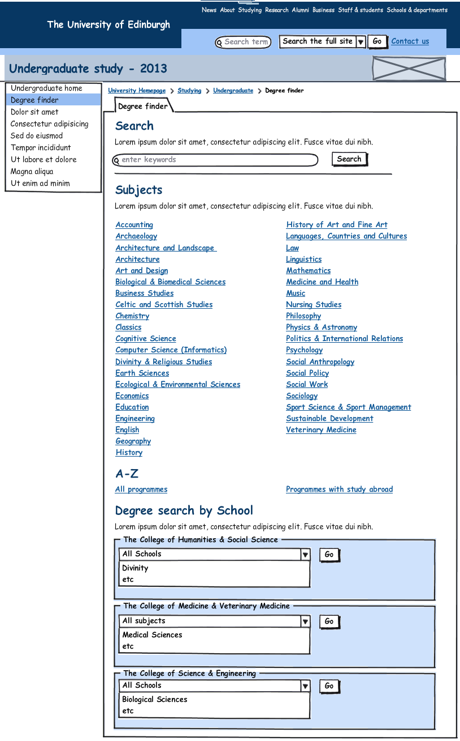

Search results interface
- Search results should:
  - Appear within the existing Degree finder tab
  - Heading: Search
  - Search box retains search term used
  - Search button
  - Link to return to browse by subject or school
  - Heading: Search results
  - Heading: Subjects
  - Display search results for subjects:
    - return multiple results if relevant
    - show subject title, image (alt tag of subject {subject}), meta description and link
    - Choosing the subject should return the subject interface
  - Heading: Programmes
  - Display search results for programmes:
    - return multiple results if relevant
    - For each programme, display on one line:
      - show {title}({award}) UCAS code (all one link),
e.g. Chemical Engineering (BEng) H800
    - Choosing the programme should return the programme interface

Mockup: Search results interface

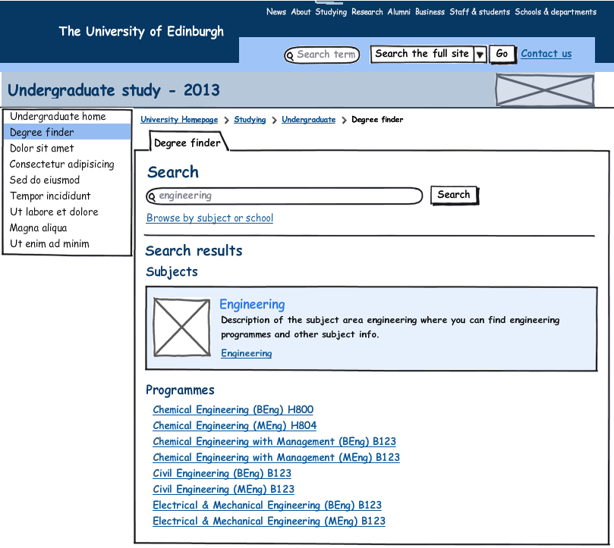

Meta subject interface
- Meta subject interface should appear within the existing Degree finder tab
- Heading: {subject}
- Standard introduction copy, tbc
- Display list of subjects
- Choosing a subject should return the Subject interface
- Horizontal rule
- Heading: Didn’t find what you were looking for?
- Search box and search button
- Link to return to browse by school (Degree finder introduction interface)
Mockup: Meta subject ‘Languages Countries and Cultures’

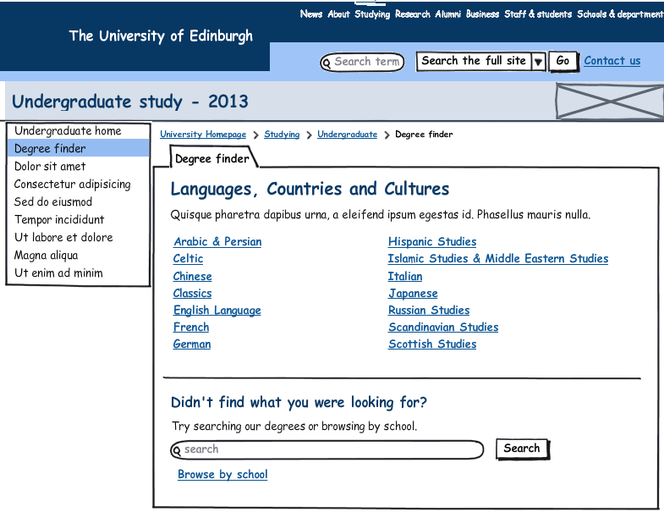

Subject interface
- Subject interface should appear in a new tab - Subject
- Introduce new design to group content into tabs and panels and reduce interface length.
- Integrate programme list, which is currently in a new tab.
- Display of content is conditional on data, i.e. if no content in the fields for a tab, the tab should not display, if no content in a field, the field content and the heading and copy for that field should not display
- Content should be grouped as follows:
{Subject}
Tab 1: Why study {subject}?
Heading: Why choose {Subject} at the University of Edinburgh?
Bullet points:
- {Why1}
- {Why2}
- {Why3}
- {Why4}
- {Why5}
- {Why6}
- {Quote text}
- {Quote name}
- (Quote title}

Tab 2: Overview
Heading: Introduction
{Introduction}
{Exception}
Tab 3: What you will study
Heading: Year 1
{Year1}
Heading: Year 2
{Year2}
Heading: Year 3
{Year3}
Heading: Year 4
{Year4}
Heading: Year 5
{Year5}
Heading: How will I be taught?
{Learning}
Heading: How will I be assessed?
{Assessment}
Heading: Placements
{Placements}
Tab 3: Where will I be taught?
Heading: Our facilities
{Facilities}
Heading: Study abroad
If study_abroad set to ‘Y’ then output as default:
Opportunities to study abroad are available in this subject area.
Unless there is content in {abroad}, in which case output content from this field.
Tab 4: Careers
Heading: Career opportunities
{Careers}
Tab 5: Degrees in this subject
Heading: Degrees in this subject
- List of programmes for this subject, for all programmes which have the subject set as ‘parent subject’.
- For each programme, display on one line which links to the relevant programme interface:
    - {title}({award}) UCAS code, e.g. Chemical Engineering (BEng) H800
- If UCAS code is longer than 4 characters then do not display
Heading: You may also be interested in:
List of programmes, to display as above for all programmes listed as related to the subject in the course subjects table.
Calls to action
- New right hand area of the programme interface which groups all calls to action, as follows:
  - Functionality:
    - Icon for print - ability to print subject content
    - Icon for email - ability to email subject interface to a friend – should use short URL
  - Image – alt tag should be subject {subject}
  - Contact box:
    - Heading: Contact
    - {Contact title}
    - Email: {email}
    - Phone: {phone}
    - Web: {web} – links to school site
    - International enquiries (static link for all subjects)
  - About this subject box
    - Heading : About this subject
    - Link for Degrees in this subject – opens the degrees in this subject tab
    - Link for Subject information sheet PDF (download the subject info PDF – stored in {subject info sheet}. The PDFs are stored in Polopoly media bank)
  - Prospectus box:
    - Heading: Prospectus
    - Icon to download prospectus (static link for all programmes to http://www.ed.ac.uk/studying/undergraduate/pdf-download. Alt text ‘Download prospectus’.)
    - Icon to order prospectus (static link for all programmes to http://www.ed.ac.uk/studying/prospectus-request. Alt text ‘Request prospectus’.)
  - See also box
    - Heading: See also
    - How to apply (static link for all programmes to http://www.ed.ac.uk/studying/undergraduate/applications-admissions/applying)
    - Accommodation (static link for all programmes to http://www.ed.ac.uk/studying/undergraduate/accommodation)
    - Financial support (static link for all programmes to http://www.ed.ac.uk/schools-departments/student-funding/undergraduate/overview)
    - Why choose Edinburgh? (static link for all programmes to http://www.ed.ac.uk/studying/undergraduate/edinburgh)
    - Visit us (static link for all programmes to http://www.ed.ac.uk/studying/undergraduate/visiting)

Mockup: Subject interface – What will you study tab

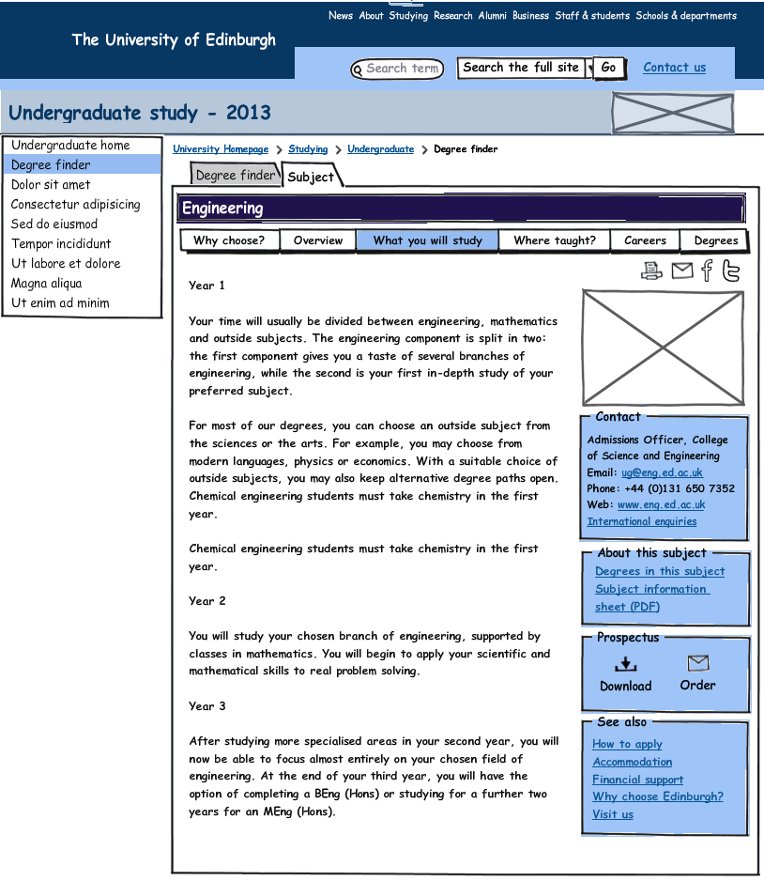
Mockup: Subject interface – Degrees in this subject tab

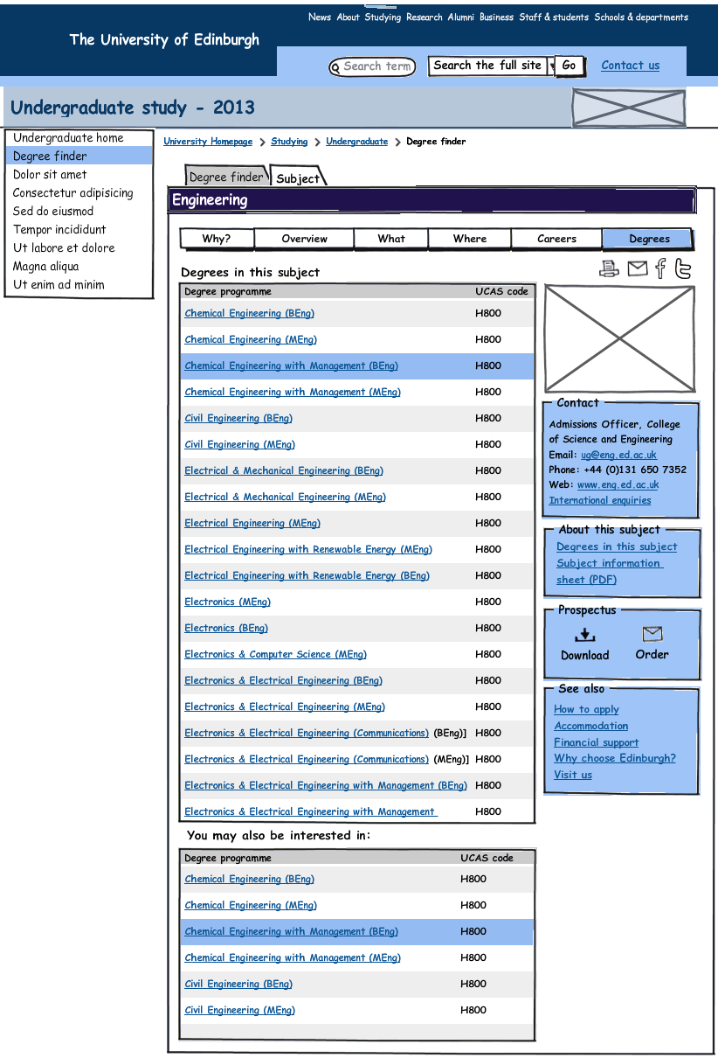

A-Z of all degree programmes interface
- A-Z results interface should appear within the existing Degree finder tab
- Heading: A-Z of all degree programmes
- Standard introduction copy, tbc
- Anchor links from letters at top of interface to letter sections
- The list should be grouped in alphabetical order by letter
- Each letter section should have a heading for the letter
- Only display letter section if there is content within that letter
- Display list of programmes
- For each programme, display on one line which links to the relevant programme interface:
  - {title}({award}) UCAS code, e.g. Chemical Engineering (BEng) H800
- If UCAS code is longer than 4 characters then do not display
- Choosing the programme should return the programme interface
- Include ‘back to top’ links for every letter section
- Horizontal rule
- Heading: Didn’t find what you were looking for?
- Search box and search button
- Link to return to browse by subject or school (Degree finder introduction interface)

Mockup: A-Z of all degree programmes

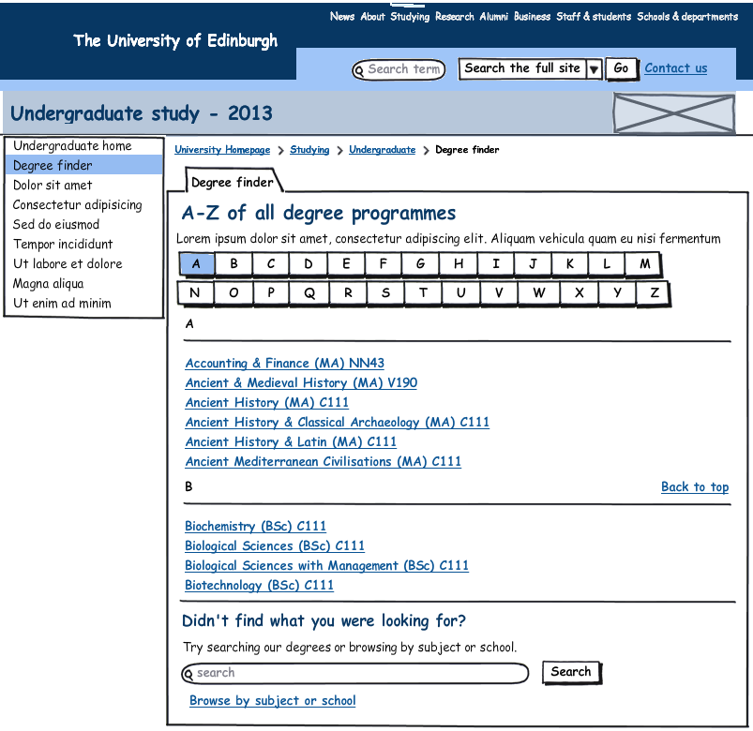

A-Z of programmes with study abroad interface
- Filter of A-Z to show only programmes with study abroad set to yes for a programme
- A-Z programmes with study abroad interface should appear within the existing Degree finder tab
- Heading: A-Z of all degree programmes with study abroad
- Display standard introduction copy, tbc
- Display anchor links from letters at top of interface to letter sections
- The list should be grouped in alphabetical order by letter
- Each letter section should have a heading for the letter
- Only display letter section if there is content within that letter
- Display list of programmes
- For each programme, display on one line which links to the relevant programme interface:
  - {title}({award}) UCAS code, e.g. Chemical Engineering (BEng) H800
- If UCAS code is longer than 4 characters then do not display
- Choosing the programme should return the programme interface
- Include ‘back to top’ links for every letter section
- Horizontal rule
- Heading: Didn’t find what you were looking for?
- Search box and search button
- Link to return to browse by subject or school (Degree finder introduction interface)
Mockup: A-Z of programmes with study abroad

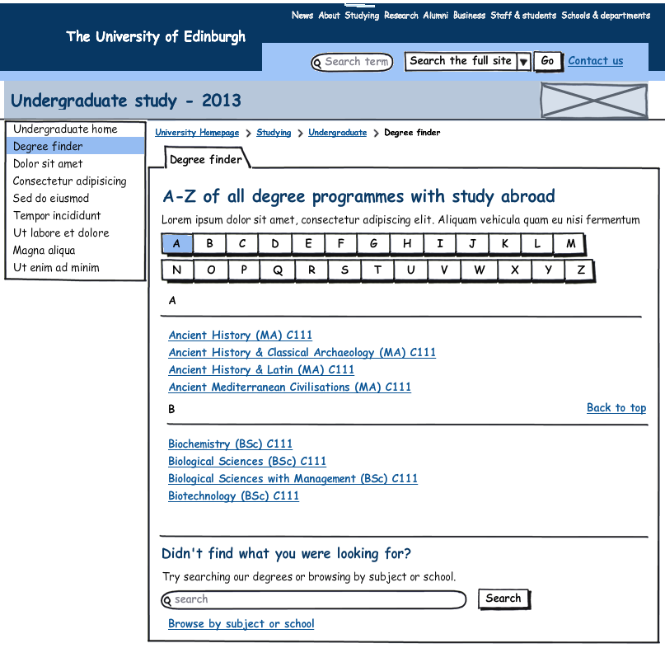
School results interface
- School results interface should appear within the existing Degree finder tab
- Heading: {School} programmes
- Standard introduction copy, tbc
- Display list of programmes
- For each programme, display on one line which links to the relevant programme interface:
  - {title}({award}) UCAS code, e.g. Chemical Engineering (BEng) H800
- Choosing the programme should return the programme interface
- The list should be grouped in alphabetical order by letter
- Each letter section should have a heading for the letter
- Only display letter section if there is content within that letter
- Include ‘back to top’ links for every letter section
- Horizontal rule
- Heading: Didn’t find what you were looking for?
- Search box and search button
- Link to return to browse by subject(Degree finder introduction interface)
Mockup: Browse by school results

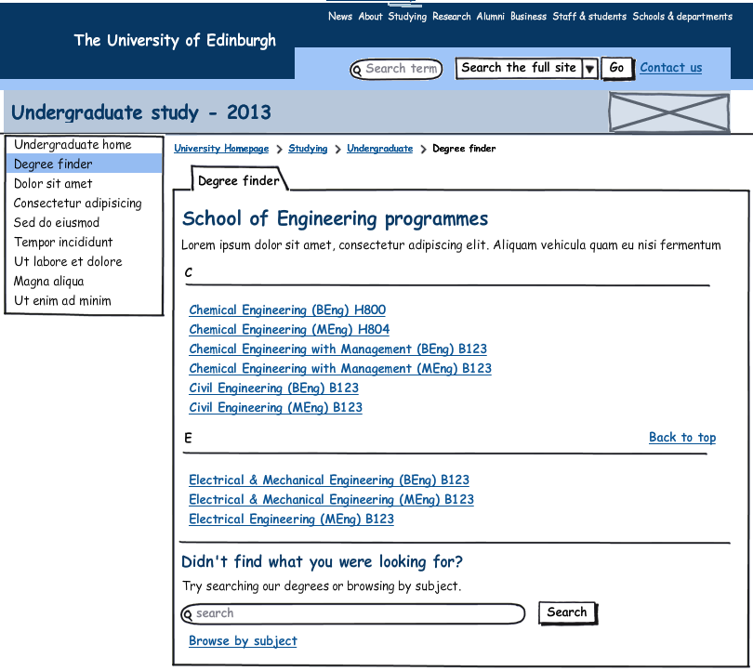

Programme interface
- Programme interface should appear in a new tab – Degree programme
- Introduce new design to group content into tabs and panels and reduce interface length.
- Display of content is conditional on data, i.e. if no content in the fields for a tab, the tab should not display, if no content in a field, the field content and the heading and copy for that field should not display
- Acronym tags to be used throughout for all acronyms
- Content should be grouped as follows:
Heading: {title}
Summary info box
UCAS code: {UCAS code} If UCAS code is not 4 digits, then display Not applicable
Duration: {duration}
Delivery: {Euclid data - methodofstudy_name}
Qualification (link text to be taken from Euclid data – {award_name} – all interfaces will link to a static interface to the appropriate anchor link for an award – this interface is not created yet)
School: (link text to be taken from Parent School {School}, links to parent School website)
College (link text to be taken from parent College {College}, links to parent College website)
Tab 1: Entry requirements
Heading: Entry requirements
Heading: Typical offer
The typical offer is likely to be:
  - SQA Highers: {SQA – Typical entry}
  - GCE A Levels: {GCE typical entry}
  - IB: {IB typical entry}
Heading: Minimum entry requirements

  - SQA Highers: {SQA Requirements}
  - GCE A Levels: { GCE requirements}
  - IB: {IB requirements}
  - ILC:{ILC requirements}

Heading: English language requirements
{English Language requirements} (from College, Subject, or Programme English language requirements field). Content to display is conditional. Default is to display college content; if content at subject then display subject instead and if content at programme, display programme instead)
Heading: Alternative qualifications
Link: Other UK qualifications (static link to http://www.ed.ac.uk/studying/undergraduate/applications-admissions/entry-requirements/other-uk )
Link: Non-UK qualifications (static link to http://www.ed.ac.uk/studying/undergraduate/applications-admissions/entry-requirements/non-uk )
If parent College is Humanities & Social Science and the programme is set to ‘Y’ for International Foundation programme, output:
Heading: International Foundation Programme
If you are an international student and your school qualifications are not accepted for direct entry to the University you may be eligible for admission to this degree programme through our International Foundation Programme.
Link: International Foundation Programme (static link to http://www.ed.ac.uk/schools-departments/humanities-soc-sci/undergraduate-admissions/international-eu/foundation-prog)
Heading: Entry to second year
For direct entry to second year the minimum requirements must be exceeded, including the following:
  - SQA Advanced Highers:{sqa_req2}
  - GCE A Levels: {gce_req2}
  - IB:{ib_2nd}
If parent College is Science and Engineering, then output:
Heading: Other entry pathways
Entry to many degrees in Science & Engineering is possible via other qualifications (e.g. HNC/D, Access, SWAP).
Link: Science & Engineering applications (static link tohttp://www.ed.ac.uk/schools-departments/science-engineering/studying/undergraduate)
{addn_req}
Heading: More information
Link: Find out more about our admissions policy and selection process (static link to http://www.ed.ac.uk/studying/undergraduate/applications-admissions)

Notes
- If there is content in {diff_entry_req} then do not display ‘typical offer, minimum entry requirements, alternative entry requirements and English language requirements and instead output the {diff_entry_req} content
- If parent College is Science & Engineering and the programme is set to ‘Y’ for International Foundation programme, do not display ‘typical offer, minimum entry requirements, alternative entry requirements and English language requirements, and instead output:
This programme is designed for international students who have not previously been able to access our undergraduate degrees, due to the fact that their school-leaving qualification was not recognised by the University of Edinburgh.
This innovative programme will be integrated into the first year of study, so unlike many other foundation programmes, will not mean an extra year of study.
After successful completion of the first year, students will have the opportunity to transfer into a variety of different degree programmes, within their chosen subject area.
Applications should be made through UCAS in the usual way. Further information is available from the College of Science & Engineering:
Link: Science & Engineering foundation programme (static link to http://www.ed.ac.uk/schools-departments/science-engineering/studying/international/foundation )
Tab 2: Overview
Heading: Overview
{introduction}
Heading: Why study {title}
{why_study}
{exception}
Heading: Accreditation
{accreditation}
Heading: Placements
{Placements}
Heading: Careers
{Careers}
Tab 3: What you will study
Heading: What you will study
{What study}
Heading: Year 1
{what_year1} if blank then pull from parent subject:{year1}
Heading: Year 2
{what_year2} if blank then pull from parent subject:{year2}
Heading: Year 3
{what_year3} if blank then pull from parent subject:{year3}
Heading: Year 4
{what_year4} if blank then pull from parent subject:{year4}
Heading: Year 5
{what_year5} if blank then pull from parent subject:{year5}
Heading: How will I be taught?
{Learning} from parent subject
Heading: How will I be assessed?
{Assessment} from parent subject
Heading: Placements
{Placements}
Heading: Study abroad
{abroad_detail}
Heading: Programme structure
Find out more about the compulsory and optional courses in this degree programme.
Link: Structure of degree programme (links to DPT entry, uses Euclid link, logic for this should still apply from STU222)
Heading: Details
Find out more about this programme's aims, what you will learn, how you will be assessed and what skills and knowledge you will develop.
Link: Details of degree programme (links to proxied DPS entry, uses Euclid link, logic for this should still apply from STU222)
Tab 4: Applications
Heading: Applications
Standard intro copy for all programmes, tbc.
Heading: What are admissions selectors looking for?
{admissions} from parent subject
{high_demand}
If {Protecting Vulnerable Groups (PVG)} flag is set to ‘Y’, then output:
Heading: Protecting Vulnerable Groups
All successful applicants will be required to complete a Protecting Vulnerable Groups (PVG) criminal record check before starting the programme. In addition, all applicants who don’t live in the UK, or who have spent more than a year abroad, will need to provide equivalent verification from the relevant national authority.
If {requiresAtas} is set to ‘Y’ for a programme in the Euclid feed then output:
Heading: International students: Academic Technology Approval Scheme
If you are not an EU, EEA or Swiss national you may need an Academic Technology Approval Scheme clearance certificate in order to study this programme.
Link: Academic Technology Approval Scheme (static link to http://www.ed.ac.uk/schools-departments/international-office/immigration/new-students/atas)
{other_application}
Heading: More information
Link: How to apply (static link to http://www.ed.ac.uk/studying/undergraduate/applications-admissions/applying)
Link: Find out more about our admissions policy and selection process (static link to http://www.ed.ac.uk/studying/undergraduate/applications-admissions)
Tab 5: Key Information Set
(Logic for this section should still apply from STU222)
Heading: Key Information Set
Key Information Sets (KIS) are part of a government initiative to enhance the information that higher education institutions provide about their degree programmes.
KIS are available for most undergraduate programmes and are intended to make it easier for you to find information about the programmes you are interested in studying. It is one of many sources of information available that will enable you to make an informed decision on what and where to study.
You can also use this website to find more information on our programmes and the learning environment you will experience at the University of Edinburgh.
Link: Undergraduate study (static link to http://www.ed.ac.uk/studying/undergraduate)
{kis_info} from Parent College
{kis_info} from Parent School
{kis_info}
Heading: Why choose Edinburgh?
Choose to study with us and you will be investing in an education that will help you build a successful future.
You'll be taught by world-leading experts who will give you a lifelong thirst for knowledge and understanding.
Our research-led teaching encourages a pioneering, innovative and independent attitude to learning, while our focus on professional skills ensures success within and beyond University.
Link: Find out why we're one of the top universities in the world (static link to http://www.ed.ac.uk/studying/undergraduate/edinburgh)
Our undergraduate Open Days are a great opportunity to come and see the University for yourself. You can learn more about the range of degree programmes available and ask questions about admissions, accommodation and job prospects.
Link: Undergraduate Open Days (static link to http://www.ed.ac.uk/studying/undergraduate/visiting/open-days/)
Calls to action
- New right hand area of the programme interface which groups all calls to action and links, as follows:
- Functionality:
    - Icon for print - ability to print programme content – this should pull content from both the parent subject and programme, without duplication. Alt text ‘Print this degree programme’.
    - Icon for email - ability to email programme to a friend – should use short URL. Alt text ‘Email this degree programme’.
- Contact box:
From parent subject:
    - Heading: Contact
    - {Contact title}
    - Email: {email}
    - Phone: {phone}
    - Web: {web} – links to parent school website
    - International enquiries (static link for all subjects)
- About this programme box:
    - Heading: About this programme
    - Link: Programme structure (links to DPT entry, uses Euclid link, logic for this should still apply from STU222)
    - Link: Programme details (links to proxied DPS entry, uses Euclid link, logic for this should still apply from STU222)
    - Tuition fees (links to proxied fees entry, uses Euclid link, logic for this should still apply from STU222)
- About this subject box:
    - Heading: About this subject
    - Why choose [Subject](links to parent subject interface)
    - Careers (links to Careers info on parent subject interface)
    - Degree programmes (links to programmes list on parent subject interface)
- Prospectus box:
    - Heading: Prospectus
    - Icon to download prospectus (static link for all programmes to http://www.ed.ac.uk/studying/undergraduate/pdf-download)
    - Icon to order prospectus (static link for all programmes to http://www.ed.ac.uk/studying/prospectus-request)
- See also box:
    - Heading: See also
    - How to apply (static link for all programmes to http://www.ed.ac.uk/studying/undergraduate/applications-admissions/applying)
    - Accommodation (static link for all programmes to http://www.ed.ac.uk/studying/undergraduate/accommodation)
    - Financial support (static link for all programmes to http://www.ed.ac.uk/schools-departments/student-funding/undergraduate/overview)
    - Why choose Edinburgh? (static link for all programmes to http://www.ed.ac.uk/studying/undergraduate/edinburgh)
    - Visit us (static link for all programmes to http://www.ed.ac.uk/studying/undergraduate/visiting)

Mockup: Programme interface – Entry requirements tab
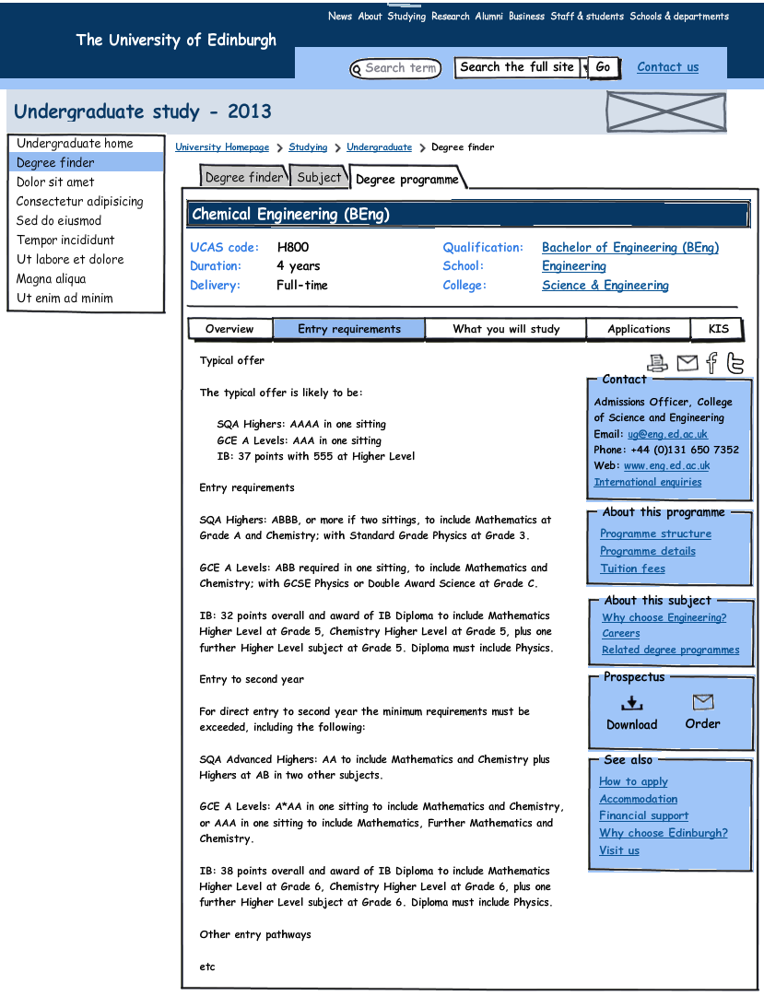

Mockup: Programme interface –Key Information Set tab

