

**Moodle Data Feeds**

**Application and Data Architecture**

**TEL025**

**Document Version: 0.3**

**Date: 01/10/15**

**Contents**

1 Document Management 3

1.1 Contributors 3

1.2 Version Control 3

2 Introduction 4

2.1 Current processes 5

3 Existing Core data types 6

3.1 Identity 6

3.2 Group 7

3.3 Memberships 9

4 New Core data types 12

5 System interfaces 13

5.1 Data volume 15

6 System Processes 16

6.1.1 Course and enrolments data feeds (sourced from EUCLID): 16

6.1.2 Course selection interface 17

6.1.3 Student population 17

6.1.4 Staff/Course ‘owners’ 17

6.2 Audit 18

6.3 Data retention/archive/deletion 18

7 R&D Requirements 19

7.1 How will the data be sourced? 19

7.2 How will the data be applied to Moodle? 19

8 References 20

# Document Management

When completing this document please mark any section that is not required as ‘N/A’. A brief description of why the section is not required should also be included.

## Contributors

*Please provide details of all contributors to this document.*

|  |  |  |
| --- | --- | --- |
| **Role** | **Unit** | **Name** |
| Author | IS APPS ISG | Geir Granum |
|  |  |  |
|  |  |  |
|  |  |  |
|  |  |  |

## Version Control

*Please document all changes made to this document since initial distribution.*

|  |  |  |  |  |
| --- | --- | --- | --- | --- |
| **Date** | **Version** | **Author** | **Section** | **Amendment** |
| 22/09/15 | 0.1 | GG | All | Initial version |
| 29/09/15 | 0.2 | GG | All | Update after feedback |

# Introduction

Moodle is a VLE (Virtual Learning Environment) platform available to use at University of Edinburgh for courses that are taught completely online for distance students.

At present the courses are created and students are added via manual processes, these can be completed either via Moodle Interface or by import of a CSV file. This creates a staff overhead that will be difficult to sustain in the medium to long term if the service is to be expanded to accommodate new and successful Online Distance Learning (ODL) courses, as well as making it impossible to expand the use of the service for blended or on campus courses.

We aim to automate the creation of courses and the ability to populate these courses in Moodle with students and course organisers and course secretaries.

To do this we will need feeds containing the following **course** information:

* Course Id e.g.:‘ECNM11036’
* Course instance Id (something that identifies an unique instance of a course e.g.: course Id + session id + course occurrence + course period – these items do not have to be provided separately) e.g.: ‘ECNM11036’+’2011-2’+’SS1’+’SEM2’
* Course name e.g.: ‘Economics for Postgraduates’
* Session Id (the academic year of the course) e.g.:’2011-2’
* Course organiser Id (initial course ‘owner’) e.g.:‘860’
* Course secretary Id (initial course ‘owner’) e.g.:‘134759’
* Course ‘parent’ (level 6 org hierarchy school Id) e.g.:‘SU284’

We will need the following **enrolment** information:

* Course instance Id (something that identifies an unique instance of a course the same way as in course information, e.g.: course Id + session id + course occurrence + course period – these items do not have to be provided separately) e.g.: ‘ECNM11036’+’2011-2’+’SS1’+’SEM2’
* Student Id e.g.: ‘s1150425’

We will also need a source for **identity** information that allows lookup of:

* EduniIdsId
* First name/preferred name
* Surname
* UUN
* Email address

From either a student UUN (from the enrolments data) or from a staff Id number form the course data.

It appears that LDAP can be used as a source for **enrolment** and **identity** information. Some course information can also be found in LDAP however it does NOT contain the course organiser or the course secretary, this information can be accessed, in the same way as what currently happens with the VLE BBLearn, from a nightly data-feed provided by EUGEX in the form of a csv formatted text file.

## Current processes

Currently users, courses and enrolments are manually entered into Moodle using the processes described here:

(From <https://www.projects.ed.ac.uk/webfm_send/5863>)

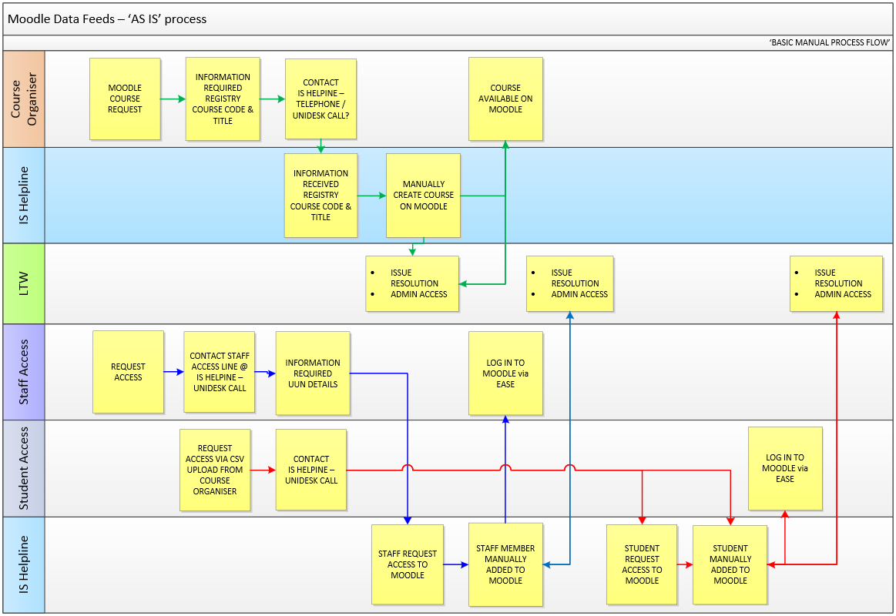

This figure illustrates the current manual process.

# Existing Core data types

Moodle supports a sub-set of the IMS Enterprise specification (<http://www.imsglobal.org/enterprise/entv1p1/imsent_infov1p1.html>)

to load identity (person), course (group) and enrolment (membership) data supplied from systems external to Moodle. The following information is derived from this sub-set.

Moodle also has core web-services available with similar functionality using the same data as described below.

## Identity

* <https://www.wiki.ed.ac.uk/display/insite/Identity>

Identities can be maintained in Moodle using the data specified in the IMS Enterprise <person> element:

|  |  |  |  |
| --- | --- | --- | --- |
| Title | Description | Datatype | Example |
| sourcedid | The ID of the Group as defined by the source system. | structure | <sourceid> |
| source | Identifier of the organization or system that assigned the ID. | string | “IDM” |
| id | Permanently unique identifier of the object as defined by the system where the object was created | string | {eduniIDMSID} |
| userid | The person's user ID to access the learning management environment | string | {uid} |
| name | The name of the Person | structure | <name> |
| fn | Formatted name | string | {eduPersonNickname} {sn} |
| n | Name with all parts distinguished. | structure | <n> |
| family | This is the family name and not the last name. | string | {sn} |
| given | The given name and not necessarily the first name |  | {eduPersonNickName} |
| email | E-mail address used to contact a Person | string | {mail} |

<person>

<sourcedid>

<source>IDM</source>

<id>{eduniIDMSID}</id>

</sourcedid>

<userid>{uid}</userid>

<name>

<fn>{eduPersonNickname} {sn}</fn>

<n>

<family>{sn}</</family>

<given>{eduPersonNickname} </given>

</n>

</name>

<email>{mail}</email>

</person>

## Group

* <http://www.imsglobal.org/enterprise/entv1p1/imsent_infov1p1.html#1427147>

Courses can be maintained in Moodle using the data specified in the IMS Enterprise <group> element.

|  |  |  |  |
| --- | --- | --- | --- |
| Title | Description | Datatype | Example |
| sourcedid | The ID of the Group as defined by the source system. | structure | <sourcedid> |
| source | Identifier of the organization or system that assigned the ID. | string | “EUCLID” |
| id | Permanently unique identifier of the object as defined by the system where the object was created | string | PHYS100942014-5SV1YR |
| description | Description/name of the Group | structure | <description> |
| short | Intended to be displayed on screen on less than one line | string | Principles of Quantum Mechanics |
| long | Longer descriptive name for the Group | string |  |
| org | In Moodle used to store course category | structure | <org> |
| orgunit | The course category | string | AY2014-15 (current usage, may change) |
| relationship | If the Group is related to another Group then this element can be used to describe that relationship |  | Relation=1 (defining the group in the <relationship> as the parent to the ‘outer’ group) |
| sourcedid | The unique identifier of the other Group with which the relationship is being established | structure | <sourcedid> |
| label | Describes the nature of the relationship between this Group and the related Group | string | ‘Main Course’ |

E.g.: this will create a course instance ‘PHYS100942014-5SV1YR’ of the course ‘PHYS10094’ under the Learning context hierarchy node identified as: ‘ORG_HIER’ and ‘SU123’

<group>

<sourcedid>

<source>EUCLID</source>

<id> PHYS10094</id>

</sourcedid>

<description>

<short> Principles of Quantum Mechanics</short>

</description>

<relationship relation=”2”>

<sourcedid>

<source>ORG_HIER</source>

<id>SU123</id>

</sourcedid>

<label>School</label>

</relationship>

</group>

<group>

<sourcedid>

<source>EUCLID</source>

<id> PHYS100942014-5SV1YR</id>

</sourcedid>

<description>

<short> Principles of Quantum Mechanics 2014-15</short>

<long>This course teaches the Principles of…</long>

</description>

<org>

<orgunit>AY2014-5</orgunit>

</org>

<relationship relation=”2”>

<sourcedid>

<source>EUCLID</source>

<id>PHYS10094</id>

</sourcedid>

<label>Main course</label>

</relationship>

</group>

## Memberships

* <http://www.imsglobal.org/enterprise/entv1p1/imsent_infov1p1.html#1427710>

Enrolments can be maintained in Moodle using the data specified in the IMS Enterprise <membership> element.

|  |  |  |  |
| --- | --- | --- | --- |
| Title | Description | Datatype | Example |
| sourcedid | The ID of the Group as defined by the source system. The memberships are defined with respect to this Group | structure | <sourcedid> |
| source | Identifier of the organization or system that assigned the ID. | string | “EUCLID” |
| id | Permanently unique identifier of the object as defined by the system where the object was created | string | PHYS100942014-5SV1YR |
| member | Group member. | structure | <member> |
| sourcedid | The ID of a Person or a Group as defined by the source system | strucure | <sourcedid> |
| source | Identifier of the organization or system that assigned the ID. | string | “IDM” |
| id | Permanently unique identifier of the object as defined by the system where the object was created | string | {eduniIDMSID} |
| role | The role of the member in the Group. | string | Roletype =”01” (learner) or Roletype=”02” (instructor) |
| status | Indicates if a member is active or inactive in the Group | integer | 0=Inactive 1=Active |

Student enrolment in a course:

<membership>

<sourcedid>

<source>EUCLID</source>

<id> HYS100942014-5SV1YR</id>

</sourcedid>

<member>

<sourcedid>

<source>IDM</source>

<id>{eduniIDMSID}</id>

</sourcedid>

<role roletype="01">

<status>1</status>

</role>

</member>

</membership>

Staff enrolment in a course:

<membership>

<sourcedid>

<source>EUCLID</source>

<id>PHYS100942014-5SV1YR</id>

</sourcedid>

<member>

<sourcedid>

<source>IDM</source>

<id>{eduniIDMSID}</id>

</sourcedid>

<role roletype="02">

<status>1</status>

</role>

</member>

</membership>

“Soft” Student un-enrolment from a course:

<membership>

<sourcedid>

<source>EUCLID</source>

<id>PHYS100942014-5SV1YR</id>

</sourcedid>

<member>

<sourcedid>

<source>IDM</source>

<id>{eduniIDMSID}</id>

</sourcedid>

<role roletype="01">

<status>0</status>

</role>

</member>

</membership>

# New Core data types

none

# System interfaces

Maintaining a list of EUCLID courses available in Moodle

* Pull list of ALL available courses from EUCLID
* Select courses for inclusion in Moodle



Maintaining EUCLID courses in Moodle

* PULL EUCLID course data
* Combine with the included list of courses and a list of the courses that are in Moodle
* Generate XML with additions, deletions and changes of courses
* For additions of courses, generate XML with additions of ‘course owners’



Maintaining student enrolments in Moodle

* PULL list of EUCLID enrolment data
* Combine with existing enrolments from Moodle
* Generate XML with additions and deletions in enrolments



Maintaining Student IDs in Moodle

* Student IDs found in enrolments processing, combined with
* PULLED identity data
* Generate XML with additions and deletions of student ID data



Maintaining Staff IDs in Moodle

* Staff IDs found in course processing, combined with
* PULLED identity data
* Generate XML with additions of staff ‘course owners’ ID data



## Data volume

Data volume is expected to be low. The XML file will be generated no more frequent than the current BBLearn process, twice a day. The course volume is expected to be low especially compared to BBLEARN. (Currently there are less than 20 courses per academic year) and with the lower number of courses the number of people and enrolments will be correspondingly low.

# System Processes



In the following sections data feeds containing similar data to what is used by BBLearn are assumed (identities, courses and enrolments How the data is accessed is irrelevant as long as the identities originates from IDM and the courses and enrolments originates from EUCLID.

### Course and enrolments data feeds (sourced from EUCLID):

This should be similar to what is currently fed to BBLearn:

* ALL EUCLID courses
  + The fields in the BBLearn feed:
    - VCL1_COURSE_CODE
    - VCL2_COURSE_OCCURENCE
    - VCL3_COURSE_YEAR_CODE
    - VCL4_COURSE_PERIOD
    - VCL5_COURSE_TITLE
    - VCL6_SUBJECT_CODE
    - VCL7_NORMAL_YEAR_CODE
    - VCL8_SCHOOL_ID
    - VCL9_COURSE_LEVEL
    - VCL10_COURSE_YEAR_CODE
    - VCL11_COURSE_ORG_REF
    - VCL12_COURSE_SEC_REF
    - VCL13_WEBCT_ACTIVE
* ALL EUCLID enrolments
  + The fields in the BBLearn feed
    - VLE1_COURSE_CODE
    - VLE2_COURSE_OCCURANCE
    - VLE3_COURSE_YEAR_CODE
    - VLE4_COURSE_PERIOD
    - VLE5_UUN
    - VLE6_ROLE

### Course selection interface

There need to be an interface somewhere where the courses for which we are processing enrolments are selected.

* Search for course must be supported
* Once found a course can be selected
* Authorisation levels: Moodle service team (admin) and Helpdesk (user)

This ‘Course selection interface’ controls which courses are added/updated/deleted using the automatic data feed process

### Student population

Using the list of courses from course-selection and the EUCLID sourced enrolment feed we can find which students we need to add to Moodle

* Anyone with an enrolment in a course who are not currently in Moodle need to be added.

The enrolment feed provides only the UUN. We could use LDAP to get the rest of the data needed for a Moodle ID (‘given name’, ‘family name’, ‘email’ and EduniIDMSId)

Student additions and deletions can be found by comparing the list of UUNs found by joining the course list and the enrolments with the list of currently existing student UUNs in automatic courses in Moodle.

### Staff/Course ‘owners’

Using the EUCLID sourced course feed the staff-number of the ‘course organiser’ and ‘course secretary’ for the courses can be found. These members of staff can then be enrolled as the initial instructors for a new course on course creation.

The course feed provides only the staff-id. We could use LDAP to get the rest of the data needed for a Moodle ID (‘given name’, ‘family name’, ‘email’ and EduniIDMSId)

## Audit

The status of the processing will be sent as an email message. If an error occurred during processing this will be logged in a database table and be part of the status email.

## Data retention/archive/deletion

The XML generated by the processing will be archived using a similar process to BBLearn where the files are stored in a subdirectory of the processing directory.

# R&D Requirements

## How will the data be sourced?

BBLearn uses a combination of IDM notifications and lookup for IDs and generated text files from EUGEX for course and enrolment information. This would work for Moodle as well.

LDAP appears to be an alternative for ID and enrolment data. The course information appears to be missing some of the information that is needed (i.e.: course-organiser and course-secretary) that is needed for an implementation that is functionally equivalent to the BBLearn implementation.

(The PHP used on the Moodle servers do not (currently) have LDAP installed)

## How will the data be applied to Moodle?

There are two methods that can be used to apply the creation, changes and deletion of users, courses and enrolments to Moodle:

* IDMS Enterprise XML data-feeds
  + + Standardised fields and structure
  + – Moodle only support a sub-set of the standard (it is possible that the final requirements will require information that cannot be controlled with the sub-set of the standard that Moodle supports)
  + + XML file, can be used to track changes applied to Moodle.
  + - XML file, needs to be physically moved around and maintained (“moving part”)
* Moodle ‘core_*’ web services
  + + Access to ALL Moodle fields
  + – No file created that can be used to track the changes applied to Moodle (unless we explicitly do so for this purpose only)

# References

Link to any external references here.

* Reference 1