System Description

For

Undergraduate Degree Finder

Document Version: 1.0

Date: 04/04/2013

Contents

1 Document Management 3
1.1 Contributors 3
1.2 Version Control 3
2 OVERVIEW 4
2.1 Service Description 4
2.2 Data Model 4
2.3 Reporting 4
2.4 Technology 4
2.5 Methodology 5
2.6 Development Tools 5
2.7 Authentication and Authorisation 5
2.8 Delivery 5
2.9 Third Party 5
2.10 Source Control 5
2.11 User Documentation 5
3 Related Projects or Major Support Work 6
4 Technical Architecture 7
5 How-To Guide 8
6 Troubleshooting Guide 9
7 Document Sign Off 9

Document Management

Contributors

Please provide details of all contributors to this document

Role | Unit | Name
Production Management Coordinator (Owner) | IS Production Management | Chris Cord
Systems Analyst Designer | IS Applications Development | Jonathan Mayo
Technical Architect | IS Development Technology | Riky Harris, Neil Grant
Project Manager | IS Project Services | Maurice Franceschi
Project Sponsor | Communication and Marketing | John Cavani
Business Analyst | IS Project Services | Sue Woodger
Business Area Manager | Communication and Marketing | Ailsa Vamplew, Steven Ross

Version Control

Please document all changes made to this document since initial distribution.

Date | Version | Author | Section | Amendment
04/04/13 | 1.0 | J Mayo |  | Initial Release

OVERVIEW

Communications and Marketing publish prospectus information for each academic year on the University website in addition to providing a printed (and PDF) copy for prospective students.

The Undergraduate Prospectus system comprises of two parts: a front end display which outputs the prospectus information held by the system in plain html which is then proxied through Polopoly for display to prospective students on the University website, and a restricted EASE authenticated back end administration system which is used by CAM to maintain the prospectus data.

The system is generally referred to as the “undergraduate degree finder” and is a highly visible service provided on the main ed.ac.uk domain. The undergraduate degree finder is a high traffic area of the University website with over 6.5 million hits per year.

Generally new prospectus information is published once a year for the undergraduate degree finder however changes are made throughout the year as required.

Service Description
There are two main components within this service, a front end display which renders the online prospectus content and a back end admin which is used to maintain it. Note that there are two identical copies of the front end code, one serves live data to the public, the other serves preview data.

See the TAD for URLs to the different environments and services.

Admin
The back end admin application allows admin users to maintain the prospectus data held within the system. The application is EASE authenticated and is authorised against the smsug.users table however there are no user roles etc. within the system, an authorised user has total control over the application.

Prospectus data is maintained for each year. Only active years can be published to the live or preview displays. Only live records within a published year will be displayed by the front end.

Subject, programme and EUCLID data load records (and their relationships to other records) are version controlled and linked to a specific year while other records are not. Subjects and programmes can have a status of draft, live or archive.

- Only live records are ever displayed.
- Drafts can exist against a live record or where no live record exists.
- When a record is published (either from draft or by editing a live record) the previous live record is archived for data retention and rollback purposes.
- For any given code within a year there can only ever be at most one live and one draft record (with any number of archive records).
- Deleting a record will also remove the version history; to retain the version history a record should be unpublished.

The admin application uses the Central Authorisation LDAP service to update user details.

Users also periodically upload a data extract from EUCLID into the system which populates certain elements of the display. This is managed by a file upload dialogue within the system.

Display
The application is rendered to the end user through the Polopoly proxy. Configuration of the proxy, including CSS used to format the final output, is maintained by Communications and Marketing and does not require support from Information Services.

There are two instances of the front end display, live and preview. The live display is proxied through Polopoly for public consumption on the University website. The preview display is proxied through Test Polopoly and is used to show CAM/staff in schools the draft prospectus for the new academic year before publishing.

The preview prospectus is restricted at the load balancer to access within EdLAN.

The prospectus picks up which year is to be displayed (public vs preview) from the table smsug.system_defaults picking the MAX(id) record and looking at the default_display_year vs _preview_year. The display application knows whether to render public or preview information by looking at the filepath of the application (if it contains “preview/htdocs/web-proxy/ug” it will use the preview year otherwise the public year will always be used).

The display environment has also been configured with a series of mod_rewrite rules at the Apache virtual-host level. These rules re-write the old application URLs to the new format (eg. subjects.php?id=0,24 becomes index.php?action=subject&code=24). The re-write rules exist for both public and preview displays.

Data Model
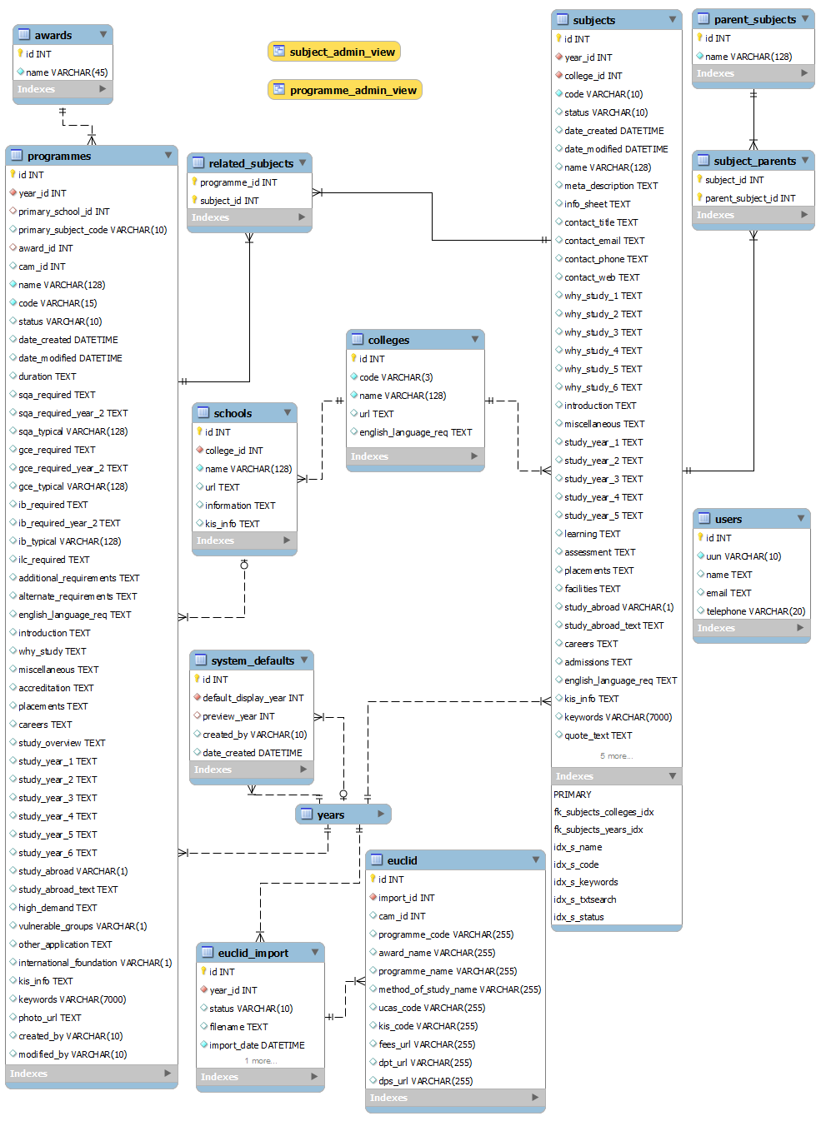

Reporting
No reporting facility exists within the system.

Technology
The applications require the following hosting platform which will is configured as specified in the TAD:

- PHP 5.3 (with php_mysqli, pdo_mysql and LDAP modules)
- MySQL 5.1 (using the InnoDB storage engine)
- Apache 2.2
- Yii Framework 1.1.13

Methodology
The admin application uses the Yii MVC framework, version 1.1.13. Additionally, the admin application uses the Yii Bootstrap theme for many of the display elements.

• http://www.yiiframework.com/
• http://www.cniska.net/yii-bootstrap/

Yii Active Record is used as an Object-Relational Mapping approach.

The front end display is written in an MVC style but does not use any proprietary framework or ORM technology (using direct mysqli queries instead).

Development Tools
Any IDE that can support PHP and JS is suitable. For example Eclipse with the PHP Development Tools (PDT) and Javascript Development Tools plugins.

MySQL Workbench is recommended for working with the database however there are plugins for use with Oracle SQL Developer to enable MySQL support.

If running the admin application in an environment other than dev/test/live, PHP needs to be configured for LDAP.

Authentication and Authorisation
The undergraduate prospectus live display contains only open access data and is intended for public consumption through the University website and as such no authentication or authorization is required for read access to this system.

The undergraduate prospectus preview display is restricted at the load balancers so that it can only be accessed within EdLAN, this is less from a security point of view and more to prevent prospective students from accidently accessing preview information and confusing it with the live data.

For the admin system authentication is provided by EASE. Authorisation is built into the admin system using a basic UUN based lookup against the users table once the user has authenticated such that only an authenticated user whose UUN exists in the users table will be granted access to the system.

Non-authorised visitors are shown a custom error page with appropriate contact information.

Delivery
The admin application is accessed directly via the appropriate URL (in the TAD).

The display application is proxied through Polopoly for display on the main university website. CAM are responsible for the correct configuration of Polopoly and any accompanying CSS to render the page correctly.

Third Party
The registry provides an extract of data from EUCLID as a tab-delimited file for upload through the admin application. These files are available from CAM.

Source Control
The application source is controlled through subversion and available as follows:

- Admin
https://svn.ecdf.ed.ac.uk/repo/is/apps/software/prospectus_maps_az_admin/trunk/src/undergraduate
- Display
https://svn.ecdf.ed.ac.uk/repo/is/apps/software/ug_prospectus/trunk/src

User Documentation
No support documentation is provided for the public facing display.

As the application has a very small user base (2-3 users in CAM) no user documentation exists for the admin application.

Related Projects or Major Support Work

The following table lists previous projects or major pieces of support work that have been carried out on this service:

Project / Major Support Work | Analyst | Developer | Description
SSG002: Student Marketing Services Infrastructure Migration (UG) | Jonathan  Mayo | Jonathan  Mayo | This was the initial development project to migrate the system from the old code on praline into these new systems.
SSG002: Student Marketing Services Infrastructure Migration (PG) | Adrian Richardson | Adrian Richardson | This project was run in parallel to the UG project and was to migrate the PG Prospectus from Praline to the new infrastructure.

Technical Architecture

https://www.projects.ed.ac.uk/project/ssg002/technical_architecture

How-To Guide

General workflow
The user creates a new year, any previous year can be used as a template which replicates information from that year against the new one (with the exception of the course entry requirements).

The admin user then adds/removes/edits subject and programme information as required for this new year.

Once the admin user is happy with the prospectus content they point the preview year in the admin application to the year they have been working on. The preview display will now show this year. Test polopoly is pointed at the preview URL and a link to this proxied content is sent out to schools to view the proposed prospectus.

When the information is to be put live, the admin user points the published year in the admin application to this year. This information is then live on the University website via Polopoly.

Only live programme and subject records are displayed by the front end. If the admin user wishes to make changes to the record they edit and save a draft of the record. The live version of the record continues to be displayed while the draft is held for review. Upon review the admin user can choose to delete the draft or to publish it, if published the current live record is archived and the draft made live. A record can be edited and published straight to live rather than draft if desired.

An admin user can also un-publish a record to stop it appearing in the prospectus, or delete a record (however this also removed the archived history).

Periodically the EUCLID data used to feed the front end display is updated. The admin user would do this by using the EUCLID import feature of the admin application to upload a EUCLID import file (tab-delimited file) which has been previously provided by the registry.

Create a new admin user
There is a facility provided within the admin to create new users, however users can also be added directly by inserting a new UUN into the smsug.users table. When the user is logged in via EASE and visits the application their details will automatically be pulled from central auth.

There are no development accounts held by default in the system.

Local installation
For deployment to dev/test/live see the implementation plan. For deployment locally for testing see below

- The application should be deployed on an appropriate platform as described in section 2.4.
- A local copy of the smsug database should be used.
- Code should be checked out from the SVN repository.
- Local Apache v-hosts/conf file should be updated to provide the mysql database connection details for the application directory (example below – this should be done for both admin and display).
<Directory "c:/dev/apache243/htdocs/ug_new">
php_value mysqli.default_host "localhost"
php_value mysqli.default_user "root"
php_value mysqli.default_pw "password"
</Directory>
- For the admin it may be necessary to manually set the php $_SERVER[‘REMOTE_USER’] variable to an authorised UUN to be able to use the system. This can be done in the index.php file.
- The admin will also require that the Yii framework directory is added to the PHP include path.
- Note that the preview will only work as expected if the path is valid as per section 2.1.

Troubleshooting Guide

Bulk Edit/Publish requires javascript.
The bulk edit and bulk publish facilities for programmes and subjects in the admin interface require javascript to function correctly. With javascript disabled a user may select records in the grid and choose to bulk edit/publish but no records will be passed into these functions.

If the user is not able to enable javascript they can edit the records individually.

Invalid EUCLID data files
Periodically admin users upload new EUCLID data extracts into the system. The application does this as a multi-part process, first uploading the file, reading it into memory and then writing it into the database within a transaction. If the file is invalid, the user chooses to abort the load or there is an error during load then the file will not be loaded into the system.

If there is a system error the import file record will be “Failed”, if the user cancels the load this will be “Processed” and if the import is successful and published the status will be live.

If the file is invalid the user must confirm the format is correct.

Debugging
PHP errors are logged to either a specific PHP error log file at /u01/app/php/php_error_log or will be included in the relevant Apache log file at /var/log/httpd/.

The Yii framework application log is available at protected/runtime/application.log.

Application debug can be turned on by uncommenting the appropriate lines in the main.config file.

Document Sign Off

Please add other sign off roles where required:

Production Management Coordinator | Chris Cord | Date
Project Manager | Maurice Franceschi | Date
Project Sponsor | Ailsa Vamplew | Date
Business Analyst | Sue Woodger | Date
Systems Analyst Designer | Jonathan Mayo | Date
Technical Architect | Riky Harris | Date

